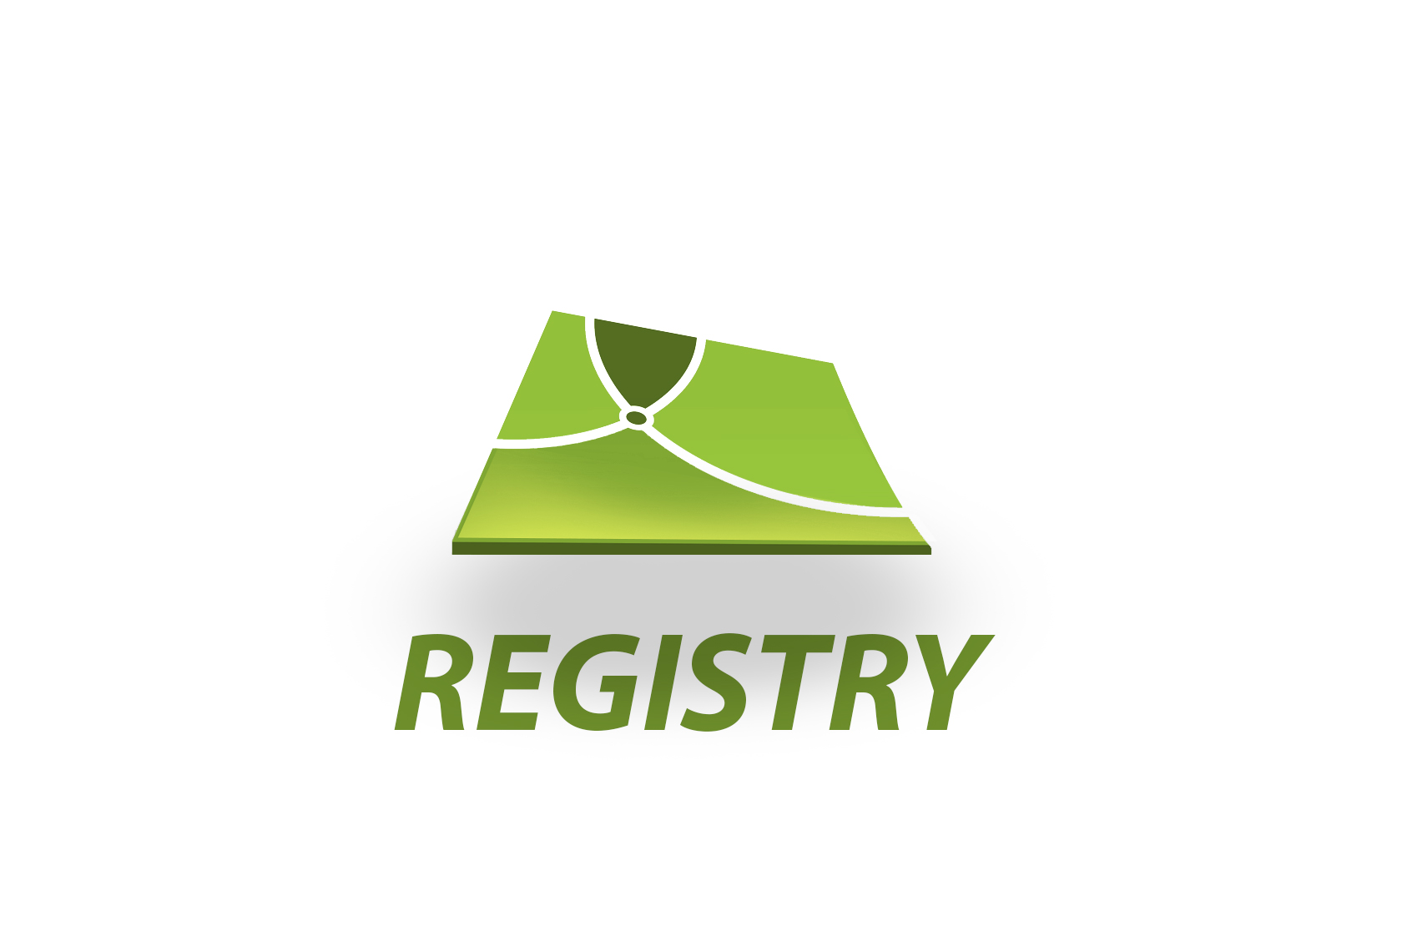

User Guide

for Release v1503a

Table of Contents

1. About this Guide 4

2. Solutions for Open Land Administration 5

2.1 Securing Land Tenure through Automation 5

2.2 Automation in Developing Countries 5

2.3 Solutions for Open Land Administration (SOLA) 5

2.4 Evolution of SOLA 6

2.5 Licensing 8

2.6 Acknowledgements 9

3. Registry Concepts 10

3.1 Application Lifecycle 11

3.2 Services 13

3.3 Service Lifecycle 17

3.4 Rights, Restrictions and Responsibilities (RRR) 18

3.5 Documents 20

3.6 Business Rules 23

4. Getting Started 25

4.1 Installation & Upgrade Pre-requisites 25

4.2 Upgrading 25

4.3 Installation 25

4.4 Installation Troubleshooting 28

4.5 Uninstall 31

5. Registry Desktop Screens 33

5.1 Dashboard and Main Menu 33

5.2 SOLA Map Viewer 35

5.3 Application Search 42

5.4 Application Details 43

5.5 Property Search 46

5.6 Property Details 47

5.7 Simple RRR 50

5.8 Rightholder RRR 51

5.9 Ownership RRR 53

5.10 Lease RRR 55

5.11 Mortgage RRR 57

5.12 Document Search 58

5.13 Document Details 61

5.14 Party Search 63

5.15 Party Details 65

5.16 User Profile 66

5.17 Rights Export 67

5.18 Document Registration 68

5.19 Person Relationship 70

5.20 Change to Cadastre 72

5.21 Redefine Cadastre 78

6. General How To 82

6.1 Log In 82

6.2 Change Language 82

6.3 Change Your Password 82

6.4 Lodge a New Application 84

6.5 Edit an Application 84

6.6 Assign an Application 85

6.7 Un-assign an Application 86

6.8 Calculate Fees 87

6.9 Verify Property Details 87

6.10 Cancel, Withdraw or Lapse an Application 88

6.11 Add location for Application 89

6.12 Add or Edit Agents and Banks 89

6.13 Perform a Title Search 90

6.14 Create a Cadastre Print 91

6.15 Print a Document Copy 92

6.16 View the Lodgement Report 92

6.17 Secure a Data Record 92

7. Documents How To 95

7.1 Add a Document to an Application 95

7.2 Attach a File to a New Document 96

7.3 Add or Update a File Attachment on an Existing Document 98

7.4 Link to Power of Attorney and Standard Documents 99

7.5 Register Power of Attorney 99

7.6 Cancel Power of Attorney 101

7.7 Register Standard Documents 103

7.8 Withdraw Standard Document 104

8. Land Registration How To 105

8.1 Lodge and Process a Land Registration Application 105

8.2 Record and Change Ownership 108

8.3 Change the Type of Estate 110

8.4 Cancel Titles and Create New Titles 111

8.5 Register, Vary and Discharge Mortgage 113

8.6 Register, Vary and Terminate Lease 114

8.7 Register, Vary and Withdraw Caveat 115

8.8 Register, Vary and Cancel Easements 117

8.9 Register or Vary General Rights or Restrictions 118

8.10 Cancel a Right or Restriction 119

8.11 Convert a Paper Title 120

8.12 Use the Add Parent Property Wizard 122

9. Survey How To 125

9.1 Record a Plan 125

9.2 Redefine the Cadastre 129

9.3 Add a Plan Image for Digitizing 131

9.4 Import a Survey Data File 133

10. Troubleshooting Registry 135

10.1 Logging 135

10.2 Known Issues 137

11. Release Notes 138

11.1 Release 1503a 138

Appendix 1 – SOLA Business Rules 140

Appendix 2 – Features of Registry 146

Appendix 3 – Trimble Pathfinder Software Configuration for SOLA Export CSV File 150

# About this Guide

This guide is intended for general users of the SOLA Registry solution (Registry) and it describes the screens and functions of Registry. As a general user, you should familiarize yourself with the content of this guide, particularly the Registry Concepts and Registry Desktop Screens sections.

The How To sections list step by step instructions describing how to complete common Land Administration tasks using Registry. You should refer to the relevant How To section when attempting a new task until you become familiar with the necessary steps. You should also refer to this guide if you need to refresh your memory of the steps required for tasks you haven’t completed in a while.

This guide is subject to change as new versions of Registry are released with new or enhanced features. If you identify content that is missing from this guide, out of date, or requires further explanation or elaboration, you should contact the SOLA FAO Team with a brief outline of the issue and we will update the guide content in subsequent releases.

The Registry Desktop includes comprehensive online help that reflects the content of this guide. You can access help from the Help > C:\Work\SOLAHelp\images\icons\help.png Registry Desktop Help menu or by pressing the F1 key when viewing any Registry Desktop screen.

# Solutions for Open Land Administration

## Securing Land Tenure through Automation

Land administration and cadastral systems play a crucial global role in safeguarding the security of access to land and natural resources. Automation of land administration through the use of information technology has become increasingly common and similarly the appreciation that automated systems can contribute positively to land tenure security through providing systems that:

* involve elements of best land administration practice;
* are sensitive to the customs and laws of the country;
* do not create an unacceptable dependency on expertise or items of equipment that are difficult to obtain, maintain and afford; and
* are sustainable.

When done correctly, automation improves efficiency and transparency through the standardisation of land administration practices along with better access to land information records. This in turn has a positive impact on the overall governance of land tenure.

Another benefit of automation is to reduce many of the drivers behind inappropriate land office staff behaviour making it easier to detect and more traceable if it does occur. Well published standards of service delivery and the ability to monitor each application processed against those standards provide a level of transparency impossible to achieve with paper based systems. In addition, using automated business rules to automatically validate the information entered for an application in preference to manual checking not only allows application processing to be streamlined, but also reduces the need for land office staff to apply discretion. This further reduces the possibility of coercion or the temptation for staff to behave inappropriately. Changes to processes and business rules also require a systematic controlled approach, reducing the ability for ad-hoc changes and variations.

## Automation in Developing Countries

While automation is becoming more prevalent in developing countries, they have largely lagged behind developed countries in the introduction of computerised systems. Often where automation has been introduced, this has been achieved by taking a highly sophisticated system from a developed country and implementing it in a way that could be likened to a “copy and paste” action of a word processing software package. Not only is this type of implementation insensitive to the law, customs and practices of the host country, these systems often require a high level of expertise to operate and maintain in countries where skills may be in short supply. In most cases there are also on-going commercial software licence and software support fees that need to be paid each year. After the project for the initial implementation is completed even more demands are made on already stretched local budgets to cover further licence fees to be paid as the system is rolled-out to other district offices.

One option for addressing these issues is the use of open source software. Open source means that, unlike proprietary software, developers have access to the software’s “engine”, which can be freely modified and extended. Open source solutions are more flexible and adaptable to local conditions and languages than proprietary software. By using and improving open source software, land administration agencies can build local knowledge and contribute to the public development of open source projects (via web communities, etc.) that can in turn benefit other land administration agencies world-wide.

## Solutions for Open Land Administration (SOLA)

In December 2012, the Food and Agriculture Organization of the United Nations (FAO) successfully concluded the Solutions for Open Land Administration (SOLA) project. The 2.5 year project was funded by the Government of Finland and dedicated to implementing an open source computerised cadastre and registration system that is both affordable and sustainable in the context of developing countries. The open source software produced by the SOLA project (also called SOLA) was based on international good practice for service delivery, responsible governance of tenure (including transparency of process and transparency of tenure details), robust data management and the need for enterprise scale software. The underlying data structures used by the SOLA software are also based on the Land Administration Domain Model (LADM), now published as ISO 19152 by the International Organization for Standardization (ISO).

As the laws and practices governing land administration are often unique to a country, SOLA was designed to be customisable so that it could appropriately reflect the laws and practices of the host country. To test the effectiveness of the software and the approach used for customisation, the SOLA project included three pilot implementations in Ghana, Nepal and Samoa. Each pilot implementation was undertaken by a team of local software developers who were first trained by an FAO SOLA mentor so they could undertake the required customizations, support the pilot implementations and maintain the software. Each pilot presented its own challenges with many lessons learned by the FAO SOLA Team along the way.

Along with the Samoa Ministry of Natural Resources and Environment and the Nepal Ministry of Land Reform and Management there are now seven operational implementations of SOLA including the Lesotho Land Administration Authority, the Tonga Ministry of Lands, Environment, Climate Change and Natural Resources and implementations supporting systematic land titling and registration work in Ondo, Kaduna Kano and Kogi States (Nigeria). Various extensions to the original SOLA software have been developed through these implementations including support for systematic registration, lease management, inclusion of orthophoto layers and an interface to finance systems.

Interest in SOLA continues to grow and FAO has continued to support SOLA through the assistance available to countries wanting to implement the [Voluntary Guidelines on Responsible Governance of Tenure](http://www.fao.org/nr/tenure/voluntary-guidelines/en/) (VGGT). In this new context, SOLA is seen as an excellent example of an enabling technology that improves transparency and service delivery in land administration agencies – key elements to improve land tenure governance. The European Union has offered its support through the VGGT by funding the Arabic, French and Russian versions of SOLA as well as the preliminary work for the Mass Property Valuation extension. Spanish, Portuguese and Chinese translations of the original SOLA software (now called Registry) are also available.

## Evolution of SOLA

Development of SOLA has continued at a fast pace to the point where the original SOLA software has now evolved into a suite of solutions under the SOLA umbrella.

* **Registry** – The original SOLA software supporting cadastral and tenure registration. Registry targets Government land administration agencies that require a robust and transparent tenure registration solution.
* **Systematic Registration** – Developed from the work in Nigeria and focuses on supporting decentralized collection of tenure information through a coordinated systematic registration process.
* **Open Tenure** – A mobile application developed for both Android and iOS devices that facilitates recording of tenure rights by a community (a.k.a. crowd sourcing).
* **Community Server** – A web based portal for recording and moderating the tenure rights captured by a community. Community Server is integrated with the Open Tenure mobile solution but can also be used independently.
* **State Land** – Designed to assist governments and state agencies to manage property owned or vested in the state from acquisition through to disposal.
* **Admin Console** – A web base administration console providing a single point of administration for all SOLA solutions deployed within a host organization.

Other complementary solutions that have been proposed for the SOLA suite include;

* **Mass Valuation** – To derive property values for general property taxation purposes using mass appraisal techniques.
* **Public** – A web based portal allowing the general public to search and view tenure information as well as obtain tenure details through and Open Data compliant interface.
* **Addressing** – To support street naming and property number allocation for emergency service location and general government administration.
* **Forest Tenure** – To assist with administration of Forest tenure.
* **Fisheries Tenure** – To assist with administration of Fisheries tenure.
* **Pastoral Tenure** – To assist with administration of Pastoral tenure.

Development of the proposed solutions will be dependent on the requirements of new countries undertaking SOLA implementations, however new funding is also being sought to enhance the existing SOLA solutions as well as accelerate the development of new solutions.

## Licensing

The source code for Registry is licensed under the Berkeley Software Distribution (BSD) 3-clause license (a.k.a. New BSD or Modified BSD). The details of this license are

Copyright (c) 2015 Food and Agriculture Organization of the United Nations (FAO). All rights reserved.

Redistribution and use in source and binary forms, with or without modification, are permitted provided that the following conditions are met:

1. Redistributions of source code must retain the above copyright notice, this list of conditions and the following disclaimer.
2. Redistributions in binary form must reproduce the above copyright notice, this list of conditions and the following disclaimer in the documentation and/or other materials provided with the distribution.
3. Neither the name of the FAO nor the names of its contributors may be used to endorse or promote products derived from this software without specific prior written permission.

THIS SOFTWARE IS PROVIDED BY THE COPYRIGHT HOLDERS AND CONTRIBUTORS "AS IS" AND ANY EXPRESS OR IMPLIED WARRANTIES, INCLUDING, BUT NOT LIMITED TO, THE IMPLIED WARRANTIES OF MERCHANTABILITY AND FITNESS FOR A PARTICULAR PURPOSE ARE DISCLAIMED. IN NO EVENT SHALL THE COPYRIGHT HOLDER OR CONTRIBUTORS BE LIABLE FOR ANY DIRECT, INDIRECT, INCIDENTAL, SPECIAL, EXEMPLARY, OR CONSEQUENTIAL DAMAGES (INCLUDING, BUT NOT LIMITED TO, PROCUREMENT OF SUBSTITUTE GOODS OR SERVICES; LOSS OF USE, DATA, OR PROFITS; OR BUSINESS INTERRUPTION) HOWEVER CAUSED AND ON ANY THEORY OF LIABILITY, WHETHER IN CONTRACT, STRICT LIABILITY, OR TORT (INCLUDING NEGLIGENCE OR OTHERWISE) ARISING IN ANY WAY OUT OF THE USE OF THIS SOFTWARE, EVEN IF ADVISED OF THE POSSIBILITY OF SUCH DAMAGE.

The geospatial cadastral map data and title information supplied with Registry has been sourced from Land Information New Zealand[[1]](#footnote-1) and is provided for the express purpose of evaluating the Registry Desktop and the SOLA Map Viewer. All other data available in Registry has been generated for testing purposes and is fictitious with ownership and mortgage details randomised to protect the privacy of landowners.

Orthophoto imagery has been sourced from NZ Aerial Mapping Limited  ([www.nzam.com](http://www.nzam.com) ). The orthophoto data is supplied on the understanding that NZ Aerial Mapping will not be liable for any direct or consequential loss, damage or expense incurred by anyone using this data.

Registry incorporates a number of tools, libraries, components and geospatial data that are subject to their own licensing terms and restrictions. If you use the Registry source code, the Developers Bundle or the geospatial data or titles information for any purpose other than evaluation of Registry, ensure you also comply with the licensing terms and restrictions of the relevant tools, libraries, components and data. In no event shall FAO or the SOLA Community be responsible for any infringement of, or non-compliance with, any licensing terms and restrictions provided for such tools, libraries, components and data.

## Acknowledgements

The SOLA FAO Team wish to thank the following people for their contributions to this release.

Jean-Roch Lebeau for his efforts preparing the Spanish translation for Registry

Tan Shuhao for her efforts preparing the Chinese translation for Registry

Lia Madureira for her efforts preparing the Portuguese translation for Registry

# Registry Concepts

While using this guide you will encounter a number of terms representing Registry concepts. A description for these concepts and how they should be interpreted in the context of Registry is provided here.

|  |  |
| --- | --- |
| Agent | An individual or organization that is requesting information or changes to the land registry and/or cadastre information recorded in Registry. This could be a lawyer or surveyor under instruction from the property owner, the property owner themselves or a third party with a vested interest in a particular property. The request made by the agent is managed in Registry as an application. |
| Application | Applications capture details and manage requests received by the land administration agency to change, update or report on land registry and/or cadastre information. Applications have a lifecycle and transition into different states as the land administration agency processes the request that instigated the application. The primary role of an application is to implement case management functionality in Registry. |
| Business Rules | Registry employs business rules to automatically validate the data entered by a user to ensure consistency of the data as well as warning the user of potential irregularities. Business rules are usually executed just prior to changes in state of an application or a service (e.g. application approval) but can also be manually triggered using the Validation tool in the Application Details screen.  All business rules have a severity rating and the failure of any critical business rule will cause the current action to be aborted. In this situation, the user will be required to remedy the issue reported by the failed critical rule(s) before processing can continue.  Registry includes a default set of business rules that can be reconfigured to match those required by the land administration agency. |
| Cadastre  (Cadastral Network) | Represents the information recorded in Registry about all of the parcels under the jurisdiction of the land administration agency. A key component of the cadastre is the spatial definition of parcels as this illustrates the shape, geographic location as well as the spatial relationship (i.e. topology) between parcels.  Registry validates all changes that occur to the spatial definition of parcels in order to prevent the formation of gaps and overlaps between adjacent parcels that would otherwise compromise the integrity of the cadastre. |
| Contact Person (Applicant) | The person to contact in regard to the application. This person will be the applicant. |
| Documents | Documents are records created in Registry that capture summary details about legal, official or other documentation supplied by the agent to support their request for changes to the land registry and/or cadastre information. Typically documentation is provided in paper form and must be scanned into digital format so that it can be attached to the document records created for the application.  Registry includes a number of document types to help categorize the documentation received and also requires certain document types to accompany services.  Registry includes a default set of document types that can be reconfigured to match those required by the land administration agency. |
| Land Administration Agency | The agency or government department responsible for maintaining a registry of land and/or cadastre information. |
| Parcel (Cadastre Object) | Represents an area of land to which ownership rights apply. Parcels captured in Registry should have a spatial definition that illustrates the shape and geographic location of the parcel although this is not a mandatory requirement. Parcels without a spatial definition may be referred to as “a-spatial” or “textual” parcels. |
| Party | An individual, organization or group that has an association to a property or a property transaction. |
| Property (Title) | Used to link the rights and restrictions over a parcel to the parties that hold those rights and restrictions. The information represented by a property is often referred to as a Title. |
| RRR | RRR are the specific rights, restrictions and responsibilities that can be registered on a property e.g. freehold ownership, lease, mortgage, caveat, etc.  Registry includes a default set of RRR that can be reconfigured to match those required by the land administration agency. |
| Service | Used to control the type of change an application can make to the land registry and/or cadastre information recorded in Registry. Services broadly identify the actions the land administration agency will undertake for the application. Every application lodged in Registry must include at least one service.  Registry includes a default set of services that can be reconfigured to match those required by the land administration agency. |

## Application Lifecycle

Applications can exist in different states as they progress through Registry. To transition an application into a different state you need to trigger an action, although not every action causes the application to change state. The actions you can apply to an application are

|  |  |
| --- | --- |
| save Lodge | This action is triggered when you save a new application for the first time. The Lodge action causes the application to be assigned the Lodged state. |
| validation Validate | Validates the details of the application and presents the results on the Validations tab of the Application Details screen.  To validate an application, use the Validate tool in the Application Details toolbar. |
| C:\Work\source\Help Images\icons\assign.png Assign | Assigns the application to the nominated user.  Triggered from the Application Assignment screen. |
| C:\Work\source\Help Images\icons\unassign.png Un-assign | Un-assigns the user currently assigned to the application.  Triggered from the Application Assignment screen. |
| requisition Requisition | An application may be requisitioned when further information is required from the applicant or the agent using the Requisition tool in the Application Details toolbar. The Requisition action transitions the application into the Requisitioned state effectively placing it on hold until the additional information is received.  This tool is only available when the application is in a Lodged state and is assigned to a user. |
| resubmit Resubmit | Once the applicant or agent supplies the necessary information, the application can be resubmitted for further processing using the Resubmit tool in the Application Details toolbar.  This tool is only available when the application is in a Requisitioned state and is assigned to a user. |
| withdraw Withdraw | Applicants and/or agents can request the application to be withdrawn prior to approval. To withdraw an application, use the Withdraw tool in the Application Details toolbar. The Withdraw action transitions the application into the Annulled state.  This tool is available when the application is in a Lodged or Requisitioned state and is assigned to a user. |
| lapse Lapse | Applications that remain requisitioned for an extended period without response from the applicant or agent may lapse. To lapse an application, use the Lapse tool in the Application action dropdown. The Lapse action transitions the application into the Annulled state.  This tool is only available when the application is in a Requisitioned state and is assigned to a user. |
| reject Cancel | Applications that are created by mistake, have become invalid or are rejected following assessment can be cancelled at the discretion of the land administration agency using the Cancel tool in the Application Details toolbar. The Cancel action transitions the application into the Annulled state.  This tool is only available when the application is in a Lodged state. |
| approve Approve | Following assessment of the application and completion of all services (completion or cancellation), the application may be approved using the Approve tool in the Application Details toolbar. The Approve action executes the approve business rules for the application and transitions it into the Approved state if the rule checks are successful.  This tool is only available when the application is in a Lodged state, is assigned to a user and all services for the application are in either a Completed or Cancelled state. |
| C:\Work\source\Help Images\icons\envelope.png Dispatch | Notifications (e.g. emails, letters and telephone calls) to the applicant or agent can be noted against the application using the Dispatch tool in the Application Details toolbar. Where practical, the notification should also be attached to the application as a document for future reference.  The Dispatch tool is only available when the application is in an Approved, Requisitioned or Annulled state. |
| C:\Work\source\Help Images\icons\archive.png Archive | When all processing is complete and the appropriate notifications dispatched, the application can be completed using the Archive tool in the Application Details toolbar. The Archive action transitions the application into the Completed state.  Once it is complete, the application will no longer appear in the Assigned or Unassigned lists on the Dashboard.  This tool is only available when the application is in an Approved or Annulled state. |

The following state transition diagram illustrates the Application Lifecycle and the effect different actions have on application state.



Figure 1 - Application Lifecycle

## Services

Services are a key component of Registry as they control the changes that can be made to the land register and cadastre information maintained by Registry. Every application lodged in Registry must include at least one service. In cases where several changes to the land registry or cadastre information are required as part of a single application, you can choose to add multiple services to the application. The categories of services supported by Registry are:

* Registration Services
* Survey Services
* Supporting Services

Changes made to the land register information as part of a service must be justified by a document of some kind. This could be a completed application form requesting a particular change or it could be a legal or official document (e.g. survey plan) describing a change to the land register information. These documents must be scanned and linked to the Registry application in support of services. If the documents required by a service are not linked to the application, Registry will not allow the service to be completed. The documents required for each service are noted in the following sections. You can obtain more details about a specific document type from the Documents section.

Each service can be assigned a fee that may have up to 3 components;

1. A base fee which represents a fixed fee component
2. A component based on the area of the property
3. A component based on the value of the property

These fee components can be used in any combination. If there is no fee applicable for a specific service, all 3 fee components can be zeroed.

Registry includes a default set of services that are described in the following sections. Note that these can be reconfigured to match those services required by the land administration agency.

### Registration Services

Registration Services can be used to add, modify or remove the rights and restrictions recorded for a property. The rights and restrictions supported by Registry are described in the Rights, Restrictions and Responsibilities (RRR) section.

| **Service Group** | **Service** | **Description** | **Required Documents** |
| --- | --- | --- | --- |
| Caveat | Register Caveat | Used to register a Caveat over a property. | Caveat  Title |
| Caveat | Remove Caveat | Used to remove a Caveat registered to the property |  |
| Caveat | Vary Caveat | Used to change the details of a Caveat registered on the property. |  |
| General Registration | Cancel Title | Used to cancel a title by changing the status of a property to Historic. |  |
| General Registration | Convert to Digital Title | Used to convert a paper title into its digital equivalent in Registry. This service allows any type of estate to be created. | Title |
| General Registration | New Apartment Title | Used to create a new apartment right for a property. | Deed |
| General Registration | New Freehold | Used to create a new freehold title over new parcels created as a result of plan subdivision (e.g. Record Plan) or similar actions. |  |
| General Registration | Registration on Title | Used to add a new right or restriction or vary any right or restriction on the property. | Title |
| General Registration | Remove Restriction (General) | Used to remove any restriction from the property. |  |
| General Registration | Remove Right (General) | Used to remove any right from the property. | Deed  Title |
| General Registration | Vary Right (General) | Used to change the details of any right (or restriction) registered on the property. | Deed Title |
| Lease | Register Lease | Used to register a new lease agreement to a property. | Lease |
| Lease | Vary Lease | Used to change the details of a lease registered on the property. | Lease  Deed |
| Mortgage | Register Mortgage | Used to register a new mortgage over a property. | Mortgage |
| Mortgage | Vary Mortgage | Used to change the details of a mortgage registered on the property. | Mortgage  Title |
| Other Registration | Register Building Restriction | Used to register a new building restriction over a property | Deed |
| Other Registration | Register Historic Preservation Order | Used to register a historic preservation order over a property. | Deed |
| Other Registration | Register Limited Road Access | Used to register a right granting limited access to road over a property. | Deed |
| Other Registration | Register Servitude | Used to register an easement such as a Right of Way over a Servient estate. | Deed |
| Ownership | Change of Ownership | Used to transfer the property to new ownership. |  |

### Survey Services

Survey Services can be used to capture details from new plans and update the cadastral network information recorded in Registry.

| **Service Group** | **Service** | **Description** | **Documents Reqd.** |
| --- | --- | --- | --- |
| Survey | Change to Cadastre | Used to capture the details from new plans (i.e. Survey, Complied, Registry, etc.) that require changes to the cadastral network such as the creation of new parcels by subdivision. | Cadastral Survey |
| Survey | Redefine Cadastre | Used to make changes to the cadastral network outside of the receipt of a survey plan such as correcting the topology of existing parcels by adding new nodes or redefining boundaries. Note that a compiled plan or sketch should be provided to describe the changes made for the service. | Cadastral Survey |

### Supporting Services

Supporting Services do not necessarily result in changes to the land registry or cadastre information, but can be used to address requests for information by agents. They can also be used to register or de-register official documentation such as Power of Attorney and Standard Documents. Registration of these documents allows them to be used to support subsequent property transactions.

| **Service Group** | **Service** | **Description** | **Required Documents** |
| --- | --- | --- | --- |
| Documents | Cancel Power of Attorney | Used to revoke a Power of Attorney. The Power of Attorney will remain linked to any applications or property transactions it was associated with prior to being revoked but it will not be possible to use the Power of Attorney on any new applications. | Deed |
| Documents | Document Copy | Used to record a request for a copy of a document lodged with an earlier application. The appropriate document should be printed as the product for this service. |  |
| Documents | Registration of Power of Attorney | Used to register a Power of Attorney that authorises a person (attorney) to act on behalf of another (grantor) in private affairs, business or some other legal matter. Once registered, the Power of Attorney can be associated to any application to support property transactions made under the Power of Attorney. | Power of Attorney |
| Documents | Registration of Standard Document | Documents that provide standard memorandum (i.e. terms and conditions) used by banks for mortgages and leases. These standard documents can be linked directly to new applications avoiding duplication and unnecessary scanning. | Standard Document |
| Documents | Withdraw Standard Document | Used to revoke the registration of a Standard Document. As with the Cancel Power of Attorney service, the cancelled memorandum will remain linked to any applications or property transactions it was associated with prior to being revoked but it will not be possible to use the memorandum on any new applications. | Deed |
| Gender Safeguards | Cancel Person Relationship | Used to disestablish or cancel the relationship between two parties that was created using the Record Person Relationship service. | Vital Record |
| Gender Safeguards | Privacy Request | Used to restrict access to the identifying details of a party such as name, address and contact details to comply with an order issued by the court. | Suppression Order |
| Gender Safeguards | Record Person Relationship | Used to establish a relationship between two parties so that any changes to the property rights or interests held by one party (the target party) are reported to the other party (the notifiable party) via email. To establish the relationship, the notifiable party must prove they have a recognized relationship with the target party such as marriage, birth, adoption, etc. | Vital Record |
| Supporting | Cadastre Print | Used to record a request for a spatial print. |  |
| Supporting | Service Enquiry | Used to record a general enquiry request. |  |
| Supporting | Title Search | Used to indicate a title search has been requested. The appropriate Property Report should be printed as the product of this service. |  |

## Service Lifecycle

Like applications, services can also exist in different states which they transition to via service actions. The actions you can apply to a service are

|  |  |
| --- | --- |
| C:\Work\source\Help Images\icons\save.png Lodge | This action is triggered when you save a new service for the first time. The Lodge action causes the service to be assigned the Lodged state. |
| C:\Work\source\Help Images\icons\start.png Start | To start processing the service, use the Start tool on the Application Details Service tab toolbar. The Start action transitions the service into the Pending state.  The Start tool is available when the application is assigned and one of the services in the services list is selected. |
| C:\Work\source\Help Images\icons\cancel.png Cancel | If a service is no longer required or is inappropriate for the application, the service can be cancelled using the Cancel tool on the Application Details Service tab toolbar. The Cancel action transitions the service into the Cancelled state. Note that all services must be in a state of Cancelled or Completed before the application can be approved.  The Cancel tool is available when the application is assigned and one of the services in the services list is selected. |
| C:\Work\source\Help Images\icons\confirm.png Complete | To complete processing of the service, use the Complete tool on the Application Details Service tab toolbar. The Complete action executes business rules for the service and transitions it into the Complete state if the rule checks are successful. Note that all services must be in a state of Cancelled or Completed before the application can be approved.  The Complete tool is available when the application is assigned and one of the services in the services list is selected. |
| C:\Work\source\Help Images\icons\revert.png Revert | During quality review or approval, if the user determines a service requires further attention, they can reset the status of the service using the Revert tool on the Application Details Service tab toolbar. The Revert action transitions the service back to the Pending state for further processing.  The Revert tool is available when the Application is assigned and the selected service has a Completed status. |

The following state transition diagram illustrates the Service Lifecycle and the effect different actions have on Service state.



Figure 2 - Service Lifecycle

## Rights, Restrictions and Responsibilities (RRR)

RRR are the rights, restrictions and responsibilities that can be registered on a property.

The primary right is used to indicate the main estate type for the property (i.e. Apartment, Ownership or State Ownership). Every property should have one primary right. The services that can be used to create, change or cancel each type of RRR are also indicated in the table.

Registry includes a default set of RRR that are described below. Note that these can be reconfigured to match the RRR required by the land administration agency.

| **Type** | **Description** | **Create** | **Change** | **Cancel** |
| --- | --- | --- | --- | --- |
| Apartment | **Primary right** indicating the property is owned under an apartment title. | New Apartment Title  New Freehold Title  Registration on Title  Convert to Digital Title | Vary Right (General)  Registration on Title | Remove Right (General) |
| Ownership | **Primary right** indicating the property is under a freehold (Fee Simple Estate) title. | New Freehold Title  Registration on Title  Convert to Digital Title | Change of Ownership  Vary Right (General)  Registration on Title | Remove Right (General) |
| State Ownership | **Primary right** indicating the property is state land owned by the government. | New Freehold Title  Registration on Title  Convert to Digital Title | Vary Right (General)  Registration on Title | Remove Right (General) |
| Building Restriction | Indicates the property is subject to a building restriction. | Register Building Restriction  New Freehold Title  Registration on Title  Convert to Digital Title | Vary Right (General)  Registration on Title | Remove Restriction (General) |
| Caveat | Indicates the property is subject to restrictions imposed by a caveat. | Register Caveat  New Freehold Title  Registration on Title  Convert to Digital Title | Vary Caveat | Remove Caveat |
| Historic Preservation | Indicates the property is subject to a historic preservation order. | Register Historic Preservation Order  New Freehold Title  Registration on Title  Convert to Digital Title | Vary Right (General)  Registration on Title | Remove Restriction (General) |
| Lease | Indicates the property is subject lease agreement. | Register Lease  New Freehold Title  Registration on Title  Convert to Digital Title | Vary Lease  Vary Right (General)  Registration on Title | Remove Right (General) |
| Limited Access (to Road) | Indicates the property is subject limited access right. | Register Limited Road Access  New Freehold Title  Registration on Title  Convert to Digital Title | Vary Right (General)  Registration on Title | Remove Right (General) |
| Mortgage | Indicates the property is under mortgage. | Register Mortgage  New Freehold Title  Registration on Title  Convert to Digital Title | Vary Mortgage  Vary Right (General)  Registration on Title | Remove Restriction (General) |
| Occupation | Indicates those parties with a right to rent or occupy buildings of the property. | New Freehold Title  Registration on Title  Convert to Digital Title | Vary Right (General)  Registration on Title | Remove Right (General) |
| Servitude | Indicates the property is subject to an easement as the servient estate. | Register Servitude  New Freehold Title  Registration on Title  Convert to Digital Title | Vary Right (General)  Registration on Title | Remove Restriction (General) |
| Usufruct | Indicates the property is subject to a right of usufruct. The holder of the usufruct (a.k.a. usufructuary) has the right to use the property and enjoy its fruits. | New Freehold Title  Registration on Title  Convert to Digital Title | Vary Right (General)  Registration on Title | Remove Right (General) |
| Water Right | Indicates the property is subject to a water right. | New Freehold Title  Registration on Title  Convert to Digital Title | Vary Right (General)  Registration on Title | Remove Right (General) |

The primary right is used to indicate the main estate type for the property.

## Documents

Documents are records created in Registry that capture summary details about legal, official or other documents supplied by the land office client (or agent of the client) to support their requests for changes to the land registry and/or cadastre.

### Document Types

Document types are used to categorize the documents received and every document recorded in Registry must have a document type. Some services also require certain documents to accompany them as noted in the following table.

Registry includes a default set of document types that are described below. Note that these can be reconfigured to match the document types required by the land administration agency.

| **Type** | **Description** | **Services requiring the document** |
| --- | --- | --- |
| Agreement | A documented or legally enforced agreement between two or more parties. |  |
| Cadastral Map | A printed map or sketch that illustrates cadastral features. |  |
| Cadastral Survey | A plan (e.g. Survey, Compiled, Registry, etc.) prepared by a surveyor or draftsman showing detailed survey observations, parcel boundaries, areas and dimensions. Plans usually indicate changes to the underlying cadastral network. | Change to Cadastre  Redefine Cadastre |
| Caveat | A document that identifies the person lodging the caveat (the caveator) has a priority interest in the property. Any dealings on the property require the caveator to be notified. | Register Caveat |
| Contract for Sale | An agreement between a vendor and a purchaser that documents the terms of sale for a property. |  |
| Court Order | An order of the court that applies to a property and/or a land registration transaction. |  |
| Deed | A legal instrument that describes the rights, obligations or interests one or more parties have over a property. | New Apartment Title  Register Building Restriction  Register Historic Preservation Order  Register Limited Road Access  Register Servitude  Remove Right (General)  Vary Lease  Vary Right (General)  Cancel Power of Attorney  Withdraw Standard Document |
| Lease | A legal instrument describing the terms of lease between the lessee and the property owner(s) / lessor. | Register Lease  Vary Lease |
| Mortgage | Documents that describe the terms of mortgage along with any other mortgage related documents. | Register Mortgage  Vary Mortgage |
| Office Note | A text file (e.g. Word, Excel, plain text, etc.) that describes and justifies a change to the register or the cadastral network by a land administration agency staff member. |  |
| Other | Document that does not fit one of the other named categories. |  |
| Power of Attorney | The instrument that authorises a person (attorney) to act on behalf of another (grantor) in private affairs, business or some other legal matter. | Registration of Power of Attorney |
| Proclamation | The relevant pages from a gazette or equivalent statutory notice that describe the proclamation and the effect it has on the rights, obligations or interests of one or more properties. |  |
| Proof of Identity | A passport or similar style photograph or an official document (e.g. birth certificate, driver’s license, etc.) that can be used to verify the identity of a person. |  |
| Requisition Notice | Notice sent by the land registration agency to inform the agent of items that must be addressed with their application before the application can be processed and approved. |  |
| Standard Document | Documents that provide standard memorandum (i.e. terms and conditions) used by banks for mortgages and leases. | Registration of Standard Document |
| Suppression Order | An order issued by the court preventing publication of a person’s private details including their name, address and contact information. | Privacy Request |
| Survey Data File | A CSV data file containing survey coordinate points that can be imported when processing a Record Plan service. |  |
| Tax Payment | Notice confirming payment of taxes. |  |
| Title | A report or certificate that describes the rights, obligations or interests a party or group of parties hold over a property. | Register Caveat  Registration on Title  Remove Right (General)  Vary Mortgage  Vary Right (General) |
| Utility Bill | Invoice issued by a utility company (e.g. water, electricity, telephone, etc.). Can be used to confirm a person’s address. |  |
| Vital Record | Records of life events kept under governmental authority, including birth certificates, marriage licenses, and death certificates. In some jurisdictions, vital records may also include records of civil unions or domestic partnerships. | Record Person Relationship  Cancel Person Relationship |
| Waiver | Agreement that describes a voluntary surrender of a specific right or privilege |  |
| Will | A legal declaration that names the benefactors of a deceased person’s estate along with those responsible for administering the estate. The Will must be probated and legally enforceable by the executor. |  |

## Business Rules

Registry employs business rules to automatically validate the data entered by a user to ensure consistency of the data as well as warning the user of potential irregularities. Business rules are usually executed just prior to changes in state of an application or a service (e.g. application approval) but can also be manually triggered using the Validation tool in the Application Details screen.

All business rules have a severity rating and the failure of any critical business rule will cause the current action to be aborted. In this situation, the user will be required to remedy the issue reported by the failed critical rule(s) before processing can continue.

The results of the business rules are displayed in the Business Rule Feedback popup. Each row in the Feedback popup represents a business rule that has been executed by the validation process. The first column is a message that describes the business rule from the perspective that the business rule passes. The last column contains either a green traffic light icon repressing a pass of the business rule or a red traffic light representing a fail. The severity rating for each business rule is also listed. As noted above, any critical fails from an automated validation will prevent the current process from completing until the critical fail has been remedied. Other severity fails will not abort the current action allowing the process to complete.

The default ordering of the validation checks is for fails to appear at the top ordered by severity.

Where possible, business rules are defined in such a way that if they are irrelevant to a particular situation, they are excluded and do not appear in the Feedback popup. Sometimes the complexity of a business rule prevents this screening process and you may find business rules listed that are not particularly relevant to the current situation. Similarly, not all business rules can be automated and so this form of checking should not be considered the only checking method. However, if you identify a new business rule that you think could be automated, contact the SOLA FAO support team with details.

A complete listing of all business rules including what remedial action should be taken is included in Appendix 1 – Registry Business Rules.

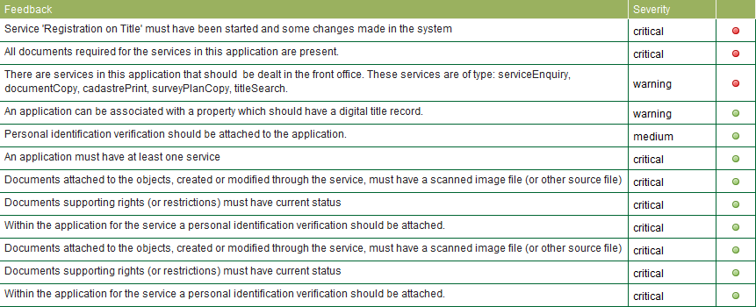

Figure 39 – Business Rule Feedback

# Getting Started

This section describes the steps to install the Release v1503a Web Start Applications on your computer. There are two web start applications, SOLA Desktop and SOLA Admin. The applications share components, so the total size of the download for both is approximately 80Mb**.**

## Installation & Upgrade Pre-requisites

The Java SE Runtime Environment 7 is required for the SOLA Web Start Applications. All versions of Java 7 are compatible with the Registry Web Start Applications. If you don’t have Java 7 installed, you can download the latest update from <http://www.oracle.com/technetwork/java/javase/downloads/index.html>.

* Download the **Standard Edition (SE) Java Runtime Environment** **(JRE)**. It should be approximately 30Mb.
* You will need to accept the Oracle Binary Code License Agreement for Java SE before downloading Java 7.
* Download the product appropriate for your operating system. If you have a Windows 64bit OS, it is recommended you install the Windows x86 Offline option (i.e. 32bit) JRE. The 32bit JRE has better integration with web browsers on both 32bit and 64bit OS.
* You will require local administration privileges to install Java 7
* It is recommended that you install update 51 of the JRE or above. Some updates prior to update 51 have compatibility issues with Java webstart applications due to new security enhancements introduced by Oracle.

## Upgrading

If you are upgrading from an earlier version of the SOLA Web Start applications, simply launch SOLA from the desktop shortcut. Java Web Start will automatically download the new release and upgrade the SOLA Desktop for you. Be aware that the upgrade will also replace your desktop shortcut and you may need to reconfigure the shortcut as described in Configuring the Desktop Shortcut in the Installation section.

If you receive an Unable to launch the application error after attempting to upgrade SOLA, it is recommended that you uninstall then reinstall all SOLA web start applications. Refer to the Uninstall section for information on how to correctly uninstall a Java Web Start application.

## Installation

These installation instructions are for the SOLA Desktop Web Start application however they can also be used to install the SOLA Admin Web Start application. Simply choose the SOLA Admin Web Start link in step 2 instead of the SOLA Desktop Web Start link.

1. Navigate to <http://www.flossola.org/downloads> and locate the Release v1503a Web Start Applications section.
2. Right click the SOLA Desktop Web Start link and choose Save link as... and save the sola-desktop.jnlp file to a known location on your local file system.
3. Once the file has been saved on your file system, browse to the sola-desktop.jnlp file using Windows Explorer or equivalent and double click the file. You should see a Java 7 splash displayed.



Figure 4 - Java 7 Splash

1. Followed by the Starting application... dialog

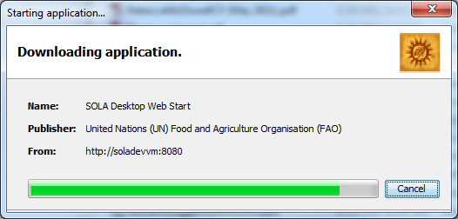

Figure 5 - Starting application... dialog

1. Once the download is complete, the installation may pause for several minutes while it performs verification of the installation package. Please wait until this action has completed.
2. When prompted with the **Do you want to run this application?** warning, tick *Do not show this again…* and choose **Run**

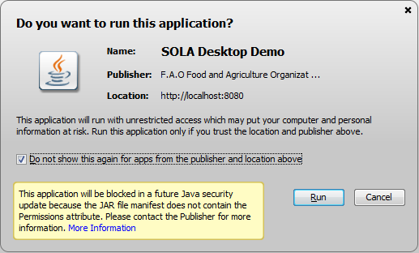

Figure 6 - Warning dialog

1. The SOLA Desktop will start automatically. At the login screen, enter User **test** and Password **test.** You will be presented with theSOLA Dashboard.

### Configuring the Desktop Shortcut

The installation will place a shortcut to the SOLA Desktop on your computer desktop. This shortcut may be configured to use an older version of Java which will prevent the application from being launched. Test the shortcut by double clicking it. If you get the **Unable to launch application** error displayed due to the requested version of the JRE, perform the following steps. Note that the Properties dialog illustrated below may vary in appearance depending in the operating system you are using.

1. Right click the SOLA Desktop Web Start shortcut and choose Properties

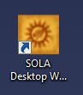

Figure 7 - SOLA Desktop Web Start desktop shortcut

1. Update the Target: field on the Shortcut tab by removing any path (e.g. C:\Windows\System32\) before the javaws.exe command. This will ensure the shortcut uses the default Java installation on the computer. You may need to scroll left to reach the start of the Target: field.

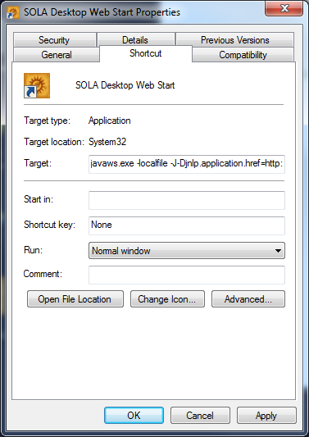

Figure 8 - SOLA Desktop Web Start Properties

### Additional Information

1. The database used for the SOLA Desktop and SOLA Admin will be reverted daily at 0100 GMT. Any data changes you make will be lost.

## Installation Troubleshooting

This section discusses some of the issues you may encounter when installing the SOLA Desktop Web Start. This may include

1. Unable to launch the application
2. Error: The application has requested a version of the JRE (version 1.7+)...
3. Microsoft Jscript compilation error
4. Download/launching of the SOLA Web Start Application hangs/freezes
5. Where is the Java Control Panel?

### Unable to launch the application

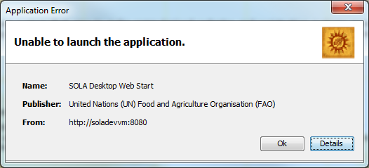

Figure 9 – Application Error dialog

Click the Details button to get the More Information dialog. The relevant error message should be displayed at the top of the dialog. You can also view the Exception tab for more details.

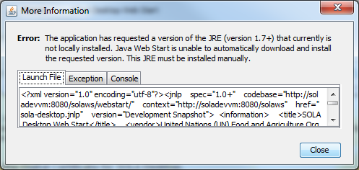

Figure 10 - More Information dialog

### Error: The application has requested a version of the JRE (version 1.7+)...

The following identifies what you should check or confirm in order to get the SOLA Desktop running using Java 7

1. Confirm you have Java 7 installed as the default JVM on your computer
   1. Using the Java Control Panel, click About... You should see the Java 7 Standard Edition dialog displayed.

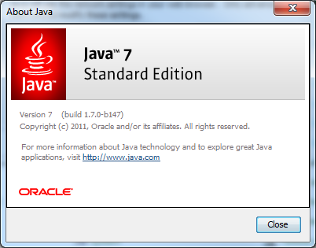

Figure 11 - About Java

* 1. If a different version of Java is displayed, install / reinstall Java 7.

1. Java version of your web browser
   1. Although Java 7 is installed as the default JVM, unfortunately it does not update the Java version used by your web browser. If you left click the SOLA Desktop Web Start link rather than right clicking and using Save link as... Java Web Start will be automatically triggered using Java configured for your web browser. To avoid this issue, right click the **SOLA Desktop Web Start** link on the Welcome page and choose **Save As**... to save the sola-desktop.jnlp file to your local file system. Once saved, use Windows Explorer or equivalent to launch the application as described in the Installation section.
2. Desktop shortcut configuration
   1. If you get this error when launching the application using the desktop shortcut you will need to configure the shortcut. Refer to Configuring the Desktop Shortcut in the Installation section.

### Microsoft JScript compilation error

This is a known issue with Java[[2]](#footnote-2).

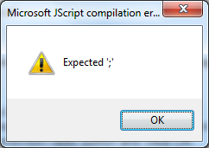

Figure 12 - JScript Compilation Error Message

To avoid this issue

1. Open the Java Control Panel
2. Choose Network Settings... in the Network Settings section of the General tab
3. Choose the Direct Connection radio button and click OK

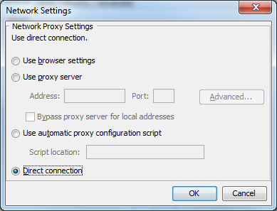

### Download/launching of the SOLA Web Start Application hangs/freezes

If the download or launching of the SOLA Web Start Application hangs / freezes, this may indicate that Java Web Start is being blocked by a firewall or anti-virus software. Try temporarily disabling your anti-virus and attempt to download the web start application again. This issue is known to occur with later versions of AVG Anti-virus (v9.0+).

### Where is the Java Control Panel?

On Windows you should find “Java” in Windows Control Panel. You may need to change from Category View to an Icon View to make it easier to find. If you have Vista or Windows 7, you should also be able to search for “Java Control Panel” from the Start Menu search.

## Uninstall

To uninstall the SOLA Desktop or SOLA Admin from your computer

1. Launch the Java Control Panel
2. Choose View... in the Temporary Internet Files section of the General tab

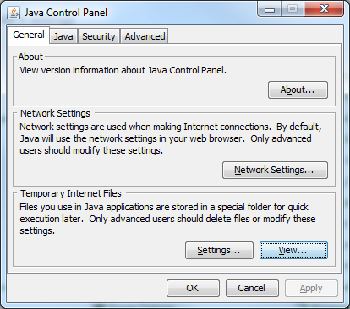

Figure 13 - Java Control Panel

1. In the Java Cache Viewer, select the SOLA Desktop Web Start application or the SOLA Admin Web Start application and remove it using the Remove tool. This will remove your desktop shortcut to SOLA and the main jar for the application.

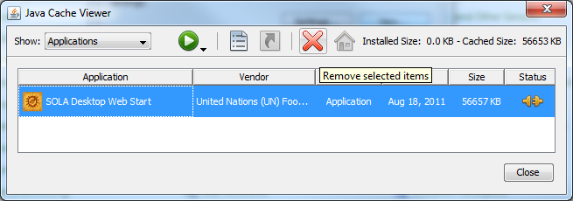

Figure 14 - Java Cache Viewer > Applications

1. To completely remove all references and jar’s used by the SOLA Application you should also clear the Resources cache. To do this, choose Resources in the Show: drop down, select all of the resources listed and remove them using the Remove tool.

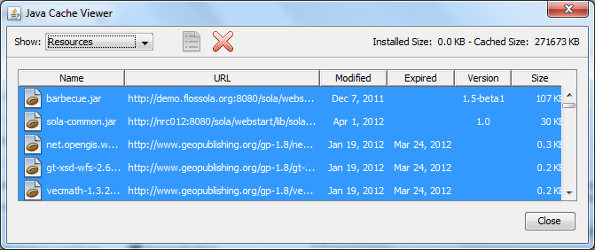

Figure 15 - Java Cache Viewer > Resources

# Registry Desktop Screens

## Dashboard and Main Menu

You will be presented with the Dashboard following successful login. The Dashboard lists the applications that are assigned to your user account along with the applications that have yet to be assigned.

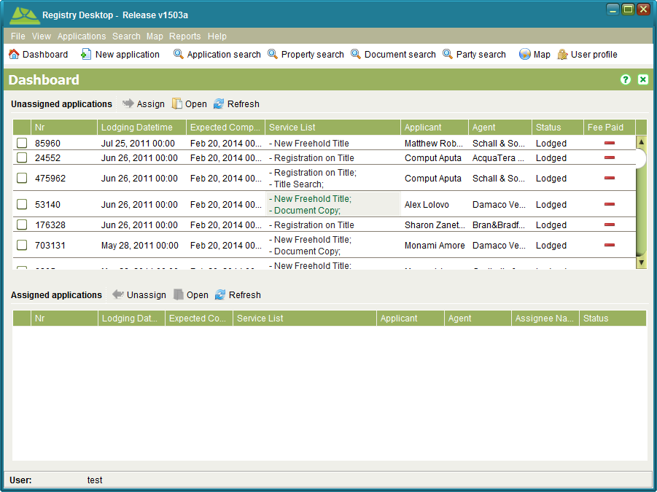

Figure 16 - Dashboard and Main Menu

Using the main menu and toolbar options you can

|  |  |
| --- | --- |
| * Exit the Registry Desktop | File > Exit or window close icon |
| * Export property rights information | File > C:\Work\SOLAHelp\images\icons\export.png Export rights |
| * Change the display language | View > Language |
| * Choose the log level | View > Log Level |
| * Navigate back to the Dashboard | home Dashboard |
| * Create and lodge a new application | Applications > new New Application or new New application |
| * Search for an existing application | Search > search Application or search Application search |
| * Search for an existing property | Search > search Property or search Property search |
| * Search for an existing document | Search > search Document or search Document search |
| * Search for an existing person and add new parties | Search > search Party or search Party search |
| * Open the SOLA Map Viewer | Map > Map or network Map |
| * Open your user profile to change your password | C:\Work\source\Help Images\X25_User_Profile_icon.png User profile |
| * View the lodgement report | Reports > Lodgement Report |
| * View the gender report for ownership | Reports > Ownership Gender Report |
| * Open the Registry Desktop help file | Help > Registry Desktop Help |
| * View the Registry Desktop About dialog | Help > About |
| * Assign an unassigned Application | Check the application and click C:\Work\source\Help Images\icons\assign.png Assign in the Unassigned applications toolbar |
| * Select and edit an unassigned or an assigned Application | C:\Work\source\Help Images\icons\folder-open-document.png Open or right click menu |
| * Un-assign an assigned Application | Check the application and click C:\Work\source\Help Images\icons\unassign.png Unassign in the Assigned applications toolbar |
| * Refresh the application lists | C:\Work\source\Help Images\icons\refresh.png Refresh or right click menu |

### Also See

* Registry Desktop Screens
  + SOLA Map Viewer
  + Application Search
  + Property Search
  + Document Search
  + Party Search
  + User Profile
  + Rights Export
* General How To
  + Change Language
  + Change Your Password
  + Lodge a new Application
  + Edit an Application
  + Assign an Application
  + Un-assign and Application
  + View the Lodgement Report

## SOLA Map Viewer

The SOLA Map Viewer allows you to navigate and interact with the geospatial data managed by Registry. It can be accessed from the Map > networkMap menu or selecting network Map.

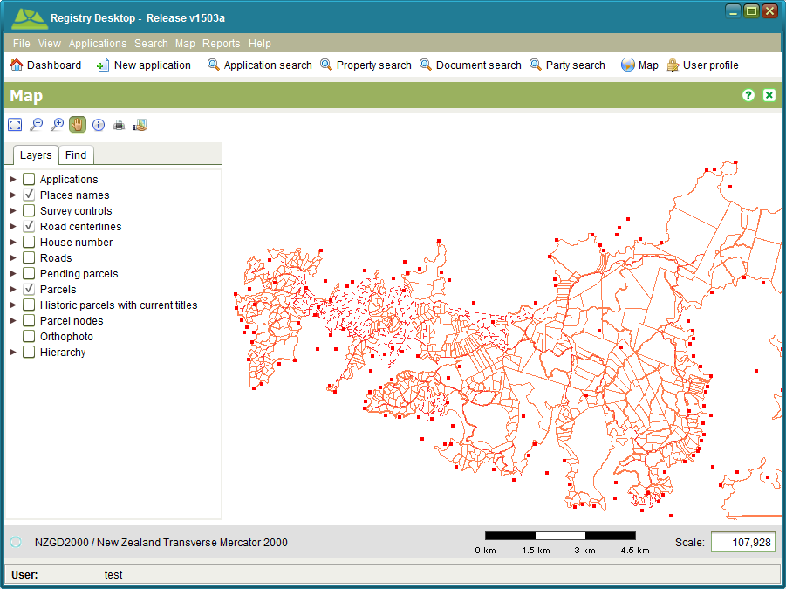

Figure 17 - SOLA Map Viewer

The SOLA Map Viewer includes a toolbar for navigating and querying the map as well as two tabs; Layers and Find. The Layers tab can be used to control the geospatial data displayed on the map while the Find tab that can be used to quickly locate parcels and other geospatial features in the map.

### Map Tools

The tools provided for the SOLA Map Viewer are

| * Zoom to extent | fullextent |
| --- | --- |
| * Zoom out | zoomout |
| * Zoom in | zoomin |
| * Pan | pan |
| * Information tool | information |
| * Print | C:\Work\source\Help Images\icons\print.png |
| * Export to KML |  |

The SOLA Map Viewer can also support additional map tools for editing and related spatial tasks (e.g. Locate Application). These tools are described in the relevant How To sections.

### Map Scale and Location

The scale of the map can be controlled using the Zoom in, Zoom out and Zoom to extent tools. The desired scale can also be entered directly into the Scale text box in the bottom right of the map.

A scale bar is displayed to help determine distances on the map. Note that due to variations in screen resolution, the scale bar is indicative only and it should not be used to obtain accurate measurements from the map.

As you pass the mouse over the map you will see map coordinates displayed in the bottom left corner under the Layers and Find tabs. This information can be used to determine coordinate locations on the map.

### Layers

The Layers tab identifies the layers of geospatial data that can be displayed in the map. You can show or hide these layers by checking or clearing the checkbox next to the layer name.

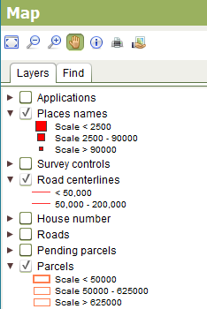

Figure 18 - SOLA Map Viewer Layers Tab

By clicking the triangle beside each layer name you can also see the symbology used to illustrate the geospatial data at different map scales. For example, when the map scale is below 2,500, Place names will be illustrated with a large red square. Between 2,500 and 90,000 a medium red square is used and above 90,000 a small red square. Using the map scale to control the layer symbology ensures the map does not become overly crowded with detail which might otherwise impair navigation or comprehension of the information displayed by the map.

The default layers available for SOLA include

|  |  |
| --- | --- |
| * Applications | Points that indicate the approximate location of applications that have been lodged in SOLA. Application points can be created using the Map Points tab when capturing details for a new application. |
| * Place names | Illustrates the approximate location of notable geographic features such as towns, headlands and bays. |
| * Survey controls | Illustrates the location of survey control (i.e. geodetic) marks. |
| * Road centrelines | Shows the location of road centrelines. The centreline is used to position road names on the map. |
| * House number | Displays the house number or street number of each parcel |
| * Roads | Shows the location of roads and the road width. |
| * Pending Parcels | New parcels that have been created by a survey subdivision or amalgamation. These parcels remain pending until the application that created them is approved. |
| * Parcels | Illustrates the location of current parcels |
| * Historic Parcels with Current Titles | This layer shows parcels that have been subdivided or amalgamated into new parcels, but still have current title references. |
| * Parcel Nodes | Illustrates the location of current parcel nodes. |
| * Orthophoto | Aerial photograph(s) that have been corrected for lens distortion, camera tilt and topography to ensure they have a uniform scale and are suitable for map display. |
| * Hierarchy | Zones and administrative boundaries including those relevant to systematic registration |

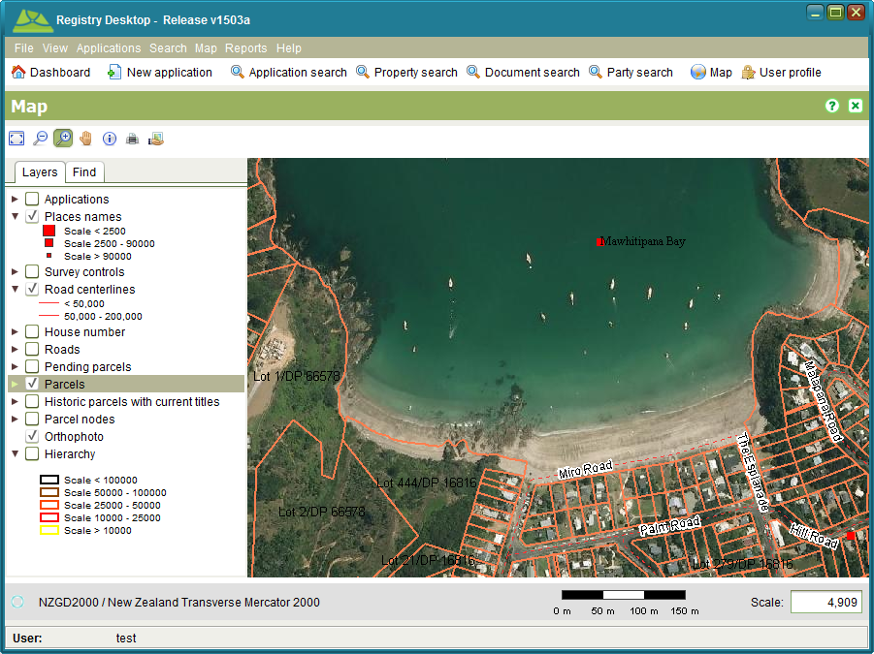

Figure 19 - Orthophoto layer

Note that the layers can be reconfigured to match those required by the land administration agency.

### Find

You can use the Find tab to perform spatial searches to quickly locate parcels or other geospatial features in the map. To use the Find, select the type of geospatial feature to search in the Search By drop down and start typing in the field provided. Once you have entered enough characters (between 1 and 3), the search will begin listing values that match the search criteria. To view one of the results, double click the result value in the result list and the map will zoom to the location of the selected feature and highlight it.

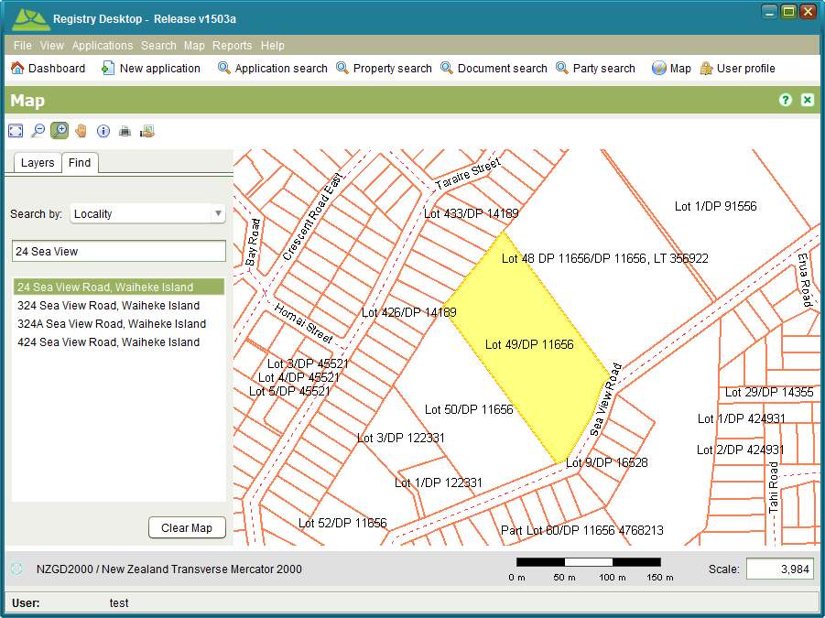

Figure 20 - SOLA Map Viewer Find by Parcel Number

To remove the highlight from your selected feature on the map, click the Clear Map button.

The spatial searches available in Registry are

|  |  |
| --- | --- |
| * Locality | Enter the house number, road name or general locality name to locate a parcel. This search will only work with parcels that have a spatial definition and a locality. Requires at least 3 characters to be entered. |
| * Number | Enter the appellation for a parcel (e.g. parcel/lot and/or plan number) to locate a parcel. This search will only work with parcels that have a spatial definition. Requires at least 3 characters to be entered. |
| * Property number | Enter the title / folio reference for a property to locate the parcel for the property. This search will only work if the property is linked to a parcel with a spatial definition. Requires at least 3 characters to be entered. |
| * Property owner | Enter the name of a current property owner to locate a parcel for the property. This search will only work if the property is linked to a parcel with a spatial definition. Requires at least 3 characters to be entered. |

Note that the spatial searches can be reconfigured to match those required by the land administration agency.

### Information Tool

The information Information Tool can be used to query geospatial features such as parcels, roads, villages, etc. As geospatial features are often in close proximity or overlap, the Information Tool displays details for all features immediately surrounding the selected location. Click the appropriate tab to see details for the various layer features.

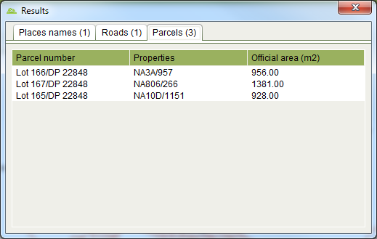

Figure 21 - Information Tool Results

Note that the tabs and the details displayed by the Information Tool can be reconfigured to match those required by the land administration agency.

### Print Tool

The C:\Work\source\Help Images\icons\print.png Print Tool can be used to export the current view of the map to a PDF file for printing. Before printing, you should setup the map with the layers you want to include in the print by turning them on or off. Once you have arranged the map with the information you want on the print, click the C:\Work\source\Help Images\icons\print.png Print Tool. This will display the Print dialog where you can select the layout (A3, A4 or A5 in Portrait or Landscape) and change the map scale.

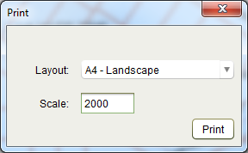

Figure 22 – Print dialog box

Click the Print button to generate a document containing the image of the map. Using the Report Viewer, you can save the print in several formats including PDF, DOCX and HTML or print a hard copy.

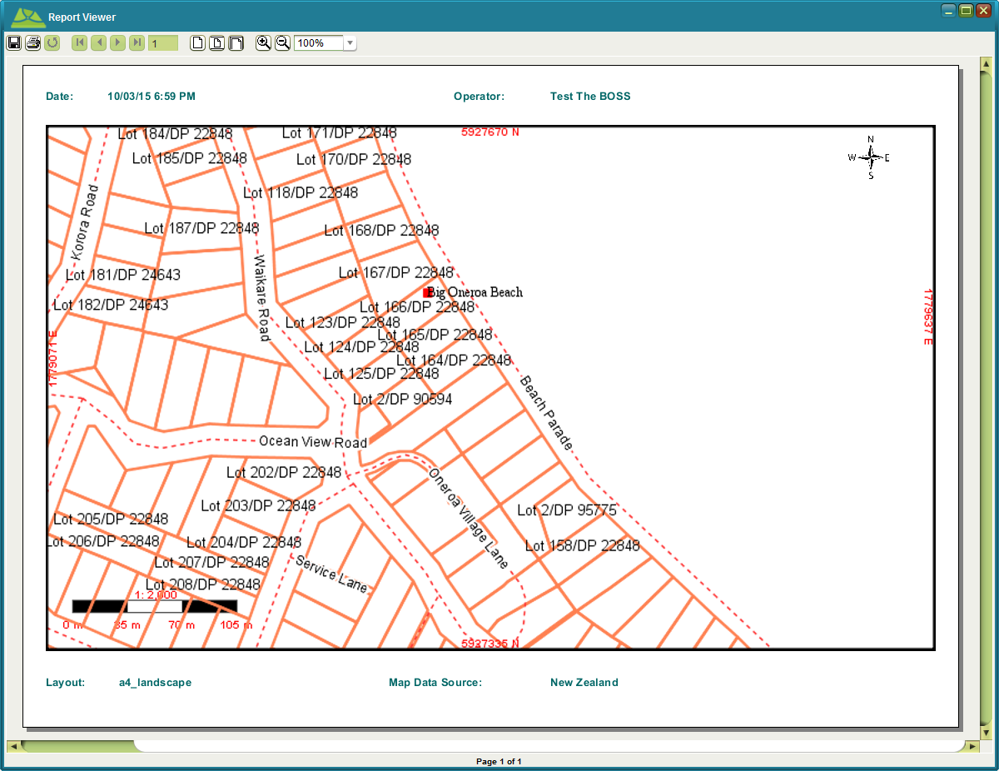

Figure 23 - Spatial Print

Note that the print templates (i.e. A3, A4 and A5) can be can be reconfigured to match those required by the land administration agency. Also note that this tool is only available to users that have the Map Print security role.

### Export to KML tool

The  Export to KML Tool can be used to export the currently selected feature of the map into a basic format KML file. That KML file can then be loaded into Google Earth and displayed.

Before exporting, you should use the Map Find to locate and select a feature and then click in the Map toolbar. This will export map data from the selection layer using longitude and latitude coordinates into a file called **mapExport.kml** in your ***<user\_home>/sola/*** directory. If you have Google Earth installed, double click the file to launch Google Earth and show the feature super-imposed on Google Earth map. Note that you can also use Google Earth to change the styling for the feature.

Note that this tool is only available to users that have the Export Map security role

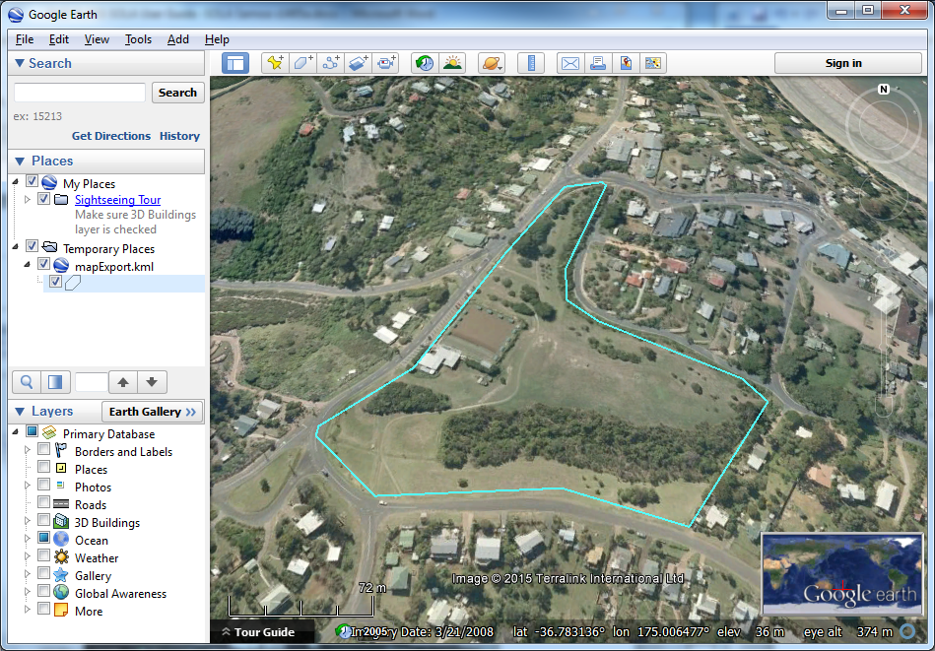

Figure 24 – KML Export styled and displayed in Google Earth

### Also See

* Registry Desktop Screens
  + Dashboard and Main Menu
  + Application Details
  + Property Details
  + Change to Cadastre
  + Redefine Cadastre
* General How To
  + Add location for Application
  + Create a Cadastre Print
* Survey How To
  + Record a Plan
  + Redefine a Cadastre
  + Add a Plan Image for Digitizing

## Application Search

The Application Search screen allows you to find applications of interest. It can be accessed from the Search > search Applications menu or clickingsearch Application search.

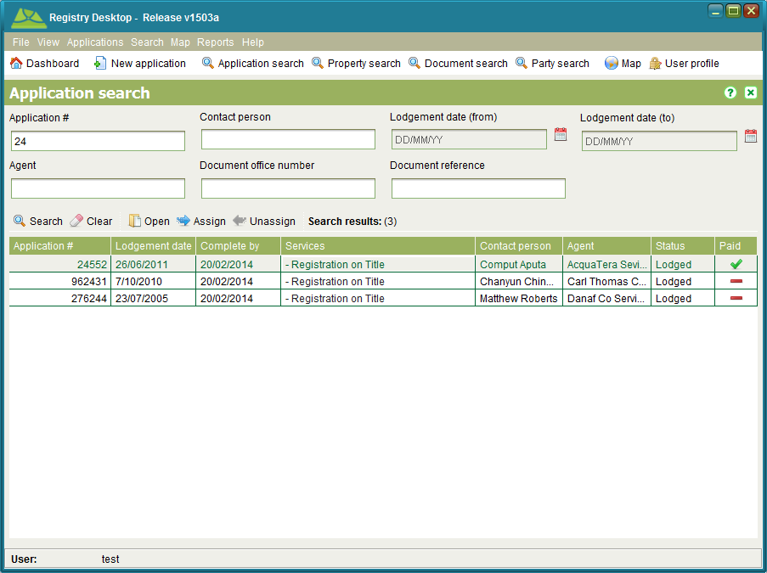

Figure 25 - Application Search

You can search by any combination of application number, agent name, contact person name, document reference and/or a lodging date range by entering your chosen search criteria then clicking search Search. The application number, agent name and contact person name also support partial and full matching so you only need to enter a partial name or number to get search results. To view the details of an application select it from the results table and click C:\Work\source\Help Images\icons\folder-open-document.png Open or double click the search results to open it automatically. To clear the job search criteria press C:\Work\SOLA\State Land Management\User Guide\Screenshots\Icons\eraser.png Clear.

The Application Search can be used to locate and assign or unassign applications that are not displayed on the Dashboard. Search for an select the application from the results table and choose the C:\Work\source\Help Images\icons\assign.png Assign or C:\Work\source\Help Images\icons\unassign.png Unassign buttons. Note that the buttons will remain disabled unless you have appropriate rights to complete the action and the application fee has been paid

The search results can also be sorted by any of the columns displayed in the Search results table. Simply click a column header one or more times to switch the sort of the column values between ascending and descending.

### Also See

* Registry Concepts
  + Application Lifecycle
* Registry Desktop Screens
  + Dashboard and Main Menu
  + Application Details
* General How To
  + Edit an Application
  + Assign an Application
  + Un-assign and Application

## Application Details

The Application Details screen allows you to enter the details for a new application and/or edit the details of an existing application. To create a new application, click the Applications > New Applications menu or select new New application

To edit an application, select the application in the assigned or unassigned application lists on the Dashboard and choose C:\Work\SOLA\State Land Management\User Guide\Screenshots\Icons\folder-open-document.png Open or search and open the application from the Application Search.

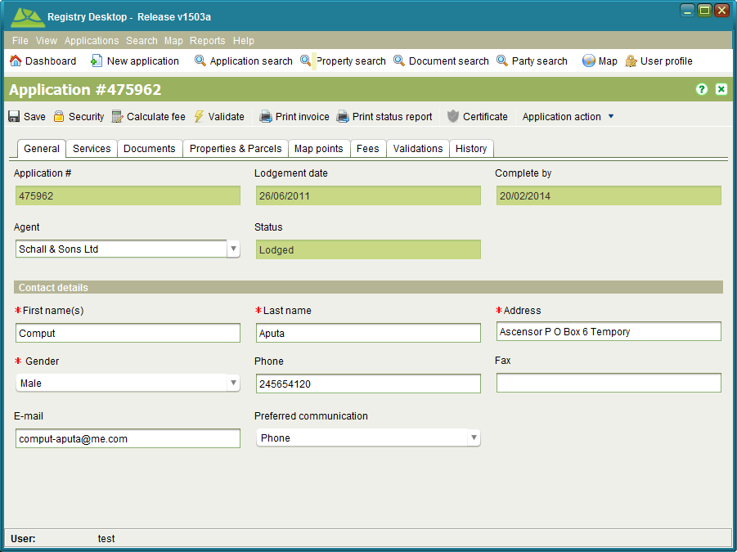

Figure 26 - Application Details General tab

An application represents a bundle of services that will be undertaken by the land administration agency, typically in response to a client request. Each service may result in changes to property information and/or associated rights. Details that can be captured for an application are

|  |  |
| --- | --- |
| Agent | An individual or organization that is requesting information or changes to the land registry and/or cadastre information recorded in Registry. This could be a lawyer or surveyor under instruction from the property owner, the property owner themselves or a third party with a vested interest in a particular property. Agent details are optional. |
| Contact details | The individual that can be contacted should the details of the application require further elaboration or clarification. A contact person must be identified with every application and will usually be the applicant. |
| Services | Used to control the type of change an application can make to the land registry and/or cadastre information recorded in Registry. These broadly identify the actions the land administration agency will undertake for the application. Refer to the Services section of information on the services available for Registry. At least one service must be added to each application. |
| Properties and Parcels | The property or properties affected by the application. Property details are optional for new applications, but may be required prior to starting services depending on the services selected for the application. Parcels are also able to be identified (lower pane) |
| Documents | The legal or other documents that explain and/or justify the reasons for changing land registry and/or cadastre information. Scanned images of documents should be attached to the application for easy reference. Document details are optional; however there are certain document types that are expected to accompany various services. The Required Document Types list on the Documents tab identifies the types of documents that should be included with the application given the services that have been selected. |
| Fees | Identifies the fees payable to the land administration agency before the application can proceed. This fee is based on the service(s) and property information recorded for the application and can be customized to satisfy specific land administration agency needs. The fee is automatically calculated when a new application is lodged.  To perform fee calculation prior to lodgement, use the C:\Work\source\Help Images\icons\calculate.png Calculate fee tool in the Application Details toolbar. You can also print a receipt for the application using the C:\Work\source\Help Images\icons\print.png Print invoice tool.  Registry prevents assignment of applications that have not had their fees paid. Once the client or agent has paid the application fee, you can flag the application for further processing by checking the Paid checkbox. At the same time you can optionally record the amount paid as well as any receipt numbers. Note that the Paid checkbox will only be editable if you have the appropriate user role. |
| Map Points | Provides the SOLA Map Viewer along with the Locate Application tools (C:\Work\SOLAHelp\images\icons\application-location-add.png and C:\Work\SOLAHelp\images\icons\application-location-remove.png) to allow you to identify the approximate location of the application. Recording this information can help to identify other applications in close proximity to the new application that could have a bearing on the new application or vice versa. Optional. |
| Validations | Displays the results of the automated business rules executed when you choose to manually validate the application using the C:\Work\SOLAHelp\images\icons\validation.png Validate action. Validation is only available after the application has been lodged. |
| History | Displays the history of actions applied to the application and its services. The actions that can be applied to applications and services are in the Application Lifecycle and Service Lifecycle sections. History details are only available after the application has been lodged. |

### Also See

* Registry Concepts
  + Application Lifecycle
  + Services
  + Service Lifecycle
  + Documents
  + Business Rules
* Registry Desktop Screens
  + Dashboard and Main Menu
  + SOLA Map Viewer
  + Application Search
  + Application Details
  + Property Details
  + Document Details
  + Party Details
* General How To
  + Lodge a new Application
  + Edit an Application
  + Assign an Application
  + Un-assign and Application
  + Calculate Fees
  + Verify Property Details
  + Cancel, Withdraw or Lapse an Application
  + Add location for Application
  + Secure a Data Record
* Documents How To
  + Add a Document to an Application
  + Link to Power of Attorney and Standard Documents
* Land Registration How To
  + Lodge and Process a Land Registration Application
* Survey How To
  + Record a Plan
  + Redefine a Cadastre
* Appendix
  + SOLA Business Rules

## Property Search

The Property Search screen allows you to find and view properties of interest. It can be accessed from the Search > search Property menu or selectingsearch Property search

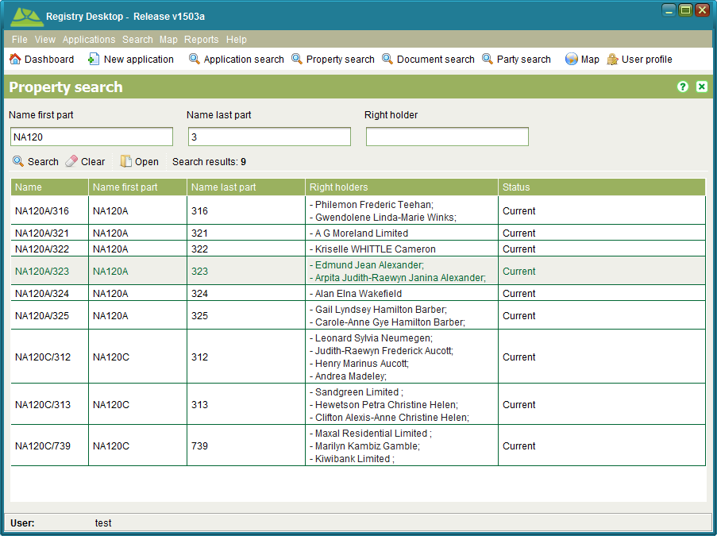

Figure 27 - Property Search

You can search by any combination of Name first part, Name last part or Right holder (name). These fields also support partial and full matching. To view the details for a property, select the property in the Search results list and click C:\Work\source\Help Images\icons\folder-open-document.png Open. To clear the search criteria from a search tab, click C:\Work\SOLA\State Land Management\User Guide\Screenshots\Icons\eraser.png Clear.

### Also See

* Registry Concepts
* Registry Desktop Screens
  + Dashboard and Main Menu
  + Property Details
* General How To
  + Perform a Title Search

## Property Details

The Property Details screen allows you to view or edit property details. You can access the Property Details screen in view only mode by opening a search result from the Property Search screen. To edit property details, you must first lodge an application that contains a Registration Service such as New Digital Title (used to create new property records) or Register New Ownership, Register Mortgage, etc. assign the application and then C:\Work\source\Help Images\icons\start.png Start the service from the Application Details Service tab. The Land Registration How To section discusses how to process various Registration Services using the Property Details screen.

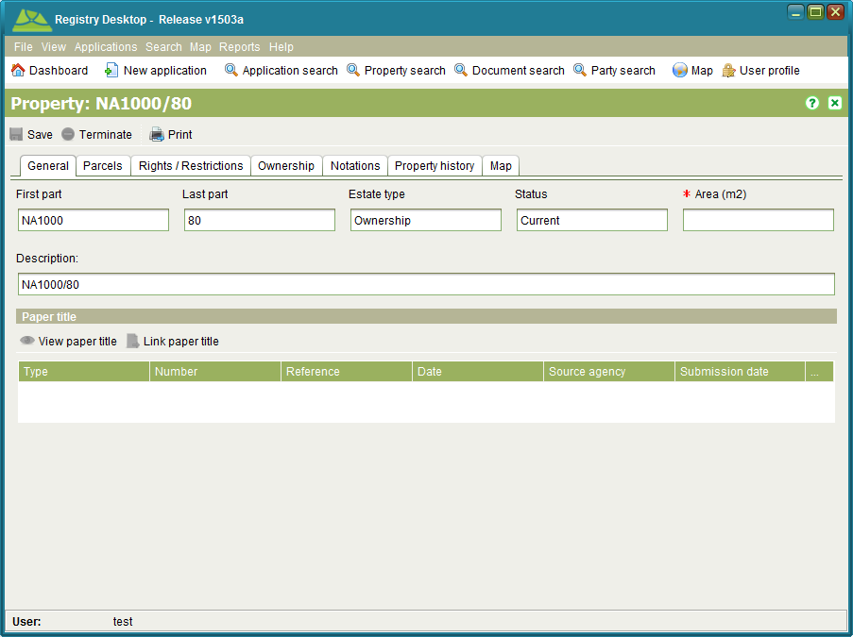

Figure 28 - Property Details

A property links the rights and restrictions over a parcel to the individuals or groups (i.e. parties) that hold those rights. The information represented by the property is often referred to as the Title. Details that can be captured for a property include

|  |  |
| --- | --- |
| General | General information about the property like the two part property reference (First part and Last part), estate type, status, area and description as well as documents relevant to the property. |
| Parcels | The area(s) of land that define the extent of a property. Parcels can be spatially defined and/or textually described. |
| Rights, Restrictions & Responsibilities | The rights, restrictions or responsibilities the right holder(s) are accorded in relation to the parcels represented by the property. These could be ownership rights, lease rights, mortgage rights, mining rights, access rights, servitudes, building restrictions, land use restrictions, caveats, etc.  This tab shows summary information of the current rights and restrictions for the property along with any pending (i.e. unregistered) rights or restrictions. |
| Ownership | Typically the primary right for a property is the right of ownership. Properties can have one or many owners each with a share in the property that may be explicitly defined (tenants in common) or undivided (joint tenants).  The Ownership tab is intended to provide quick access to current as well as pending (i.e. unregistered) ownership details. Note that any changes in ownership must captured on the primary right in the Rights / Restrictions tab using the appropriate Registration Service. |
| Notations | Short comments recorded when changes are made to the property that provides a succinct history of the changes. A.k.a. Memorials. |
| Property history | Shows the list of parent properties (if any) that are superseded by the property (i.e. Prior Title) along with the list of child properties (if any) that the property has been superseded by when the property was terminated. |
| Map | Provides the SOLA Map Viewer highlighting the parcel for the property if one exists. This can help to identify the location of the property. |

### Right and Restriction Details

The Rights and Restrictions (RRR) tab shows summary information for all current and pending (i.e. unregistered) rights and restrictions on the property. You can access further information about a specific right or restriction by selecting the RRR from the list and clicking the C:\Work\source\Help Images\icons\view.png View toolbar button. The RRR details screen displayed will be dependent on the RRR you selected, however it should contain detailed information about the RRR as well as any supporting documentation that was linked to the RRR when it was first recorded.

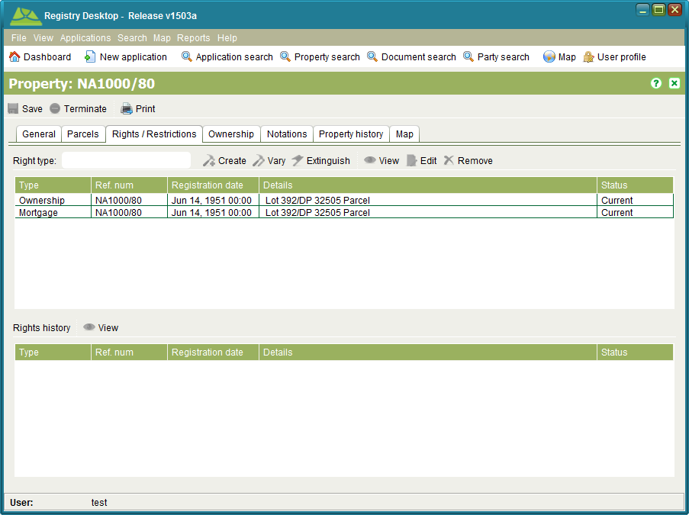

Figure 29 - Rights and Restrictions tab

This tab also displays the Rights history for the property in the bottom section of the tab. You can select and C:\Work\source\Help Images\icons\view.png View the historic rights details as required.

The other toolbar items available on this tab allow you to create, vary (modify) or extinguish (cancel) RRR. To use these toolbar items you must first lodge an application with one or more Registration Services. When you C:\Work\source\Help Images\icons\start.png Start a Registration Service from the Application Details Services tab, it configures the Property Details screen enabling or disabling the RRR toolbar items relevant for that service.

### Also See

* Registry Concepts
  + Rights Restrictions and Responsibilities
  + Documents
* Registry Desktop Screens
  + SOLA Map Viewer
  + Property Search
  + Simple RRR
  + Rightholder RRR
  + Ownership RRR
  + Lease RRR
  + Mortgage RRR
  + Document Details
  + Party Details
* General How To
  + Perform a Title Search
  + Secure a Data Record
* Land Registration How To
  + Lodge and Process a Land Registration Application
  + Record and Change Ownership
  + Change the Type of Estate
  + Cancel Titles and Create New Titles
  + Register, Vary and Discharge Mortgage
  + Register, Vary and Terminate Lease
  + Register, Vary and Withdraw Caveat
  + Register, Vary and Cancel Easements
  + Register or Vary General Rights and Restrictions
  + Cancel a Right or Restriction
  + Convert a Paper Title
  + Use the Add Parent Property Wizard

## Simple RRR

The Simple RRR screen is used to display information for RRR that only require basic details to be captured such as Building Restrictions, Historic Preservation, Limited Access and Servitudes. It can be accessed from the Rights/Restrictions tab on the Property Details screen by selecting one of the RRR types listed above and clicking C:\Work\source\Help Images\icons\view.png View or C:\Work\SOLAHelp\images\icons\document--pencil - Copy.png Edit

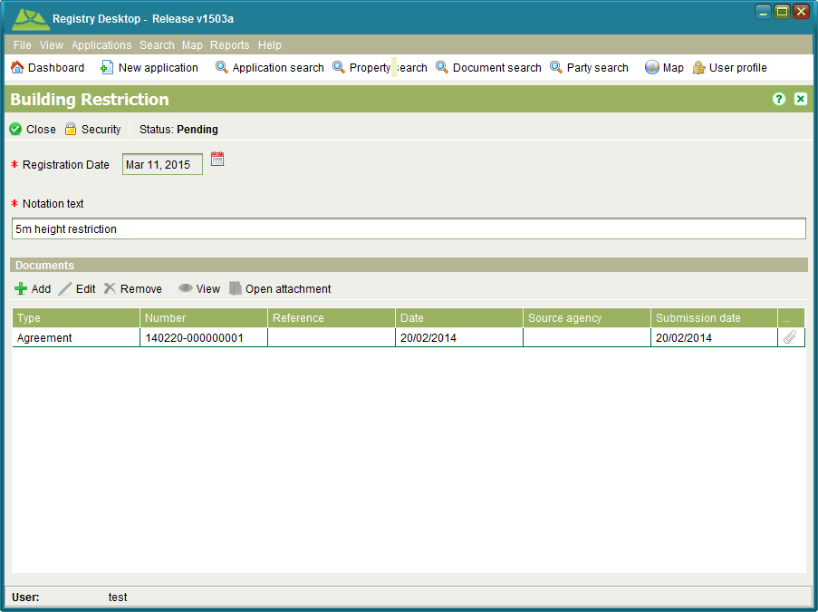

Figure 30 – Simple RRR

You can enter the registration date and notation text as well as link any relevant documents.

To create, change or cancel a simple RRR you must first lodge an application with the appropriate service i.e.; Register Building Restriction, Register Historic Preservation Order, Register Limited Road Access, Register Servitude, New Freehold Title, Registration on Title, Convert to Digital Title, Vary Right (General) or Remove Restriction (General).

### Also See

* Registry Concepts
  + Rights Restrictions and Responsibilities
* Registry Desktop Screens
  + Property Details
  + Rightholder RRR
  + Ownership RRR
  + Lease RRR
  + Mortgage RRR
  + Document Details
  + Rights Export
* General How To
  + Secure a Data Record
* Land Registration How To
  + Register or Vary General Rights and Restrictions
  + Cancel a Right or Restriction

## Rightholder RRR

The Rightholder RRR screen is used to display information for RRR that have named rightholders such as Occupation, Usufruct, Water Rights and Caveats. It can be accessed from the Rights/Restrictions tab on the Property Details screen by selecting one of the RRR types listed above and clicking C:\Work\source\Help Images\icons\view.png View or C:\Work\SOLAHelp\images\icons\document--pencil - Copy.png Edit.

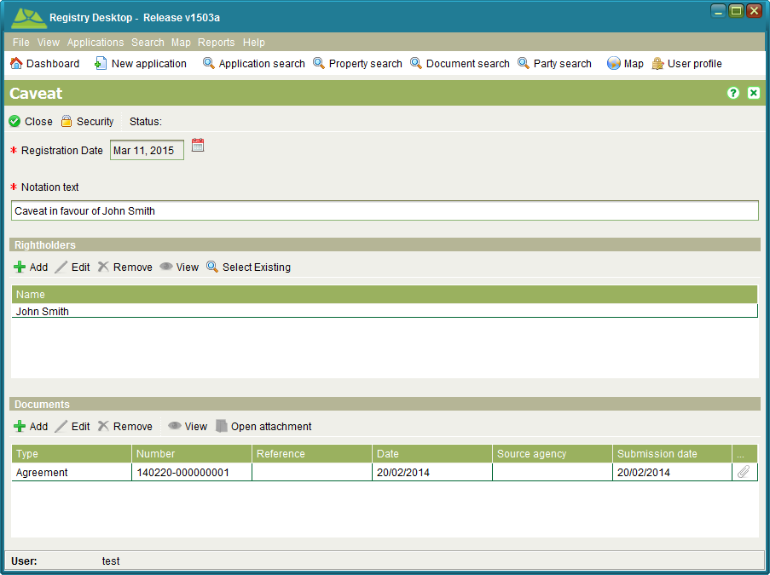

Figure 31 – Rightholder RRR

You can enter the registration date, notation text and the details of any rightholders for the RRR as well as link any relevant documents.

To create, change or cancel a rightholder RRR you must first lodge an application with the appropriate service i.e.; Register Caveat, Register Historic Preservation Order, Register Limited Road Access, Register Servitude, New Freehold Title, Registration on Title, Convert to Digital Title, Vary Caveat, Vary Right (General), Remove Caveat or Remove Restriction (General).

### Also See

* Registry Concepts
  + Rights Restrictions and Responsibilities
* Registry Desktop Screens
  + Property Details
  + Simple RRR
  + Ownership RRR
  + Lease RRR
  + Mortgage RRR
  + Document Details
  + Party Details
  + Rights Export
* General How To
  + Secure a Data Record
* Land Registration How To
  + Cancel Titles and Create New Titles
  + Register, Vary and Withdraw Caveat
  + Register or Vary General Rights and Restrictions
  + Cancel a Right or Restriction

## Ownership RRR

The Ownership RRR screen is used to display information for RRR that have named rightholders with a defined share in the RRR. For example, the owners of a property can include multiple parties with each party allocated a specific shareholding. The Ownership RRR screen can be accessed from the Rights/Restrictions tab on the Property Details screen by selecting an Ownership, Apartment Ownership or State Ownership RRR and clicking C:\Work\source\Help Images\icons\view.png View or C:\Work\SOLAHelp\images\icons\document--pencil - Copy.png Edit.

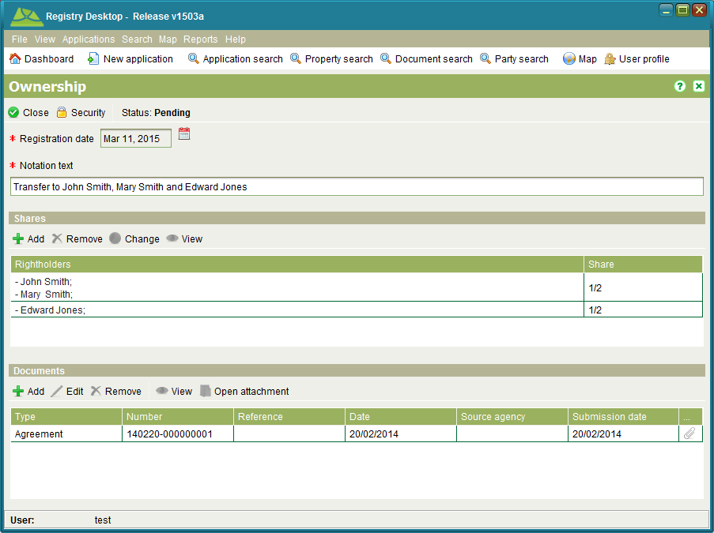

Figure 32 – Ownership RRR

When adding a new share to an Ownership RRR, you must indicate the shareholding as a fraction (e.g. ½) and list the parties that hold that share.

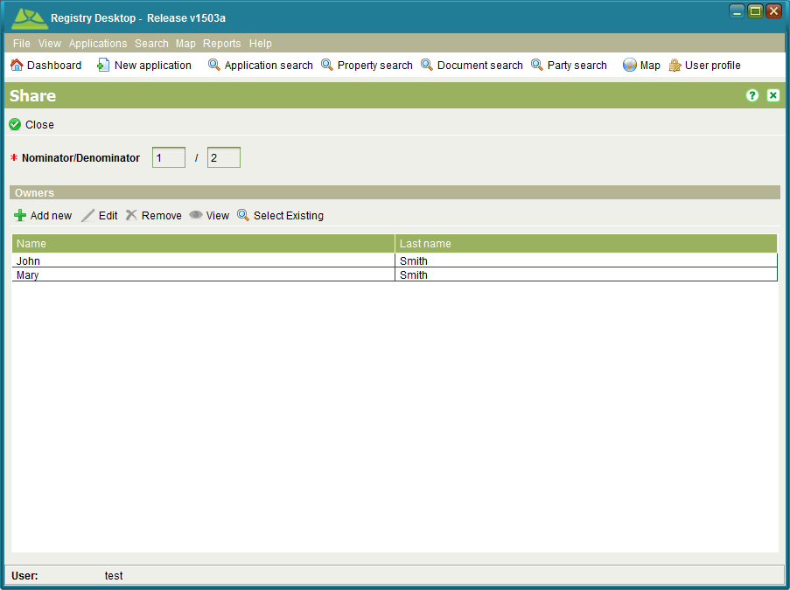

Figure 33 - Ownership Share

Shares can be used to can represent Tenants in Common (divided shares) and Joint Tenancy (undivided shares) scenarios. Tenants in Common occur when two or more parties have a specific share identified. Joint Tenancy occurs when two or more parties are named on the same share. Registry can support combined Tenants in Common and Joint Tenancy scenarios as illustrated above.

To create, change or cancel a ownership RRR you must first lodge an application with the appropriate service i.e.; New Apartment Title, New Freehold Title, Registration on Title, Convert to Digital Title, Change of Ownership, Vary Right (General) or Remove Restriction (General).

**Notes**

* Registry validates the shares in an RRR to ensure the total of all share holdings is equivalent to 1.
* If there is only one shareholding for the RRR, specific the share as 1 / 1.

### Also See

* Registry Concepts
  + Rights Restrictions and Responsibilities
* Registry Desktop Screens
  + Property Details
  + Simple RRR
  + Rightholder RRR
  + Lease RRR
  + Mortgage RRR
  + Document Details
  + Party Details
  + Rights Export
* General How To
  + Secure a Data Record
* Land Registration How To
  + Record and Change Ownership
  + Change the Type of Estate
  + Cancel Titles and Create New Titles
  + Register or Vary General Rights and Restrictions
  + Cancel a Right or Restriction

## Lease RRR

The Lease RRR screen is used to display information for leases. It can be accessed from the Rights/Restrictions tab on the Property Details screen by selecting a Lease RRR and clicking C:\Work\source\Help Images\icons\view.png View or C:\Work\SOLAHelp\images\icons\document--pencil - Copy.png Edit.

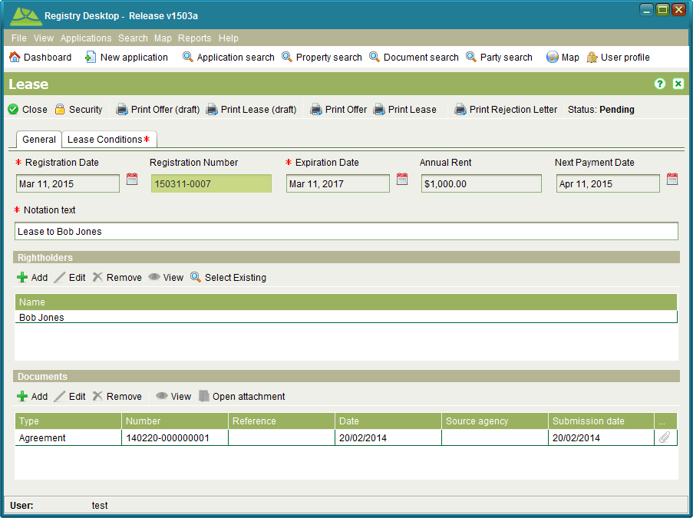

Figure 34 – Lease RRR

You can enter the registration date, expiration date, rental, next payment date, notation text and the details of the lessees. If the lease has any additional conditions, these can be specified in the Conditions tab. Relevant documents such as the lease contract can be linked to the RRR as well.

In addition, the Lease RRR screen provides a number of pre-configured reports to assist the land administration agency to grant leases over state land. The reports can produce a draft offer and lease document as well as the finalized offer and lease document once all information is confirmed. The rejection letter report can be used if the state chooses to reject a lease request.

To create, change or cancel a lease RRR you must first lodge an application with the appropriate service e.g. Register Lease, New Freehold Title, Registration on Title, Convert to Digital Title, Vary Lease, Vary Right (General) or Remove Right (General).

### Also See

* Registry Concepts
  + Rights Restrictions and Responsibilities
* Registry Desktop Screens
  + Property Details
  + Simple RRR
  + Rightholder RRR
  + Ownership RRR
  + Mortgage RRR
  + Document Details
  + Party Details
  + Rights Export
* General How To
  + Secure a Data Record
* Land Registration How To
  + Register, Vary and Terminate Lease

## Mortgage RRR

The Mortgage RRR screen is used to display information for mortgages. It can be accessed from the Rights/Restrictions tab on the Property Details screen by selecting a Mortgage RRR and clicking C:\Work\source\Help Images\icons\view.png View or C:\Work\SOLAHelp\images\icons\document--pencil - Copy.png Edit.

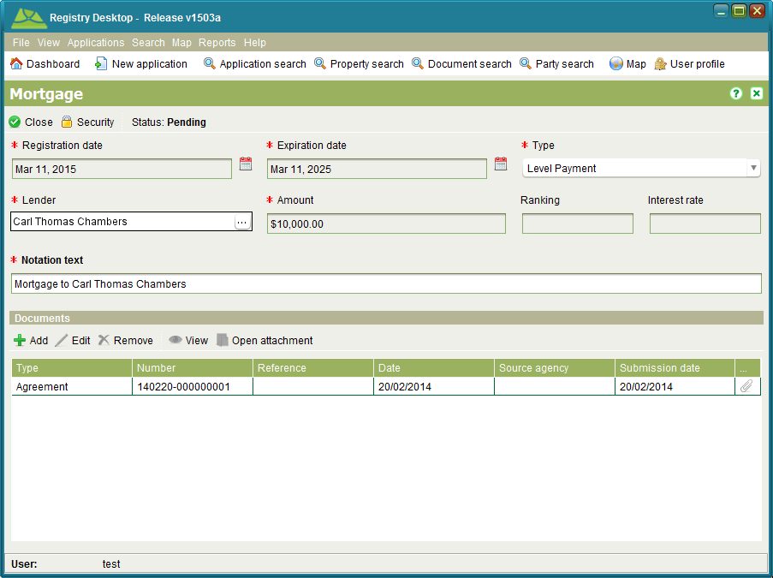

Figure 35 – Mortgage RRR

You can enter the registration date, expiration date, mortgage type, name of the lender (e.g. bank), the mortgage amount, the ranking for the mortgage and the interest rate. Relevant documents such as the mortgage contract can be linked to the RRR as well.

To create, change or cancel a mortgage RRR you must first lodge an application with the appropriate service e.g. Register Mortgage, New Freehold Title, Registration on Title, Convert to Digital Title, Vary Mortgage, Vary Right (General) or Remove Right (General).

### Also See

* Registry Concepts
  + Rights Restrictions and Responsibilities
* Registry Desktop Screens
  + Property Details
  + Simple RRR
  + Rightholder RRR
  + Ownership RRR
  + Lease RRR
  + Document Details
  + Rights Export
* General How To
  + Secure a Data Record
* Land Registration How To
  + Register, Vary and Discharge Mortgage

## Document Search

The Document Search screen allows you to find documents of interest for editing or viewing. It can be accessed from the Search > Document menu or selectingsearch Document search.

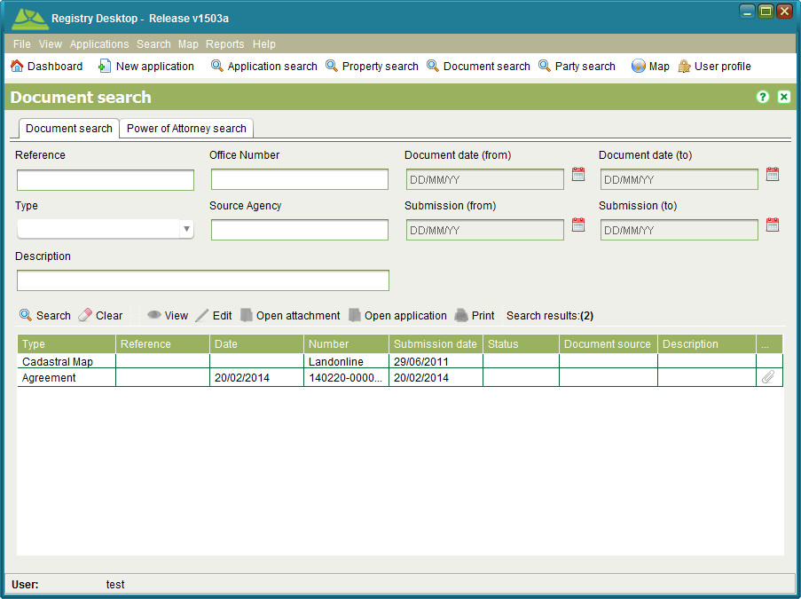

Figure 36 - Document Search

You can search by any combination of Reference, Office Number, Type, Submission date range Document date range, Source Agency or Description. The data applicable to each search field is as follows

|  |  |
| --- | --- |
| * Reference | If the document is a legal or a government document, it may already have an identifying reference number printed or written on the face of it. The reference number can be searched if it was recorded when capturing the document details. This search field supports partial and full matching. |
| * Office Number | The number automatically assigned to the document when it was added into Registry. This search field supports partial and full matching. |
| * Type | The type of document to search. The document types available for Registry are discussed in the Document types section of this guide. |
| * Submission Date Range | A date range covering the period when the document was submitted in Registry. |
| * Document Date Range | The date printed or written on the face of the document. This date can be searched if it was recorded when capturing the document details. If the document was not dated, then this date range should remain blank. |
| * Source Agency | The source of the document, e.g. the name of the firm or bank that created the document. This search field supports partial and full matching. |
| * Description | A description given to the document to provide a summary of its content. This search field supports partial and full matching. |

To view the details recorded for a document, select the document in the Search results list and click the C:\Work\source\Help Images\icons\view.png View toolbar button. Documents with attachments will show a paperclip C:\Work\SOLA\State Land Management\User Guide\Screenshots\Icons\paper-clip.pngicon. The C:\Work\source\Help Images\icons\folder-open-document.png Open attachment toolbar button can be used to open the image of the document if an image has been linked to it. To edit the details of the document, select the C:\Work\source\Help Images\icons\pencil.png Edit toolbar button. You can update the details captured for the document as well as attach an image to the document.

The C:\Work\source\Help Images\icons\print.png Print toolbar button is not currently implemented. To print a document, open the document attachment and print the document using the print menu options available from the default document viewer.

### Power of Attorney

A Power of Attorney is a legal document that authorises a person (attorney) to act on behalf of another person (grantor) in private affairs, business or some other legal matter. Power of Attorney documents can be registered in Registry and linked into applications to justify land transactions made by the attorney on behalf of the grantor.

It is possible to search for registered Power of Attorney documents using the Document search; however the Power of Attorney tab provides additional search criteria allowing you to search for Power of Attorney documents using the Attorney name or the name of the person the attorney is acting on behalf of (i.e. grantor).

Both searches will return current and historic (i.e. cancelled) Power of Attorney documents however these searches exclude new Power of Attorney documents that are not yet registered. To search for pending Power of Attorney documents, use the Application Search to locate the document using the Document reference number.

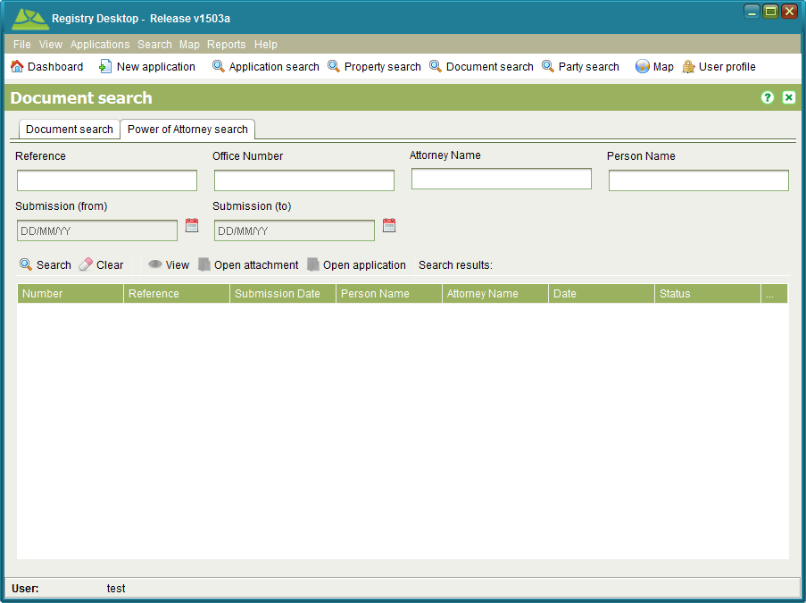

Figure 37 - Power of Attorney Search

### Also See

* Registry Concepts
  + Documents
* Registry Desktop Screens
  + Dashboard and Main Menu
  + Document Details
* General How To
  + Print a Document Copy
* Documents How To
  + Add or Update a File Attachment on an Existing Document
  + Link to Power of Attorney and Standard Documents

## Document Details

The Document Details screen allows you to view and edit document details. This screen can be accessed by multiple functions in Registry including the Document Search screen.

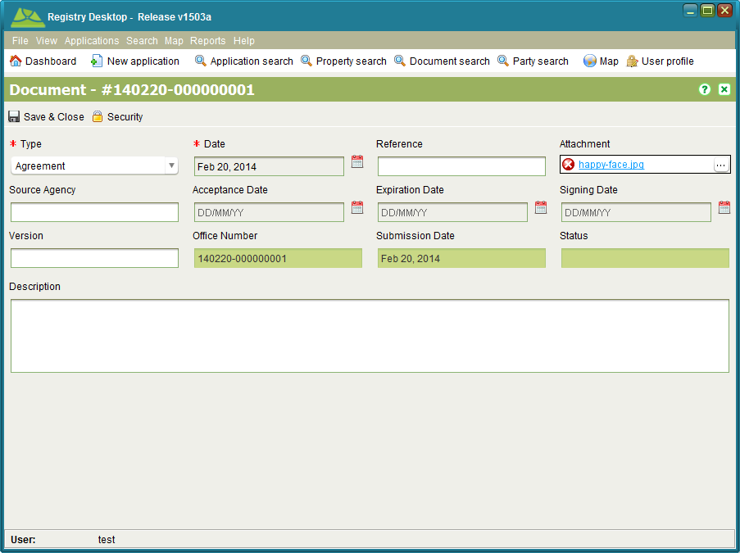

Figure 38 – Document Details

Every document must have a type specified along with a document date. Use the date printed or written on the face of the document as the document date. If the document has no such date, enter the current date.

When editing a document, you can link an attachment using the Attachment field. Simply click the … button to open the File Attachments screen. This button is not displayed when viewing document details in read only mode.

To save your edits to the document and close, click C:\Work\source\Help Images\icons\save.png Save & Close.

### Also See

* Registry Concepts
  + Documents
* Registry Desktop Screens
  + Application Details
  + Property Details
  + Simple RRR
  + Rightholder RRR
  + Ownership RRR
  + Lease RRR
  + Mortgage RRR
  + Document Search
  + Document Registration
* General How To
  + Lodge a new Application
  + Edit an Application
  + Print a Document Copy
  + Secure a Data Record
* Documents How To
  + Add a Document to an Application
  + Attach a File to a New Document
  + Add or Update a File Attachment on an Existing Document
  + Link to Power of Attorney and Standard Documents
* Land Registration How To
  + Lodge and Process a Land Registration Application

## Party Search

The Party Search screen allows you to locate parties which include both people (Natural Person) and organizations/groups (Non-natural Person) that are associated to property or property transactions. You can also add, edit, remove or view party details from this screen. It can be accessed by selectingsearch Party search or using Search > search Party menu.

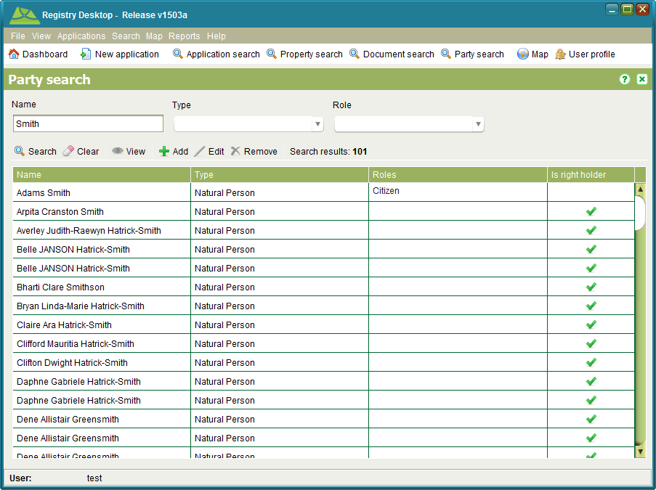

Figure 39 – Party Search

You can search by any combination of Name, Type and Role. The Name also supports partial and full matching. Registry makes no attempt to automatically link or de-duplicate new party records. This can result in an individual or organization/group being listed multiple times in the search results.

The Is right holder flag indicates whether the party has a direct association to a property as an owner or as a named party for another property right. Parties that are flagged as right holders cannot be edited or removed using this screen. Instead changes to the right holder details can only be made using one of the property or interest tasks.

Using this screen you can add a new party by clicking C:\Work\source\Help Images\icons\add.png Add or edit existing parties that are not flagged as right holders by selecting a search result and clicking C:\Work\source\Help Images\icons\pencil.png Edit. Both actions will open the Persons Details screen allowing you to enter details for an individual or an entity. It is also possible to add new parties as well as edit parties using other functions in Registry such as property owners and right holders.

To remove an existing party, select it and click C:\Work\source\Help Images\icons\remove.png Remove. If the party is not linked as a property owner or right holder, the record will be removed.

If you simply need to view the party details, select it and click C:\Work\SOLAHelp\images\icons\view.png View.

### Also See

* Registry Concepts
* Registry Desktop Screens
  + Dashboard and Main Menu
  + Party Details
* General How To
  + Add or Edit Agents and Banks

## Party Details

The Party Details screen allows you to create new parties as well as edit existing party details. This screen can be accessed by multiple functions in Registry including the Party Search screen.

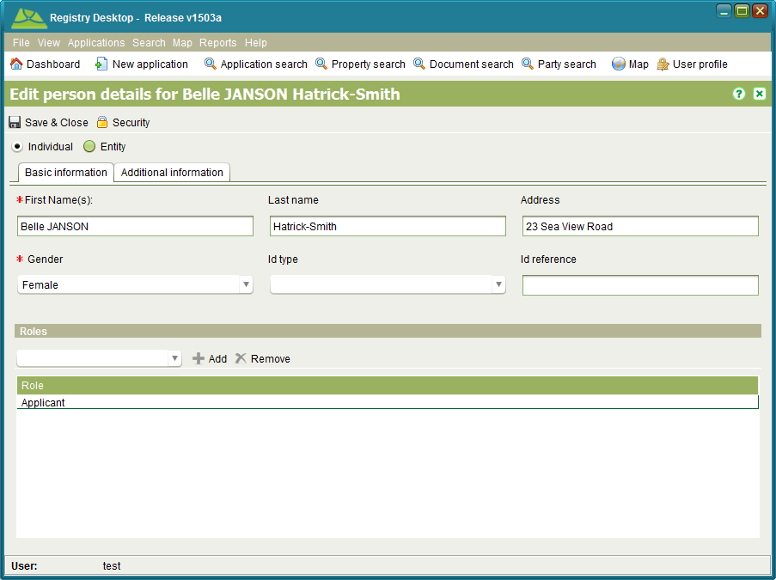

Figure 40 – Party Details

You can enter details for an entity (i.e. organization, group or company) or an individual. The basic information required includes the name of the party with additional information such as contact information and alias details entered as required on the Additional Information tab. Once the necessary party details have been entered click C:\Work\source\Help Images\icons\save.png Save & Close to create or update the party.

### Also See

* Registry Concepts
* Registry Desktop Screens
  + Property Details
  + Rightholder RRR
  + Ownership RRR
  + Lease RRR
  + Party Search
* General How To
  + Add or Edit Agents and Banks
  + Secure a Data Record

## User Profile

Every user is able to update their name details and change their password from the User Profile screen. It can be accessed by clicking C:\Work\source\Help Images\icons\lock--pencil.png User profile.

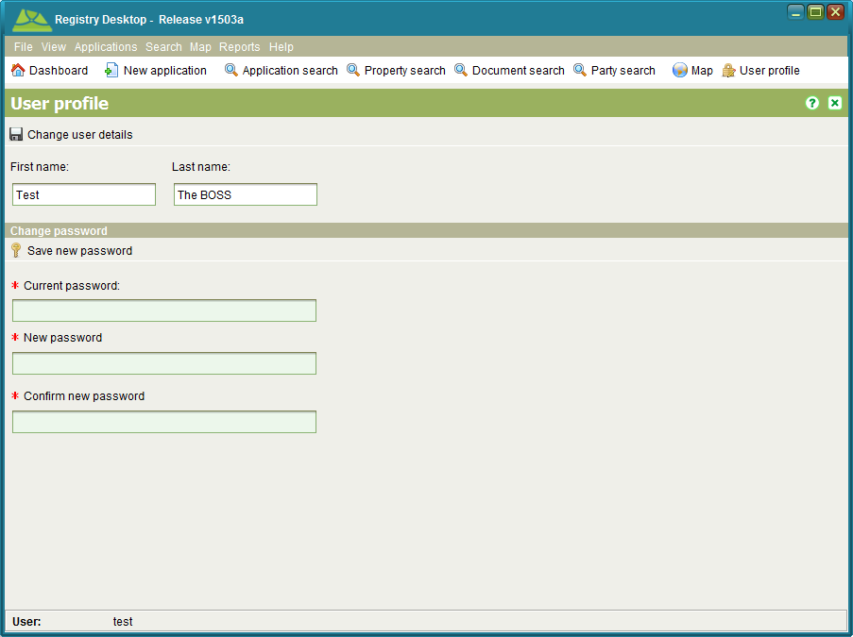

Figure 41 - User Profile

To change your first or last name details, update the First or Last name and click C:\Work\source\Help Images\icons\save.png Change user details. Changing your first or last name does not affect the username you use to login to Registry.

To change your password, enter your current password in the text field provided and enter your new password twice then click C:\Work\source\Help Images\icons\key.png Save new password. New passwords must be at least 5 characters in length. Also note that changing your password will automatically exit the application. If the application does not close automatically, you will need to close it manually before continuing.

### Also See

* Registry Desktop Screens
  + Dashboard and Main Menu
* General How To
  + Log In
  + Change Your Password

## Rights Export

The Rights Export screen can be used to extract information on property rights into a Comma Separated Value (CSV) file. The data in the file can be used for additional reporting and/or loaded into other third party systems. To access the Rights Export screen use the File > C:\Work\SOLAHelp\images\icons\export.png Export rights menu.

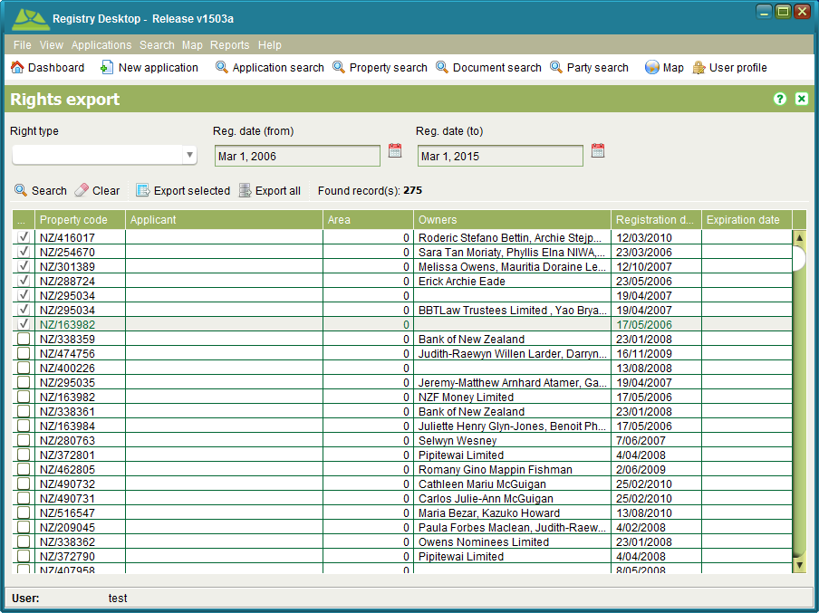

Figure 42 - Rights Export

Set the Right type (optional) and registration date range to match your needs then click C:\Work\SOLAHelp\images\icons\search.png Search. A list of all rights and restrictions matching your criteria will be displayed. If no records match your search criteria, a message will be displayed instead.

You can choose to export a subset of the results by checking the checkbox beside each result you want and using the C:\Work\SOLAHelp\images\icons\export.png Export selected tool. To export all results use the C:\Work\SOLAHelp\images\icons\export2.png Export all tool. Both export tools will prompt for a file location and create a CSV file containing details of the rights you have chosen to export.

To quickly clear your search criteria and the results, click C:\Work\SOLAHelp\images\icons\eraser.png Clear.

### Also See

* Registry Concepts
  + Rights Restrictions and Responsibilities
* Registry Desktop Screens
  + Dashboard and Main Menu
  + Simple RRR
  + Rightholder RRR
  + Ownership RRR
  + Lease RRR
  + Mortgage RRR

## Document Registration

Certain document types, specifically Power of Attorney and Standard Document must first be registered in Registry before they can be referenced by an application to support or justify a property transaction. The Document Registration screen lets you register these official documents as well as deregister them once they are revoked / cancelled. To access the Document Registration screen you need to lodge an application containing one or more of the following services; Registration of Power of Attorney, Registration of Standard Document, Cancel Power of Attorney or Withdraw Standard Document. Once the application is lodged and assigned, you then need to C:\Work\source\Help Images\icons\start.png Start the service from the Application Details Services tab.

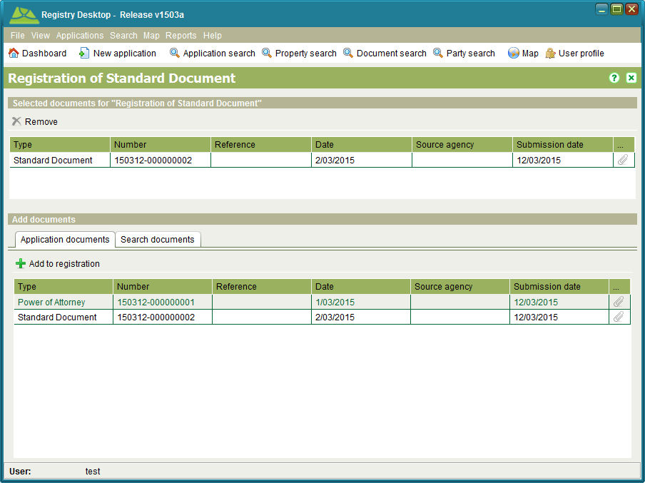

Figure 43 - Document Registration

Before accessing the Document Registration screen, add the document to register to the application so that it will appear in the Application documents list. To register a document, select the document from the Application documents list and click C:\Work\source\Help Images\icons\add.png Add to registration. You can add multiple documents for registration if required. If you mistakenly add a document to the registration list you can remove it using C:\Work\source\Help Images\icons\remove.png Remove.

### Power of Attorney Details

When adding a Power of Attorney document for registration, you will also be prompted to enter the Attorney name as well as the name of the person the Power of Attorney applies to (i.e. the Grantor).

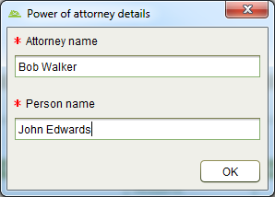

Figure 44 - Power of Attorney Details

### Also See

* Registry Concepts
  + Services
  + Documents
* Registry Desktop Screens
  + Application Details
* Documents How To
  + Link to Power of Attorney and Standard Documents
  + Register Power of Attorney
  + Cancel Power of Attorney
  + Register Standard Document
  + Withdraw Standard Document

## Person Relationship

The Person Relationship screen can be used to record a relationship between two parties such as a husband and wife, parent and child, grandparent and grandchild or other similar relationships. The purpose is to safeguard the interests of one of the parties (the notifiable party) and inform them of any changes to the property rights held exclusively by the other party (the target party). The goal of this feature is to prevent the notifiable party from being unduly disadvantaged if the target party sells, trades or transfers the property rights they hold. To access the Person Relationship screen you need to lodge an application containing one of the following services; Record Person Relationship or Cancel Person Relationship. Once the application is lodged and assigned, you then need to C:\Work\source\Help Images\icons\start.png Start the service from the Application Details Services tab.

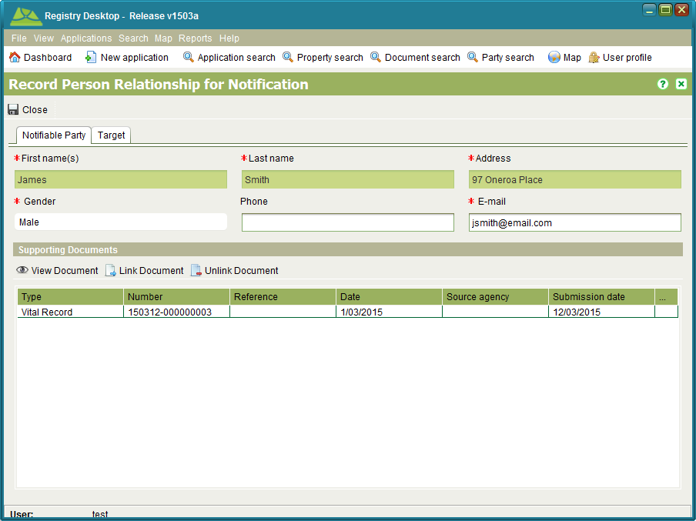

Figure 45 – Person Relationship – Notifiable Party tab

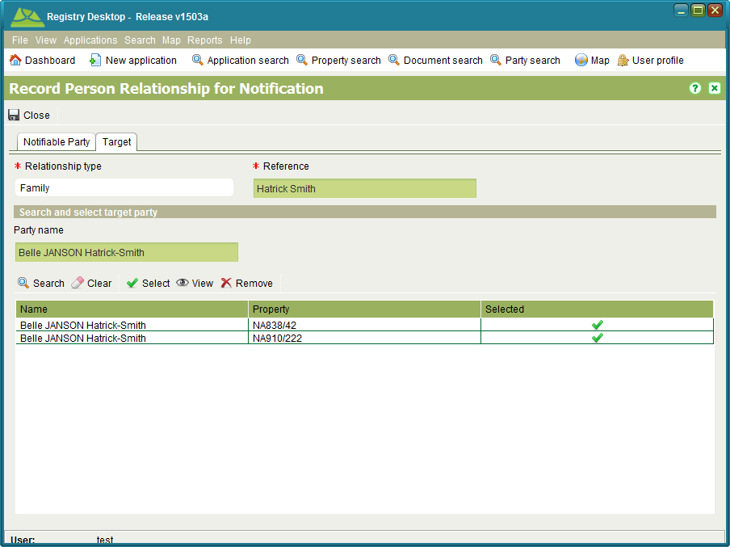

Figure 46 - Person Relationship - Target tab

Record the details of the party to be notified on the Notifiable Party tab. Notifications are sent via email, so an email address is mandatory. To create a Person Relationship, you need a copy of Vital Record such as a Birth Certificate, Marriage Certificate, Death Certificate, etc. to verify the relationship between the two parties. Use the C:\Work\SOLAHelp\images\icons\document-link.png Link Document tool to link a scanned copy of Vital Record proving the validity of the relationship.

On the Target tab, select the appropriate Relationship type and enter a reference. You then need to identify the target party by entering their name in the Party name field and clicking C:\Work\SOLAHelp\images\icons\search.png Search to locate all property the party holds rights to. C:\Work\SOLAHelp\images\icons\confirm.png Select the appropriate search results and C:\Work\SOLAHelp\images\icons\save.png Close to save your changes.

**Notes**

* The target party may appear more than once in the search results if they hold rights across multiple properties. You should select all results relevant to the relationship.

### Also See

* Registry Concepts
  + Services
* Registry Desktop Screens
  + Application Details

## Change to Cadastre

The Change to Cadastre screen allows you to subdivide/split or merge/amalgamate parcels. It can be used to capture new parcel information obtained from a plan (e.g. Survey, Complied, Registry, etc.). It can be accessed by C:\Work\source\Help Images\icons\start.png starting the Change to Cadastre service from the Application Details Service tab.

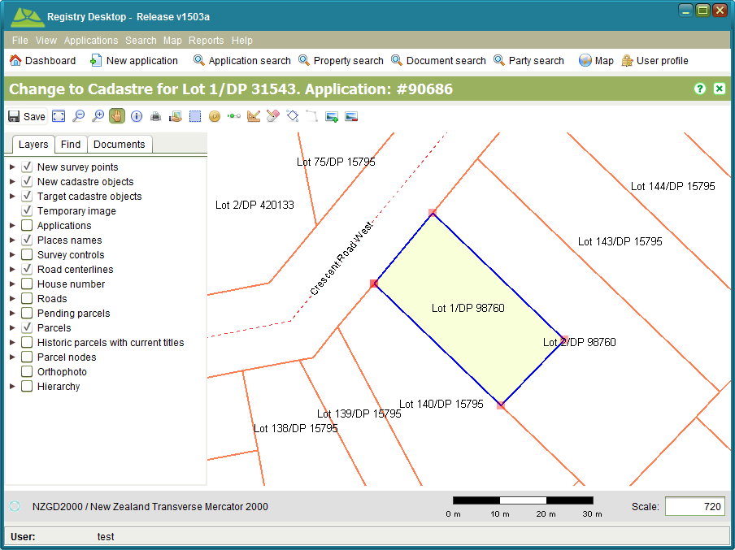

Figure 47 – Change to Cadastre with Target Parcel Selected

The Change to Cadastre screen extends the SOLA Map Viewer with additional tools to aid spatial editing of parcels. The additional tools provided are

|  |  |
| --- | --- |
| * Select / Deselect Target Parcel | C:\Work\source\Help Images\icons\select-parcel.png |
| * Survey Points screen | C:\Work\source\Help Images\icons\point-show.png |
| * Create / Link Survey Points | C:\Work\source\Help Images\icons\node-linking.png |
| * Create New Parcel | C:\Work\source\Help Images\icons\new-parcel.png |
| * Parcel List screen | C:\Work\source\Help Images\icons\eraser.png |
| * Select a boundary to change | C:\Work\source\Help Images\icons\cadastre-boundary-select.png |
| * Change selected boundary | C:\Work\source\Help Images\icons\linestring.png |
| * Add image | C:\Work\source\Help Images\icons\image-add.png |
| * Remove added image | C:\Work\source\Help Images\icons\image-remove.png |

### Target Parcels

Before capturing the data from a plan, you should identify the underlying parcels (a.k.a. target parcels) that are being subdivided or amalgamated. If the Map Viewer is not already zoomed to the location of the plan, use the map search or the map navigation tools to locate the target parcels and use the Select / Deselect Target Parcel toolC:\Work\source\Help Images\icons\select-parcel.png to select (or deselect) parcels as required. Target parcels display with a dark blue border and light yellow fill.

### Survey Points

Survey points represent coordinates recorded on a survey plan. They can be located directly on the map via a single click with the Create / Link Survey Points tool C:\Work\source\Help Images\icons\node-linking.png , loaded from a survey data file or the coordinates can be manually entered using the Survey Points screen which can be accessed using the Survey Points tool C:\Work\source\Help Images\icons\point-show.png.

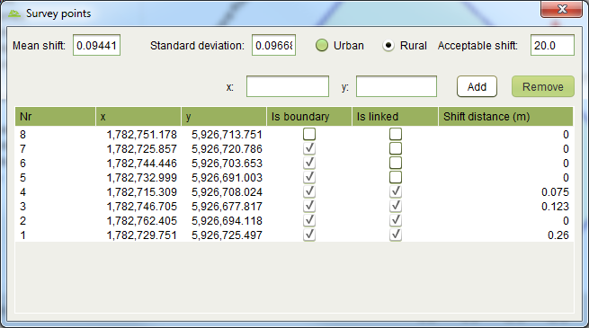

Figure 48 - Survey Points Screen

By default, new survey points are created as boundary points. You can change a survey point to a traverse point by clearing the Is boundary checkbox. Traverse points are displayed on the map as red triangles.

You can also link a boundary point to the node of a target parcel using the Create / Link Survey Points tool C:\Work\source\Help Images\icons\node-linking.png. Simply select the new boundary point and drag it close to the target parcel node. The new boundary point will snap to the location of the target parcel node and the blue cross will change to a green cross to confirm the linkage. The Survey Points screen also indicates when the boundary point is linked. To unlink the boundary point, clear the Is linked check box.

If you need to delete a survey point that has been added in error, select the point from the list and click the Remove button.

Coordinate data can also be loaded from a Comma Separated Values (CSV) text file. Loading a CSV coordinate file requires attaching a .csv file as a document to the application and using the Add Points button on the Documents tab of Record Plan to import the data. For details on the file format and the steps required to import a survey data file see Import a Survey Data File.

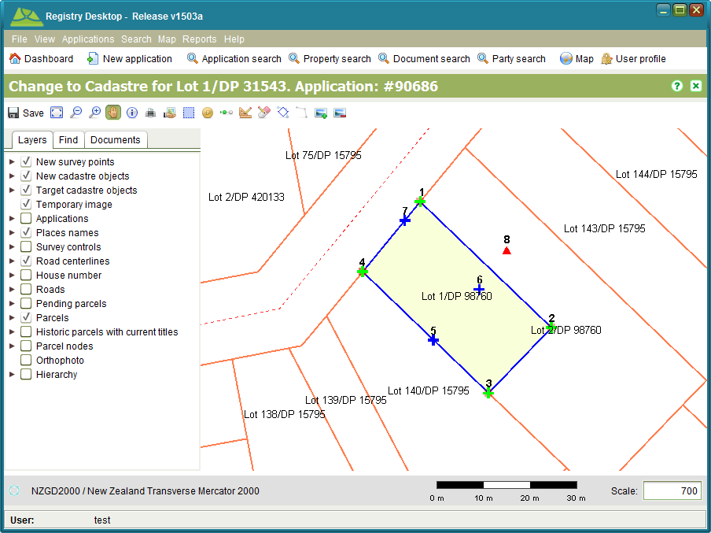

Figure 49 - Linked Boundary Points

### Heads up Digitizing

To assist capturing the location of survey points from the plan, you can load an image of the survey plan onto the Map Viewer and use the mouse to capture the location of the new survey points.

To add a plan image to the map you must first have an image file available on your local hard drive. The file formats supported by the Map Viewer are TIFF, PNG and JPEG. If you have an image in a different format (e.g. PDF), then you will need to convert the file to one of the accepted image formats before it can be displayed in the Map Viewer.

The Add Image toolC:\Work\source\Help Images\icons\image-add.png works by matching two points you select on the map with two points you select from the image. For the best match accuracy, the first node you select should be at the bottom left of the plan image and the second point at the top right (or top left and bottom right). The image is then scaled and displayed in the Map Viewer accordingly.

Note that the current Add image tool does not rotate the image. If the plan does not have a standard North orientation, then do not attempt to digitize from the plan as the result will be inaccurate.

### Creating New Parcels

You can create new parcels using the Create New Parcel tool C:\Work\source\Help Images\icons\new-parcel.png. Using the tool, single click each survey point of the new parcel in sequence in either a clockwise or anti-clockwise direction and double click on the final survey point to close the parcel boundary. The new parcel will display with a green border and yellow fill.

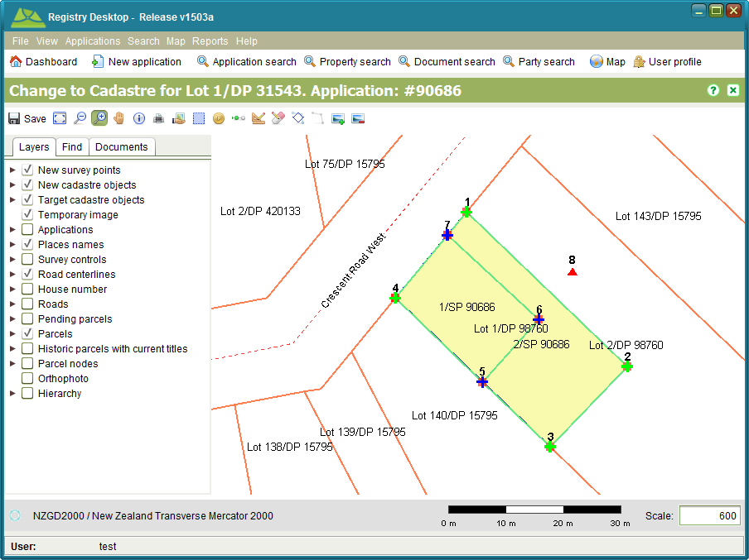

Figure 50 - New Parcels

If you make a mistake while forming the new parcel, right click to cancel the shape and start again.

To edit the identifier for the new parcel, use the Parcel List tool C:\Work\source\Help Images\icons\eraser.png to open the Parcel List screen and update the First part of the appellation as required. The Last part is set to the application number and cannot be edited. You can also use the Parcel List to remove a new parcel if it is created in error as well as set the official area for the parcel.

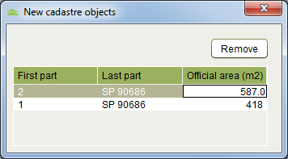

Figure 51 - Parcel List

### Creating Parcels with Irregular Boundaries

The Create New Parcel tool allows you to create new parcels with simple right-line boundaries where the start and end point for each boundary line must be a survey point. If the parcel requires an irregular boundary (a.k.a. natural boundary) then you need to use the Boundary Change tools to modify the right line boundary line of a new parcel.

**IMPORTANT**: Before using the Boundary Change tools, ensure you add all existing parcels that will share the irregular boundary as target parcels. Only modifying a parcel on one side of the boundary may result in gaps and overlaps forming in the cadastral network. To do this may require to you add parcels that are not recorded on the plan. You also need to re-create new parcels over all target parcels using the Create New Parcels toolC:\Work\source\Help Images\icons\new-parcel.png prior to using the Boundary Change tools. The exception to this rule is where the irregular boundary will form the shoreline of a lake or the sea. In this case it is unlikely there will be an adjacent parcel to update.

The Select Boundary tool C:\Work\source\Help Images\icons\cadastre-boundary-select.png can be used to identify the boundary line(s) of a new parcel that must be changed into an irregular boundary. Use the tool to select the start and end points of the irregular boundary by dragging a small selection box around the appropriate new parcel node when prompted to do so by the tool.



Figure 52 – Selecting a Parcel Node

The order that you select the start and end points for the new irregular boundary is important. The tool will highlight all parcel boundary line(s) in a clockwise direction from the start point to the end point. The highlighted boundary lines indicate the boundary lines that will be replaced by the new irregular boundary. If the wrong sequence of boundary lines is highlighted, repeat the selection ensuring the end point is selected as the start point and vice versa.

Selecting a boundary to change will enable the Change Boundary tool C:\Work\source\Help Images\icons\linestring.png. Use this tool to reshape the parcel boundary using the mouse.

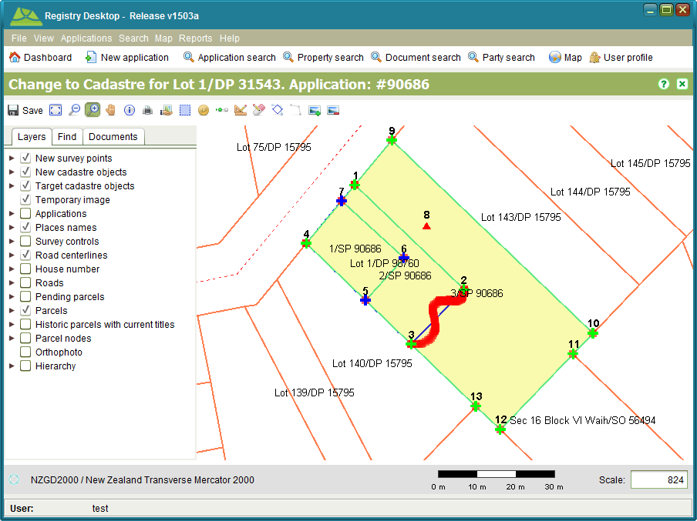

Figure 53 - Irregular Parcel Boundary

If the new boundary covers a large area, it can be difficult using the Change Boundary tool C:\Work\source\Help Images\icons\linestring.png to create the new boundary in one go. In this situation, create an initial boundary that approximately represents the new boundary you require. You can then zoom in and use the Boundary Change tools to improve segments of the initial boundary as required.

### Approving a Plan

Changes made to the cadastre remain pending until the application containing the Record Plan service is approved. You can approve the application by completing all services on the application and approving the application using the Approve tool C:\Work\source\Help Images\icons\approve.png in the Application action dropdown. The new parcels will then show as current parcels in the SOLA Map Viewer.

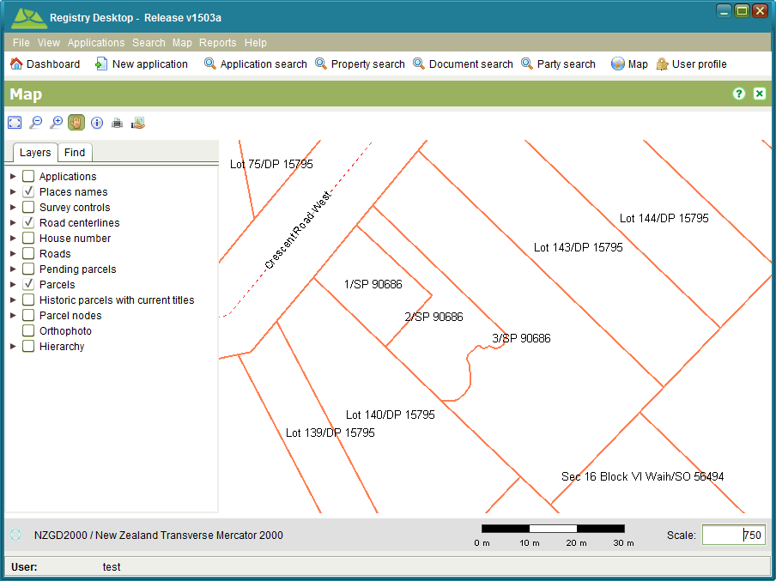

Figure 54 – Approved Plan

### Also See

* Registry Concepts
  + Services
* Registry Desktop Screens
  + SOLA Map Viewer
  + Application Details
  + Redefine Cadastre
* Survey How To
  + Record a Plan
  + Add a Plan Image for Digitizing
  + Import a Survey Data File
* Appendix
  + Registry Business Rules
  + Timble Pathfinder Software Configuration for SOLA Export CSV File

## Redefine Cadastre

The Redefine Cadastre screen allows you to change the boundaries of an existing parcel both entirely and point by point (adding nodes and changing node coordinates) outside of the receipt of a survey plan. It can be accessed by starting a Redefine Cadastre service from the Application Details Service tab.

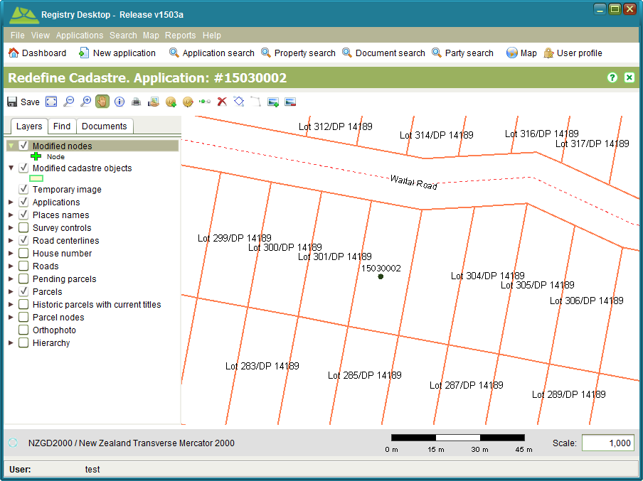

Figure 55 – Redefine Cadastre

The Redefine Cadastre screen extends the SOLA Map Viewer with additional tools to aid spatial editing of parcels. The additional tools provided are

|  |  |
| --- | --- |
| * Add Node | C:\Work\source\Help Images\icons\add-node.png |
| * Select Node | C:\Work\source\Help Images\icons\change-node.png |
| * Move Node | C:\Work\source\Help Images\icons\node-linking.png |
| * Reset changes | C:\Work\source\Help Images\icons\remove.png |
| * Select a boundary to change | C:\Work\source\Help Images\icons\cadastre-boundary-select.png |
| * Change selected boundary | C:\Work\source\Help Images\icons\linestring.png |
| * Add image | C:\Work\source\Help Images\icons\image-add.png |
| * Remove added image | C:\Work\source\Help Images\icons\image-remove.png |

### Nodes

Nodes represent the fixed points of the parcel boundary. New nodes can be added using the Add Node tool C:\Work\source\Help Images\icons\add-node.png . Existing nodes can be relocated by using the Select Node tool C:\Work\source\Help Images\icons\change-node.png and either updating the node coordinate displayed in the Modify Node dialog or by using the Move Node tool C:\Work\source\Help Images\icons\node-linking.png.

To add a new node, use the Add Node tool C:\Work\source\Help Images\icons\add-node.png to drag a small selection box around the approximate location for the new node. Note that the selection box must be on top of an existing boundary. If the selection box is not on top of an existing boundary, the tool will not work.

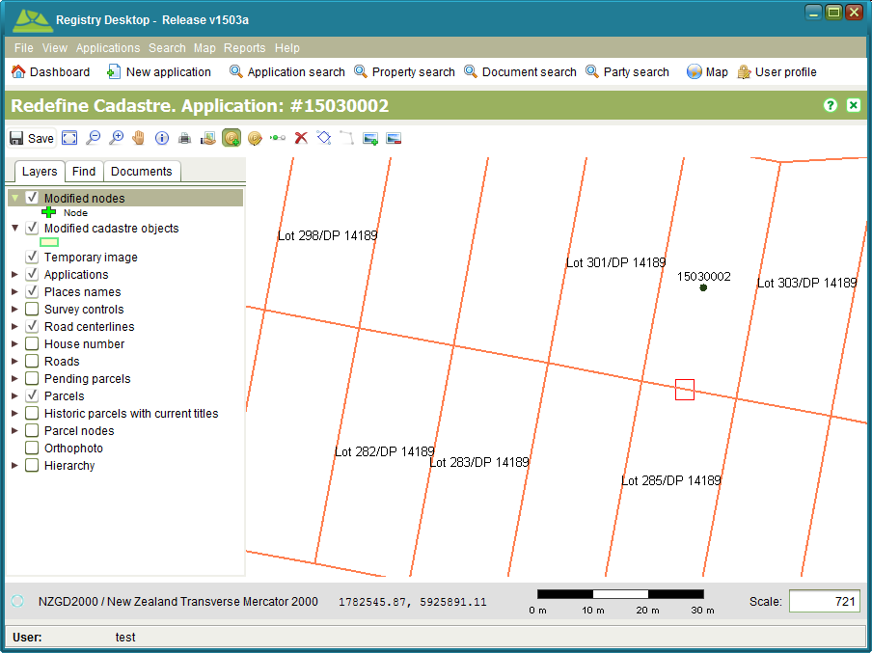

Figure 56 – Select the location approximate for a new node

You will then be prompted with the Modify Node dialog where you can choose to enter the node coordinate (if you have the coordinate value) or use the Move Node tool C:\Work\source\Help Images\icons\node-linking.png to locate the new node interactively on the map.

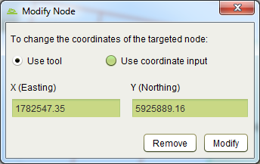

Figure 57 – Modify Node dialog

To enter a coordinate directly, select the Use coordinate input radio button on the Modify Node dialog. This will enable the X (Easting) and Y (Northing) fields allowing you to enter the coordinate. Once done, click the Modify button and the boundaries of the two adjacent parcels will be modified to include the new node. The new parcel boundaries will appear in light green (with yellow fill) while the original boundary will remain orange so that it is possible to differentiate between the two.

If you choose to locate the node interactively using the Move Node tool C:\Work\source\Help Images\icons\node-linking.png, make sure the Use tool radio button is selected on the Modify Node dialog and click Modify. The map will redraw showing the parcels on either side of your selected boundary line with a light green boundary and yellow fill. Adjust the scale of the map and using the Move Node tool C:\Work\source\Help Images\icons\node-linking.png, click on the boundary line you wish to add the new node to. A new node will appear and you will be able to drag the new node into the appropriate location.

Editing the location of an existing node follows much the same process as adding a new node. Using the Select Node tool C:\Work\source\Help Images\icons\change-node.png, drag the selection box around an existing node. The Modify Node dialog will reappear and you will be able to modify the coordinate value directly, use the Move Node tool C:\Work\source\Help Images\icons\node-linking.png to interactively relocate the node or remove the node altogether by clicking the Remove button.

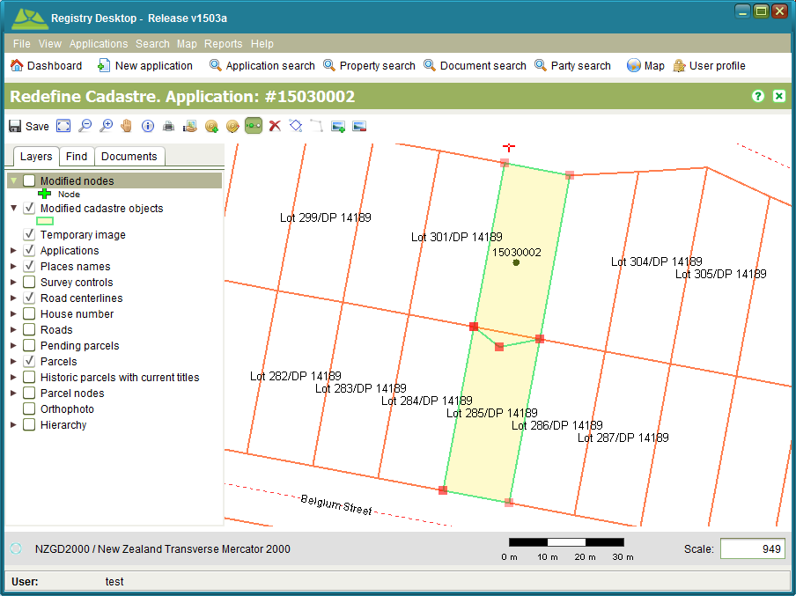

Figure 58 – Pending Parcels with updated boundaries

**Notes**

* When entering a coordinate the value must be in terms of the coordinate system displayed on the map. No transformation between coordinate systems will occur.
* You can see the name of the coordinate system used by the map in the bottom left of the map viewer
* Just like Change to Cadastre, changes made to the cadastral network remain pending until the application containing the Redefine Cadastre service is approved

### Boundaries

The Boundary Change tools in Redefine Cadastre work in much the same way as the Boundary Change tools in Change to Cadastre. The main difference is that the Boundary Change tools in Redefine Cadastre allow you to redefine the boundary of an existing parcel without having to create a new parcel. The Select Boundary tool C:\Work\source\Help Images\icons\cadastre-boundary-select.png also automatically selects both parcels adjacent to the selected boundary to ensure the redefined boundary is shared by the parcels on both sides avoiding gaps and overlaps in the cadastral network.

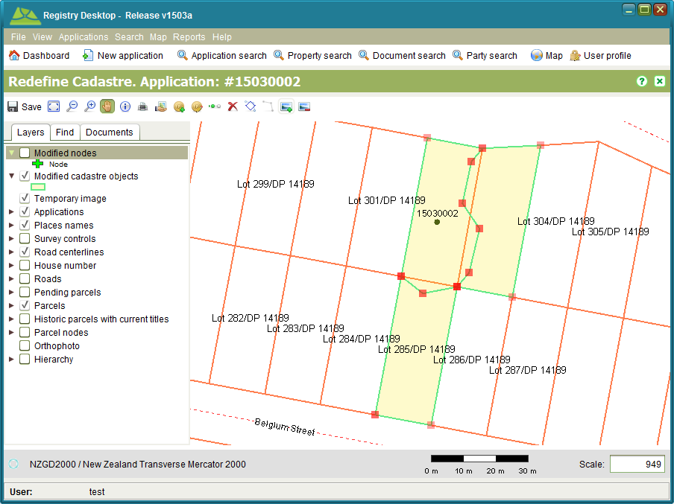

Figure 59 – Boundary Change

### Cancelling Redefine Cadastre

If you make a mistake while using Redefine Cadastre, you can remove all your changes using the Reset Changes tool C:\Work\source\Help Images\icons\remove.png. This tool will remove all pending changes, so use it with care. If you use it in error, close the Redefine Cadastre screen without saving and open the screen again. Any changes you previously saved should remain.

### Also See

* Registry Concepts
  + Services
* Registry Desktop Screens
  + SOLA Map Viewer
  + Application Details
  + Change to Cadastre
* Survey How To
  + Redefine a Cadastre
  + Add a Plan Image for Digitizing
  + Import a Survey Data File
* Appendix
  + Registry Business Rules
  + Timble Pathfinder Software Configuration for SOLA Export CSV File

# General How To

## Log In

Launch the Registry Desktop from the shortcut on your computer desktop. At the Login screen, enter your Registry username and password details and click the Login button. If you are not sure what your Registry username is, or require your password to be reset, contact the Registry System Administrator.

**Notes**

* For the demonstration version of Registry, you can login using the following credentials

User **test**

Password **test**

### Also See

* Registry Desktop Screens
  + Dashboard and Main Menu
  + User Profile
* General How To
  + Change your Password

## Change Language

The Registry Desktop supports English, Russian, Arabic, French, Spanish, Portuguese and Chinese languages for display of labels, messages and reference values. To change the language, select your preferred language from the View > Language menu option on the main menu. Once a selection is made, SOLA will automatically restart displaying the selected language.

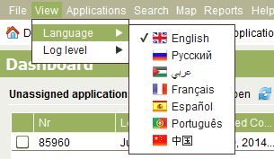

Figure 60 - Change Language

### Also See

* Registry Desktop Screens
  + Dashboard and Main Menu

## Change Your Password

Users are required to change their password at regular intervals to reduce the risk of Registry’s audit and security features from being compromised. From time to time you may be prompted with the following message when logging into the Registry Desktop.

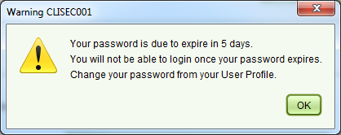

Figure 61 - Password Due to Expire Message

When you click OK to this prompt, the User Profile screen will be displayed allowing you to change your password.

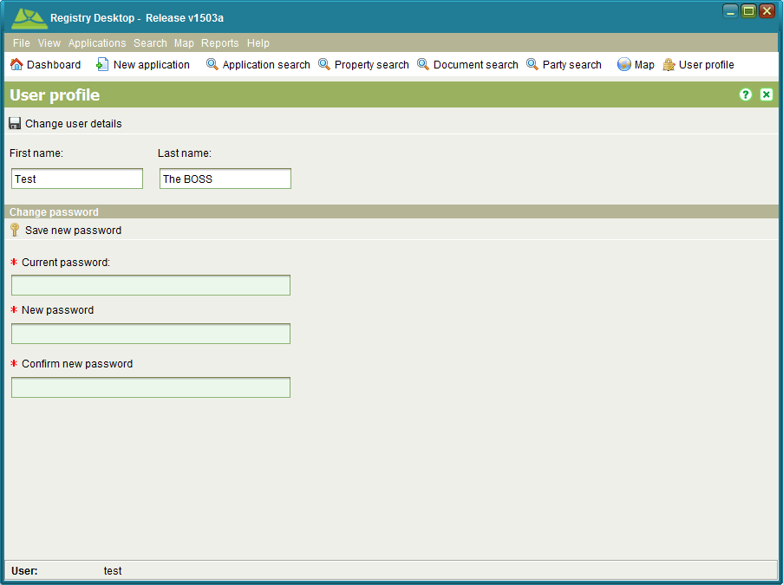

Figure 62 - User Profile Change Password

**Steps**

1. Enter your current password in the Current Password field.
2. Enter your new password in the New password field. Your new password must differ from your old password by at least one character and have a minimum length of 5 characters.
3. Re-enter your new password in the Confirm new password field. Be aware that passwords are case sensitive so you must re-enter the password exactly.
4. Click C:\Work\SOLA\Samoa\Documentation\Screenshots\icons\key.png Save new password to change your password.
5. If your new password is accepted a message will display stating that your password was successfully changed and the Registry Desktop will close.
6. Restart the Registry Desktop and login using your new password.

Registry will warn you for up to 10 days that your password is due to expire. If you fail to change your password during this period, you will be locked out and you will not be able to login. In this situation, contact the System Administrator so they can change your password for you. Note that if the Administrator resets your password, you will be prompted to change it again the next time you successfully login to the Registry Desktop.

If you intend to take extended leave or you feel your password has been compromised then you should change your password immediately without waiting for the password expiry message to appear. To change your password at any time, open the User Profile and follow the steps as above.

### Also See

* SOLA Desktop Screens
  + Dashboard and Main Menu
  + User Profile
* General How To
  + Log In

## Lodge a New Application

To create a new application, access the Application Details screen from the Applications > New Applications menu or selecting new New Application.

### The minimum information required for a new application are Contact Person details including first name, last name address and gender and at least one service. Other information can be entered has appropriate. Once the necessary information has been entered, C:\Work\SOLAHelp\images\icons\save.png Save the application. This will lodge the application, assign an application number and display the Lodgement Notice for your review. You can choose to print or save the Lodgement Notice. Also See

* Registry Concepts
  + Application Lifecycle
  + Services
  + Documents
  + Business Rules
* Registry Desktop Screens
  + Dashboard and Main Menu
  + SOLA Map Viewer
  + Application Details
  + Document Details
* General How To
  + Edit an Application
  + Assign an Application
  + Un-assign and Application
  + Calculate Fees
  + Verify Property Details
  + Cancel, Withdraw or Lapse an Application
  + Add location for Application
  + Secure a Data Record
* Documents How To
  + Add a Document to an Application
* Land Registration How To
  + Lodge and Process a Land Registration Application
* Survey How To
  + Record a Plan
  + Redefine a Cadastre
* Appendix
  + Registry Business Rules

## Edit an Application

To edit an application, select the application in the assigned or unassigned application lists on the Dashboard and choose Edit. If the application is not displayed in the application lists, use the Search Application screen to locate it and click the Edit button. This will open the Application Details screen allowing you to edit the application details and save changes.

### Also See

* Registry Concepts
  + Application Lifecycle
  + Services
  + Service Lifecycle
  + Documents
* Registry Desktop Screens
  + Dashboard and Main Menu
  + SOLA Map Viewer
  + Application Search
  + Application Details
  + Document Details
* General How To
  + Lodge a new Application
  + Assign an Application
  + Un-assign and Application
  + Calculate Fees
  + Verify Property Details
  + Cancel, Withdraw or Lapse an Application
  + Add location for Application
  + Secure a Data Record
* Documents How To
  + Add a Document to an Application
  + Attach a File to a New Document
  + Add or Update a File Attachment on an Existing Document

## Assign an Application

To assign an application, you must first ensure the Paid flag on the Fees tab is checked. If you have permission to set the Paid flag, you can do this by editing the application and checking the Paid checkbox on the Fees tab. Make sure toC:\Work\source\Help Images\icons\save.png Save your changes.

To assign the application, check the checkbox beside the application you want to assign in the Unassigned applications list and click the C:\Work\source\Help Images\icons\assign.png Assign tool.

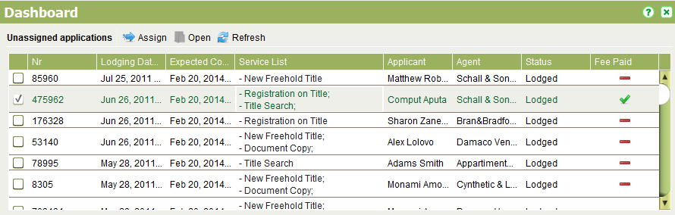

Figure 63 - Unassigned Applications List

This will open the Application Assignment dialog

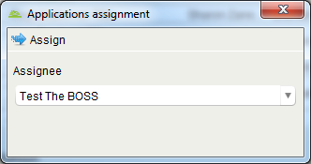

Figure 64 - Application Assignment Dialog

In the Assignee to dropdown, select the appropriate user and click assign Assign again. A confirmation message will display stating the application has been assigned. Click OK the message to return to the Dashboard screen.

Typically users will only be able to assign applications to themselves (i.e. they will be able to pull work), however team leaders will be able to manage the workload of their teams and will be able to assign and reassign applications to other users by selecting the appropriate user from the User drop down list.

**Notes**

* If the application you need to reassign is not displayed in your Unassigned applications list on the Dashboard, you can use the Application Search screen to locate the application and assign it to a different user using the steps described above.
* You can only assign applications to another user if you have the Assign to Others security role. If you do not have this role, you will not be able to change the Assignee dropdown (it will be preset with your name).
* The Dashboard can be used to reassign multiple applications at the same time. Simply check the checkbox beside multiple applications before clicking assign Assign. All checked applications will be assigned to the user selected in the Application Assignment dialog.

### Also See

* Registry Concepts
  + Application Lifecycle
* Registry Desktop Screens
  + Dashboard and Main Menu
  + Application Search
  + Application Details
* General How To
  + Edit an Application
  + Un-assign and Application

## Un-assign an Application

To un-assign an application, check the checkbox beside the application you want to un-assign in the Assigned applications list and click the C:\Work\source\Help Images\icons\unassign.png Unassign tool. At the prompt, click Yes to confirm the assignment change. The Dashboard will then refresh showing the application in the Unassigned applications list.

### Also see

* Registry Concepts
  + Application Lifecycle
* Registry Desktop Screens
  + Dashboard and Main Menu
  + Application Search
  + Application Details
* General How To
  + Edit an application
  + Assign an application

## Calculate Fees

To calculate the fee for an application go to the Fees tab in Application Details and click the C:\Work\source\Help Images\icons\calculate.png Calculate Fee button.

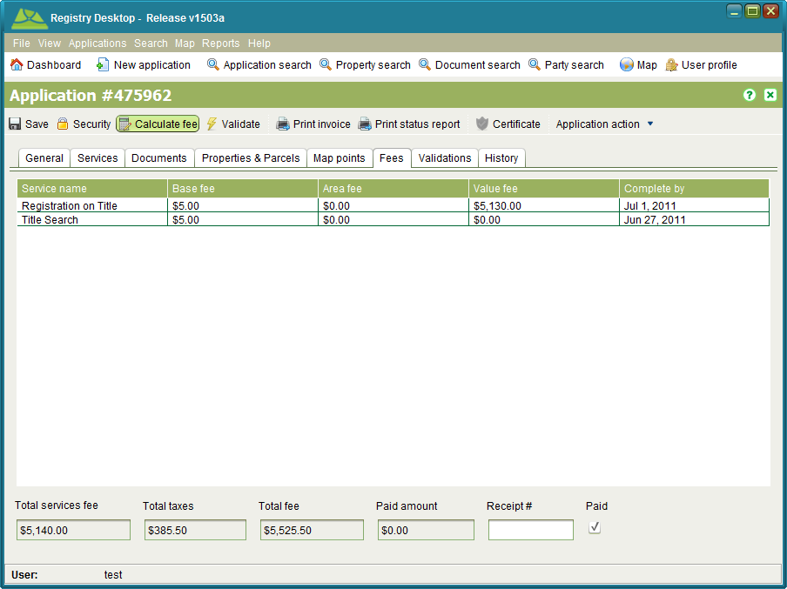

Figure 65 - Application Details Fees tab

Using Calculate Fee will not save any changes to the application. This allows you to determine the fees that will apply to a new application prior to lodging it. Fee calculation is also performed automatically when the application is lodged.

### Also See

* Registry Concepts
  + Application Lifecycle
* Registry Desktop Screens
  + Application Details
* General How To
  + Lodge a new Application
  + Edit an Application

## Verify Property Details

All applications that result in changes to the land register or cadastre information should reference the affected property or properties on the Property tab of Application Details. For land registration changes this will be the property being transacted upon. For survey applications, this will be the underlying property or properties that are being subdivided or amalgamated. Note that new parcels created by the plan should not be recorded here.

To verify if the property details provided by the agent match details recorded in Registry, use the Property tab.

To verify a property, you must add it to the application. On the Property tab, enter the title reference (i.e. First part and Last part) in the fields provided and click C:\Work\SOLAHelp\images\icons\add.png Add property. This will add the property to the list in the bottom half of the tab and automatically verify its details. You can also verify a property manually by selecting it from the list and clicking theC:\Work\source\SOLA\code\clients\swing\desktop\src\main\resources\images\common\document-task.png Verify tool. To remove a property added by mistake, select it and click the C:\Work\source\Help Images\icons\remove.png Remove tool.

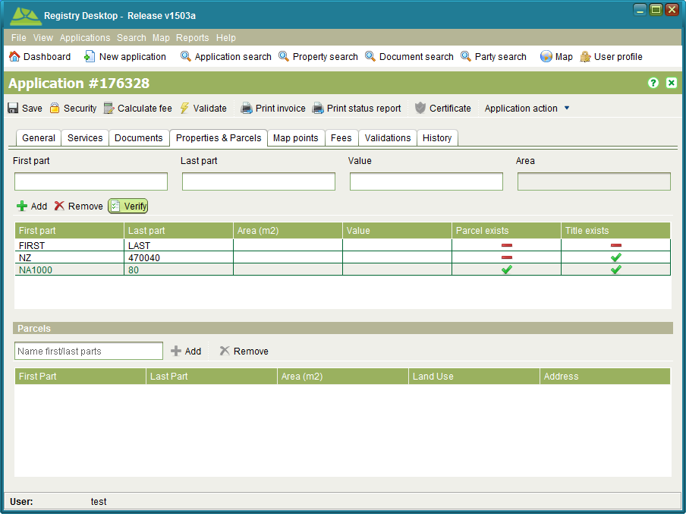

Figure 66 - Application Details Property tab

If the title reference you entered exactly matches a property in the Registry database, the property will be flagged as Title Exists. If the property also has a spatial definition, it will be flagged as Parcel exists.

If the Title Exists checkbox is not checked, it may indicate the title reference is invalid or the title has yet to be converted from paper format. Use the Property Search screen and/or Map Find to attempt to locate the property record.

### Also See

* Registry Concepts
  + Application Lifecycle
* Registry Desktop Screens
  + Application Details
* General How To
  + Lodge a new Application
  + Edit an Application

## Cancel, Withdraw or Lapse an Application

If you have the appropriate security roles, you can cancel, withdraw or lapse an application using the Application action dropdown in the Application Details screen. These actions are enabled depending on the state of the application. For details refer to Registry Concepts – Application Lifecycle.

### Also See

* Registry Concepts
  + Application Lifecycle
* Registry Desktop Screens
  + Application Details
* General How To
  + Edit an Application

## Add location for Application

You can indicate the approximate location of an application using the Map points tab of Application Details and the Locate Application tool application-location-add. The tool allows you to add more than one location point for the application in case the application covers a large or disjoint area.

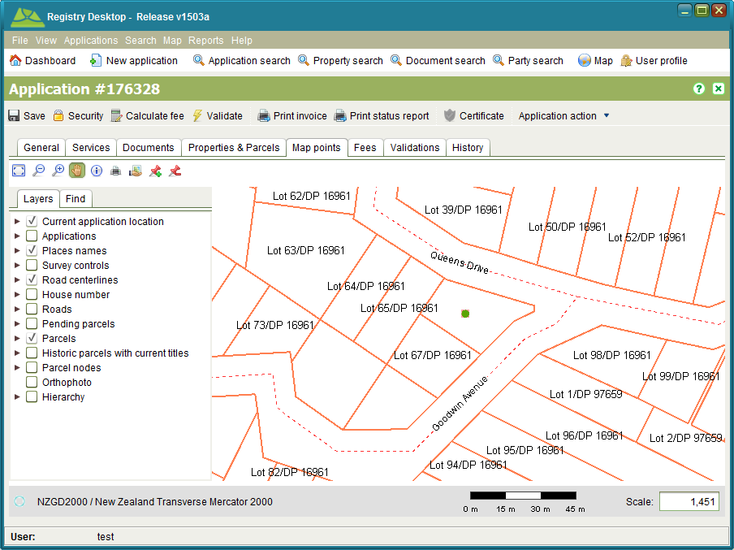

Figure 67 - Application Details Map Points tab

The location point can help to identify other applications in close proximity to the new application that could have a bearing on the new application or vice versa.

The Application Location Remove tool application-location-remove can be used to remove all location points that have been added to an application.

### Also See

* Registry Desktop Screens
  + SOLA Map Viewer
  + Application Details
* General How To
  + Lodge a new Application
  + Edit an Application

## Add or Edit Agents and Banks

Agents are listed in the Agent drop down on the Application Details screen and are required to lodge new Applications. Banks are required when entering or modifying mortgage details.

The Party search screen allows you to quickly locate and add or modify agent and bank details. To locate all agents in Registry, search using the Lodging Agent role. To locate all banks, search using the Bank role. You can edit the agent or bank details by selecting the appropriate search result and clicking the C:\Work\source\Help Images\icons\pencil.pngEdit tool. This will open the Party Details screen.

When adding a new Agent or a new Bank, make sure you configure the appropriate party role(s). Agents require the Lodging Agent and banks require the Bank role.

If you need to remove an Agent or Bank so they are no longer available for selection when lodging a new application or modifying mortgage details, simply remove the Lodging Agent or Bank role from the party record. You can try to use the Party search remove function, but that may fail if the agent or bank has already been linked to an application or mortgage.

### Also See

* Registry Desktop Screens
  + Application Details
  + Mortgage RRR
  + Party Search
  + Party Details

## Perform a Title Search

The Title Search service is used to indicate that information on a particular property has been requested by an agent or a member of the public. It requires printing and optionally certifying (i.e. stamping) the Property Report for the named property.

### Lodge an Application

**Steps**

1. From the Dashboard select the C:\Work\source\Help Images\icons\new.png New application tool to open the Application Details screen.
2. On the General tab, enter the contact details for the person making the request and select the agent from the Agent drop down if appropriate.
3. On the Services tab, add the Title Search service to the application.
4. On the Property tab, enter the title references for the property or properties that have been requested. You can quickly check if Registry records information about a property using the C:\Work\SOLAHelp\images\icons\document-task.png Verify tool. If the Titles Exist flag remains unchecked, it means Registry does not contain a record for the property and will not be possible to produce a Property Report.
5. No supporting documents are required for this service, so there is no need to enter any documents on the Documents tab.
6. No Map points are required.
7. Click the C:\Work\source\Help Images\icons\save.png Save button. This will lodge the application and produce the lodgement notice. Print the notice and give it to the person as proof the application has been lodged. The lodgement notice will indicate the fee to be paid for the application.

### Fee Payment

Once the lodgement notice is printed, the person will need to take the notice to the cashier and arrange payment. When payment has been made, the cashier will locate the Unassigned application list on the Registry Dashboard, C:\Work\source\Help Images\icons\folder-open-document.png Open the application and check the Fee Paid flag on the Fees tab to indicate the application can continue processing.

### Assign the Application

**Steps**

1. From the Registry Dashboard, check the Unassigned applications list to confirm the fee for the application has been paid. If the fee has not been paid it will not be possible to assign the application. In this situation notify the person noted as the contact and/or cashier to confirm the payment status for the application.
2. If the application fee has been paid, select the application in the Unassigned applications list and click the C:\Work\source\Help Images\icons\assign.png Assign tool. This will open the Application Assignment screen.
3. Click the Assign button to assign the application. When the Assign action is complete, you will be returned to the Dashboard and the assigned application will appear in your Assigned applications list.

### Print the Property Report

**Steps**

1. From the Registry Dashboard, open the C:\Work\source\Help Images\icons\search.png Property search, enter the property details and search for the property.
2. Select the property from the search results and C:\Work\source\Help Images\icons\folder-open-document.png Open the Property Details screen.
3. Select C:\Work\source\Help Images\icons\print.png Print and print the Property Report.
4. Stamp the report as required and pass (or deliver / post) the stamped report to the person noted by the application.

### Complete the Service and Application

Once the report has been printed, the service needs to be completed and the application archived.

**Steps**

1. From the Dashboard, folder-open-document Open the application with the Title Search service from your Assigned applications list.
2. On the Services tab, select the Title Search service and click the C:\Work\source\Help Images\icons\confirm.png Complete tool. This will run the Registry business rules to validate the application data. If there is a critical failure, you must remedy the failure as it will not be possible to approve the application otherwise.
3. Use the C:\Work\source\Help Images\icons\approve.png Approve action in the Application action dropdown to approve the application.
4. Use the C:\Work\source\Help Images\icons\archive.png Archive action to complete the Application.

### Also See

* Registry Concepts
  + Services
* Registry Desktop Screens
  + Application Details
  + Property Search
  + Property Details

## Create a Cadastre Print

The Cadastre Print service is used to record a request from an agent or member of the public for a map printout. The steps for creating a cadastre print are similar to those for performing a Title Search with the following exceptions

* When creating the application add a Cadastre Print service instead of the Title Search service.
* To produce the map printout, use the C:\Work\source\Help Images\icons\print.png Print tool on the SOLA Map Viewer.

### Also See

* Registry Concepts
  + Services
* Registry Desktop Screens
  + SOLA Map Viewer

## Print a Document Copy

The Document Copy service is used to record a request for a copy of a document lodged with an earlier application. The steps for printing the document copy are similar to those for performing a Title Search with the following exceptions

* When creating the application add a Document Copy service instead of the Title Search service.
* Use the Document Search screen to locate the document
* Once found, open the document and print it from the default document viewer application.

### Also See

* Registry Concepts
  + Services
  + Documents
* Registry Desktop Screens
  + Application Details
  + Document Search
  + Document Details

## View the Lodgement Report

The Lodgement Report lists information on the number of applications and services processed during a given time period. It can be accessed using the Reports > Lodgement Report menu option in the Registry Desktop main menu. Enter the appropriate time interval in the dialog displayed and click View Report to generate the Lodgement Report.

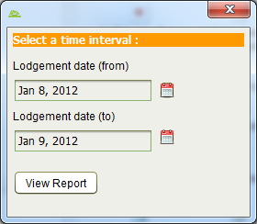

Figure 68 - Lodgement Report Interval

### Also See

* Registry Concepts
  + Application Lifecycle
* Registry Desktop Screens
  + Dashboard and Main Menu
  + Application Details

## Secure a Data Record

Registry supports the application of security classifications to commercially sensitive or culturally sensitive data records in order to limit the users that can view those records. To configure security for a specific record, click C:\Work\SOLA\State Land Management\User Guide\Screenshots\Icons\lock.png Security in the applicable details screen. This will open the Security dialog.

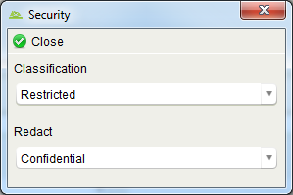

Figure 69 - Security dialog

You can select a Classification level and/or a Redact level. If the Classification level is set, only users with that classification level (or a higher level) will be able to view the record. If the user has a lesser classification level, the record will not appear in any search results or lists preventing them from accessing the record.

The Redact level can be used to obscure specific fields on the record (i.e. redaction). The record will still appear in search results or other lists, but when the user views the record, the redacted fields will either appear blank or contain a generic message to inform the user they are not viewing the actual data value. Redaction can be useful where it is necessary for users to be aware that a record exists, but should not be aware of sensitive details within the record.

The options available for selection for both classification and redaction are

|  |  |
| --- | --- |
| None / Blank | No security level applies. The record is unrestricted and all users have access to the record. The default level for all new records. |
| Unrestricted | No security level applies. The record is unrestricted and all users have access to the record. This is the same as the None / Blank option, but indicates that a user has explicitly determined the record is unrestricted. |
| Restricted | The record is restricted. Only users with the Restricted, Confidential, Secret or Top Secret security roles can view all the record details. |
| Confidential | The record is restricted. Only users with the Confidential, Secret or Top Secret security roles can view all the record details. |
| Secret | The record is restricted. Only users with the Secret or Top Secret security roles can view all the record details. |
| Top Secret | The record is restricted. Only users with the Top Secret security role can view all the record details. |
| Suppression Order | Indicates the record is subject to a legal suppression order to prevent the details from being broadly accessible. Only users with the Suppression Order or Top Secret security roles can view all the record details. |

Once you have selected the Classification and/or Redact level, click C:\Work\SOLA\State Land Management\User Guide\Screenshots\Icons\confirm-close.png Close to close the Security dialog and return to the details screen. Be sure to C:\Work\SOLA\State Land Management\User Guide\Screenshots\Icons\save.png Save the details screen otherwise your changes in the Security dialog will be lost.

**Notes**

* The Redact field will only display if the record type has been configured to support redaction. Currently the only record type that supports redaction is Party.
* You can set both the classification level and redact level for the same record. Be aware that if you set the classification level to a higher security level than the redact level, then the redact level will have no effect as the classification will prevent the record from being displayed to users with a lower security level.
* Users are assigned security classifications through assignment of Registry security roles. Contact the System Administrator if you believe your security classifications are not configured correctly.
* The fields subject to redaction must be configured during customization of Registry. It is not possible for users to specific the fields that are to be redacted, only the redaction level..
* Registry supports custom additional classification levels that can be configured during customization.

### Also See

* Registry Desktop Screens
  + Application Details
  + Property Details
  + Simple RRR
  + Rightholder RRR
  + Ownership RRR
  + Lease RRR
  + Mortgage RRR
  + Document Details
  + Party Details

# Documents How To

Documents are records created in Registry that capture summary details about legal, official or other documentation supplied by the agent or applicant to support their request for changes to the land registry and/or cadastre information.

## Add a Document to an Application

Registry allows documents to be added and/or linked to applications, properties and RRRs. The primary way to add documents into Registry is via the Documents tab on the Application Details screen.

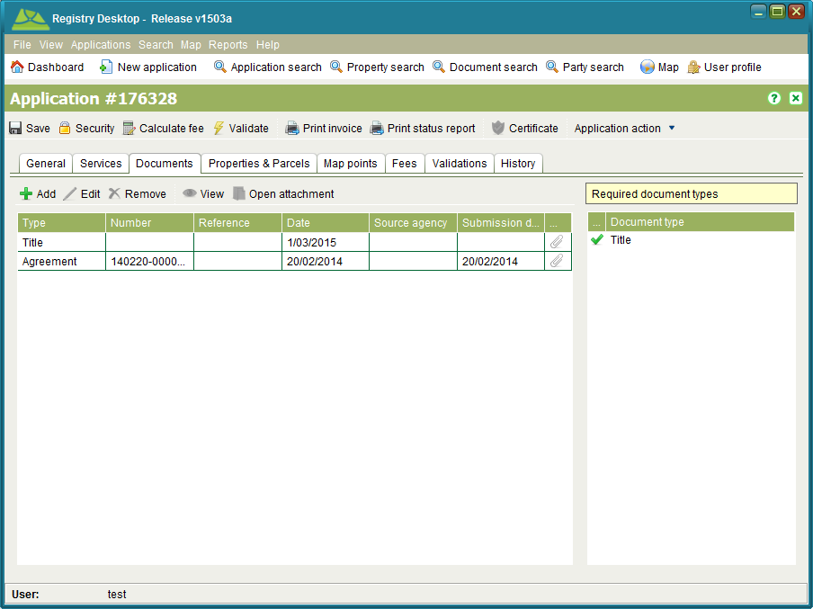

Figure 70 - Application Details Documents tab

The summary details that can be captured for the document are

|  |  |
| --- | --- |
| * Type | The type of document to search. The document types available for Registry are discussed in the Document types section of this guide. |
| * Date | The date printed or written on the face of the document. This date can be searched if it was recorded when capturing the document details. If the document was not dated, then enter today’s date. |
| * Reference | If the document is a legal or a government document, it may already have an identifying reference number printed or written on the face of it. This reference number should be entered here. If there is not identifying number on the document, this field can remain blank. |
| * Source Agency | The source of the document, e.g. the name of the firm or bank that created the document. This search field supports partial and full matching. |
| * Attachment | The name of the file that contains the image of the document. Use the button “...” button to attach the file. |
| * Description | A description given to the document to provide a summary of its content. |

**Steps**

1. From the Documents tab on Application Details, click Add to open the C:\Work\SOLAHelp\images\icons\add.png Add Document dialog and select the New document tab if it is not already selected.
2. Select the document type and enter a document date
3. If an attachment is available or the file to attach has previously been uploaded into SOLA, click the “...” button in the Attachment field and locate the file on your local disk or the shared remote disk location.
4. Once all of the document details are correct and the appropriate file is attached, click the add Add button to add the document to the application. You should see a new document added to the application, but the Add Document dialog will not close. This allows you to enter multiple documents at the same time. If you have completed entering all documents for the application, close the Add Document dialog.
5. save Save the application to ensure the new document is created as well as any file attachment.

**Notes**

* The Required Document Types list box shows the document types that must be included with the application. Be sure to add all required documents otherwise it will not be possible to approve the application.
* If you attach the wrong file as an attachment, use the remove icon C:\Work\source\Help Images\icons\delete_icon.gif in the Attachment field to remove the file (if prior to Add) or C:\Work\source\Help Images\icons\remove.png Remove the document record from the Documents list and re-add it.
* You can also search for an existing document to add to the job by using the Document search tab in the Add Document dialog
* It is not possible to update the file attachment for Power of Attorney and Standard Documents. Ensure you link these documents with the appropriate attachments when the documents are added to the application.

### Also See

* Registry Concepts
  + Documents
* Registry Desktop Screens
  + Application Details
  + Document Details
* General How To
  + Lodge a new Application
  + Edit an Application
* Documents How To
  + Attach a File to a New Document
  + Add or Update a File Attachment on an Existing Document

## Attach a File to a New Document

To attach a file to a new document, click the “...” button in the Attachment text field. The File Attachment dialog will display and you will be able to use it to select a file from your local computer file system or the remote file location configured for Registry.

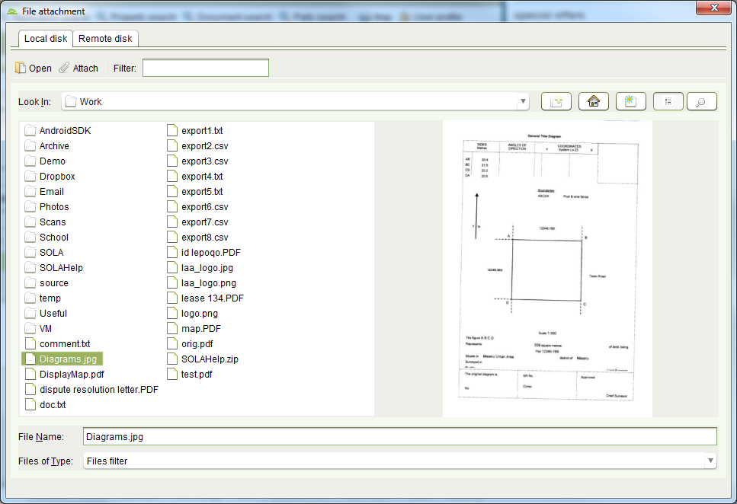

Figure 71 - File Attachment Local disk tab

The File Attachment dialog will show a thumbnail preview for standard image formats (png, tiff, jpg) as well as PDF files. If your folder has a large number of documents, type the name of the file you want in the Filter text box to restrict which files are shown. If you need to view the content of a file, select the file and click folder-open-document Open.

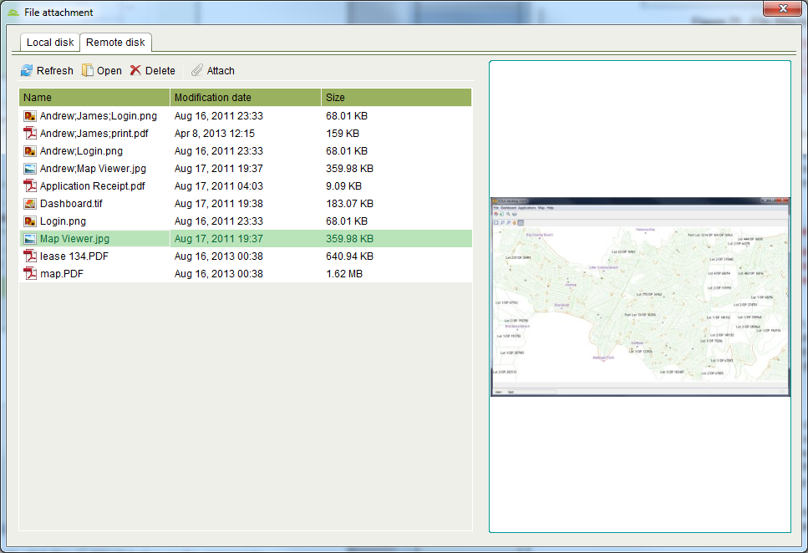

Figure 72 - File Attachment Remote disk tab

The Remote disk view displays files that have been placed in a specific network file system location e.g. the output folder configured for a network attached scanner. This tab also supports thumbnail previews for standard image formats (png, tiff, jpg) and PDF files. You can folder-open-document Open or cadastre-redefinition-reset Delete files from the remote file location if required.

Once you have chosen the document to attach, click the C:\Work\source\Help Images\icons\paper-clip.png Attach button on the appropriate tab of the File Attachment dialog. This will return you to the Documents tab (or screen) and the filename of the attachment will be display in the Attachment text field along with a remove icon C:\Work\source\Help Images\icons\delete_icon.gif. If you select the wrong file as the attachment, you can click the remove icon to remove the file attachment.

**Notes**

* The maximum size of a file that can be attached into SOLA is 100Mb. Files larger than this should be resized or split and added as 2 or more documents.
* If you successfully attach a file from the Remote disk, the file will be automatically deleted from the remote file location.
* The File Attachment dialog can be resized to enlarge the document preview if required.

### Also See

* Registry Concepts
  + Documents
* Registry Desktop Screens
  + Application Details
  + Document Search
  + Document Details
* Documents How To
  + Add a Document to an Application
  + Add or Update a File Attachment on an Existing Document

## Add or Update a File Attachment on an Existing Document

Registry allows you to create a new document without adding an attachment. If you need to add or update an attachment for an existing document, you can pencil Edit the document from the Application Details Documents tab or you can search for the document using Document Search and edit it from there.

**Steps**

1. Locate the document to edit on the Documents tab of Application Details or by searching for the document using the Document Search screen.
2. Select the document to update in the results list and click the pencil Edit tool to open the Document Details screen

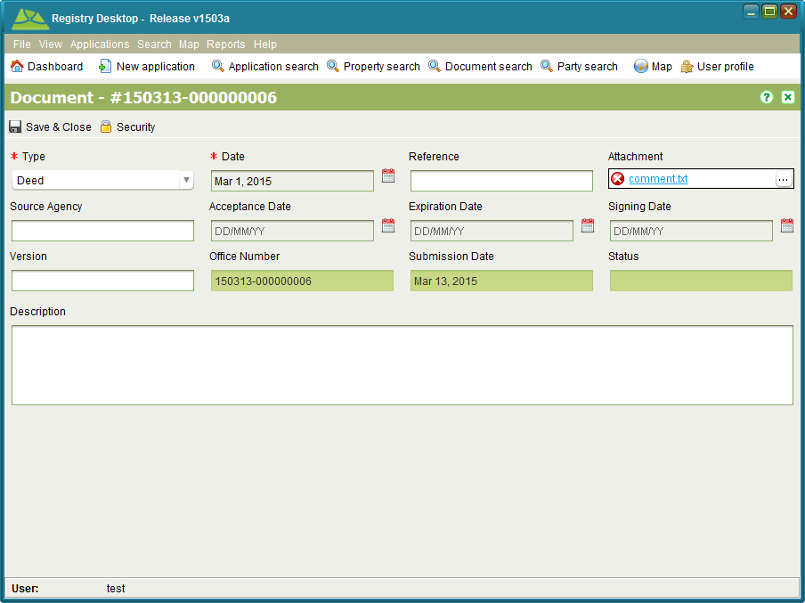

Figure 73 - Document Details

1. Edit the document information and/or change the file attachment as required
2. Click C:\Work\source\Help Images\icons\save.png Save & Close to save the changes.
3. If the document was opened from Application Details, click C:\Work\source\Help Images\icons\save.png Save on Application Details to ensure the changes are saved.

**Notes**

* It is not possible to update the file attachment for Power of Attorney and Standard Documents. Ensure you link these documents with the appropriate attachments when the documents are added to the application.

### Also See

* Registry Concepts
  + Documents
* Registry Desktop Screens
  + Application Details
  + Document Search
  + Document Details
* Documents How To
  + Add a Document to an Application
  + Attach a File to a New Document

## Link to Power of Attorney and Standard Documents

Registry allows registered Power of Attorney and Standard Documents to be linked into new applications.

**Steps**

1. When creating a new application that must reference a Power of Attorney or Standard Document, use the Documents tab to enter details appropriate for the POA or Standard Document
2. Use the Document search tab or the Power of attorney search tab on the Add Document dialog to search for and locate the POA or Standard Document and attach this to your new application
3. Continue with application lodgement as per normal.

**Notes**

* The Document search will only show registered Power of Attorney and Standard Documents. It is not possible to link to documents that are not registered or have been revoked.

### Also See

* Registry Concepts
  + Documents
* Registry Desktop Screens
  + Application Details
  + Document Search
  + Document Details
  + Document Registration
* Documents How To
  + Register Power of Attorney
  + Withdraw Standard Document

## Register Power of Attorney

This service is used to register a Power of Attorney that authorises a person (attorney) to act on behalf of another (grantor) in private affairs, business or some other legal matter. Once registered, the Power of Attorney can be associated to any application to support property transactions made under the Power of Attorney.

### Lodge an Application

**Steps**

1. From the Dashboard select the C:\Work\source\Help Images\icons\new.png New application tool to open the Application Details screen.
2. On the General tab, enter the contact details for the person making the request and select the agent from the Agent drop down if appropriate.
3. On the Services tab, add the Registration of Power of Attorney service to the application.
4. This service does not directly reference a property so no property information is required on the Property tab.
5. On the Documents tab, record each of the physical documents provided by the person registering the POA. At a minimum the Registration of Power of Attorney service requires a Power of Attorney document.
   1. Ensure you select the appropriate document type and record the document date (i.e. the date recorded on the face of the physical document) or today’ s date if the physical document is not dated.
   2. Enter a reference number for the document and a description. The reference number should be taken from the physical document. If the physical document does not have any reference number, then enter the application number, period and document sequence number (e.g. 120001.03).
   3. The Source Agency is the name of the organization that created the physical document. E.g. For the POA, this may be the name of the grantor. This field is optional and can be left blank.
6. No Map points are required.
7. Click the C:\Work\source\Help Images\icons\save.png Save button. This will lodge the application and produce the lodgement notice. Print the notice and give it to the person as proof the application has been lodged. The lodgement notice will indicate the fee to be paid for the application.

### Fee Payment

Once the lodgement notice is printed, the person will need to take the notice to the cashier and arrange payment. When payment has been made, the cashier will locate the Unassigned application list on the Registry Dashboard, C:\Work\source\Help Images\icons\folder-open-document.png Open the application and check the Fee Paid flag on the Fees tab to indicate the application can continue processing.

### Assign the Application

**Steps**

1. From the Registry Dashboard, check the Unassigned applications list to confirm the fee for the application has been paid. If the fee has not been paid it will not be possible to assign the application. In this situation notify the person noted as the contact and/or cashier to confirm the payment status for the application.
2. If the application fee has been paid, select the application in the Unassigned applications list and click the C:\Work\source\Help Images\icons\assign.png Assign tool. This will open the Application Assignment screen.
3. Click the Assign button to assign the application. When the Assign action is complete, you will be returned to the Dashboard and the assigned application will appear in your Assigned applications list.

### Register the Power of Attorney

You use the Document Registration screen to register the POA.

**Steps**

1. From the Dashboard, folder-open-document Open the application with the Registration of Power of Attorney service from your Assigned applications list.
2. On the Services tab, select the Registration of Power of Attorney service and click the C:\Work\source\Help Images\icons\start.png Start tool. This will open the Document Registration screen.
3. Select the POA document from the list of Application documents and click C:\Work\source\Help Images\icons\add.png Add to registration.
4. Enter the Attorney name and the Person name (i.e. grantor) in the the Power of Attorney Details dialog.
5. Once complete, close the Document Registration screen and on the Services tab of Application Details, select the Registration of Power of Attorney service and click C:\Work\source\Help Images\icons\confirm.pngComplete. This will run the Registry business rules to validate the application data. If there is a critical failure, you must remedy the failure as it will not be possible to approve the application otherwise

### Complete the Application

**Steps**

1. From the Dashboard, folder-open-document Open the application with the Registration of Power of Attorney service from your Assigned applications list (if not already opened).
2. Use the C:\Work\source\Help Images\icons\validation.png Validate tool to check the status of the application data. If there are any rule failures, review the application data and correct the issues as appropriate before proceeding to approve the application.
3. Use the C:\Work\source\Help Images\icons\approve.png Approve action in the Application action dropdown to approve the application.
4. Manually prepare a notification to confirm the POA has been registered and send/deliver this to the contact person. You can record that when the notification has been sent by using the C:\Work\source\Help Images\icons\envelope.png Dispatch action of the Application action dropdown.
5. Use the C:\Work\source\Help Images\icons\archive.png Archive action to complete the Application.

### Also See

* Registry Concepts
  + Documents
* Registry Desktop Screens
  + Application Details
  + Document Details
  + Document Registration
* Documents How To
  + Link to Power of Attorney and Standard Documents
  + Cancel Power of Attorney
  + Register Standard Document
  + Withdraw Standard Document

## Cancel Power of Attorney

This service is used to revoke a Power of Attorney. The Power of Attorney will remain linked to any applications or property transactions it was associated with prior to being revoked but it will not be possible to use the Power of Attorney on any new applications.

### Lodge an Application

**Steps**

1. From the Dashboard select the C:\Work\source\Help Images\icons\new.png New application tool to open the Application Details screen.
2. On the General tab, enter the contact details for the person making the request and select the agent from the Agent drop down if appropriate.
3. On the Services tab, add the Cancel Power of Attorney service to the application.
4. This service does not directly reference a property so no property information is required on the Property tab.
5. On the Documents tab, record each of the physical documents provided by the person cancelling the POA. At a minimum the Cancel Power of Attorney service requires a Deed document.
   1. Ensure you select the appropriate document type and record the document date (i.e. the date recorded on the face of the physical document) or today’ s date if the physical document is not dated.
   2. Enter a reference number for the document and a description. The reference number should be taken from the physical document. If the physical document does not have any reference number, then enter the application number, period and document sequence number (e.g. 120001.03).
   3. The Source Agency is the name of the organization that created the physical document.
6. No Map points are required.
7. Click the C:\Work\source\Help Images\icons\save.png Save button. This will lodge the application and produce the lodgement notice. Print the notice and give it to the person as proof the application has been lodged. The lodgement notice will indicate the fee to be paid for the application.

### Fee Payment

Once the lodgement notice is printed, the person will need to take the notice to the cashier and arrange payment. When payment has been made, the cashier will locate the Unassigned application list on the Registry Dashboard, C:\Work\source\Help Images\icons\folder-open-document.png Open the application and check the Fee Paid flag on the Fees tab to indicate the application can continue processing.

### Assign the Application

**Steps**

1. From the Registry Dashboard, check the Unassigned applications list to confirm the fee for the application has been paid. If the fee has not been paid it will not be possible to assign the application. In this situation notify the person noted as the contact and/or cashier to confirm the payment status for the application.
2. If the application fee has been paid, select the application in the Unassigned applications list and click the C:\Work\source\Help Images\icons\assign.png Assign tool. This will open the Application Assignment screen.
3. Click the Assign button to assign the application. When the Assign action is complete, you will be returned to the Dashboard and the assigned application will appear in your Assigned applications list.

### Revoke the Power of Attorney

As with registering the POA, you use the Document Registration screen to revoke the POA.

**Steps**

1. From the Dashboard, folder-open-document Open the application with the Cancel Power of Attorney service from your Assigned applications list.
2. On the Services tab, select the Cancel Power of Attorney service and click the C:\Work\source\Help Images\icons\start.png Start tool. This will open the Document Registration screen.
3. Use the Power of Attorney search to locate the POA to be revoked, select it from the search results list and click C:\Work\source\Help Images\icons\add.png Add to registration.
4. Once complete, close the Document Registration screen and on the Services tab of Application Details, select the Cancel Power of Attorney service and click C:\Work\source\Help Images\icons\confirm.pngComplete. This will run the SOLA business rules to validate the application data. If there is a critical failure, you must remedy the failure as it will not be possible to approve the application otherwise.

### Complete the Application

**Steps**

1. From the Dashboard, folder-open-document Open the application with the Cancel Power of Attorney service from your Assigned applications list (if not already opened).
2. Use the C:\Work\source\Help Images\icons\validation.png Validate tool to check the status of the application data. If there are any rule failures, review the application data and correct the issues as appropriate before proceeding to approve the application.
3. Use the C:\Work\source\Help Images\icons\approve.png Approve action in the Application action dropdown to approve the application.
4. Manually prepare a notification to confirm the POA has been revoked and send/deliver this to the contact person. You can record when the notification has been sent by using the C:\Work\source\Help Images\icons\envelope.png Dispatch action of the Application action dropdown.
5. Use the C:\Work\source\Help Images\icons\archive.png Archive action to complete the Application.

**Notes**

* Revoking the Power of Attorney will not delete it from Registry, but it will prevent the POA being used on any future application.

### Also See

* Registry Concepts
  + Documents
* Registry Desktop Screens
  + Application Details
  + Document Details
  + Document Registration
* Documents How To
  + Link to Power of Attorney and Standard Documents
  + Register Power of Attorney
  + Register Standard Document
  + Withdraw Standard Document

## Register Standard Documents

This service can be used to register documents that provide standard memorandum (i.e. terms and conditions) used by banks for mortgages and leases. These standard documents can be linked directly to new applications avoiding duplication and unnecessary scanning.

The process for registering a Standard Document is very similar to that for recording a Power of Attorney. Refer to the steps described in the Register Power of Attorney section for guidance. Note that the document type to create on the application is Standard Document.

### Also See

* Registry Concepts
  + Documents
* Registry Desktop Screens
  + Application Details
  + Document Details
  + Document Registration
* Documents How To
  + Link to Power of Attorney and Standard Documents
  + Register Power of Attorney
  + Cancel Power of Attorney
  + Withdraw Standard Document

## Withdraw Standard Document

This service can be used to revoke the registration of a Standard Document. As with the Cancel Power of Attorney service, the cancelled memorandum will remain linked to any applications or property transactions it was associated with prior to being revoked but it will not be possible to us the memorandum on any new applications.

The process for withdrawing a Standard Document is very similar to that for cancelling a Power of Attorney. Refer to the steps described in the Cancel Power of Attorney section for guidance. Note that you will need to use the standard Document search on the Document Registration screen to locate the Standard Document to revoke.

### Also See

* Registry Concepts
  + Documents
* Registry Desktop Screens
  + Application Details
  + Document Details
  + Document Registration
* Documents How To
  + Link to Power of Attorney and Standard Documents
  + Register Power of Attorney
  + Cancel Power of Attorney
  + Register Standard Document

# Land Registration How To

## Lodge and Process a Land Registration Application

The following provides detailed steps on how to lodge and process a land registration application. For information on how to process Land Registration services, refer to the appropriate Land Registration How To section.

### Lodge an Application

The first step when making changes to the land registry is to create an application with the appropriate service or services. Where those services are likely to require payment, lodging the application should be done while the agent or applicant is in attendance so that you can provide them with the lodgement notice detailing the fees payable.

**Steps**

1. From the Dashboard select the C:\Work\source\Help Images\icons\new.png New application tool to open the Application Details screen.
2. On the General tab, enter the contact details for the person making the request and select the agent from the Agent drop down if appropriate.
3. On the Services tab, select one or more land registration services depending on the changes you need to make to the land registry. If you select more than one service, you should order the services in a logical sequence. E.g. for a discharge, transfer and mortgage, the Remove Restriction (General) service should be at the top, followed by the Change of Ownership service with the Register Mortgage service at the bottom.
4. On the Property tab, enter the title reference for the property that is being changed and add them to the application using the Add property button. In the case of a new plan, you should add the title references for the properties being subdivided or amalgamated (i.e. the properties that will be extinguished) by the plan.
5. You should verify each property using the C:\Work\SOLAHelp\images\icons\document-task.png Verify tool to confirm Registry contains the appropriate details for the property. If the Title Exists checkbox is not checked, this may indicate the title reference is invalid or the title has yet to be converted from paper format. Use the Property Search screen and/or Map Find to attempt to locate the property record.
6. On the Documents tab, record each of the physical documents provided by the applicant. The documents required are dependent on the service(s) selected. When capturing document information
   1. Ensure you select the appropriate document type and record the document date (i.e. the date recorded on the face of the physical document) or today’ s date if the physical document is not dated.
   2. Enter a reference number for the document and a description. The reference number should be taken from the physical document. If the physical document does not have any reference number, then enter the application number, period and document sequence number (e.g. 120001.03).
   3. The Source Agency is the name of the organization that created the physical document. For example, this could be the bank for mortgage documents, or the agents firm details for agreements and other document types. This field is optional and can be left blank.
   4. If you have scanned the document, use the Attachment field to link in the scanned image. If you have not yet scanned the document, you will need to do this at a later stage and link it into the document using the Edit Document functionality available from Document Search.
7. You should also attach a Proof of Identity document for the agent/applicant to the application. This could be a passport style photo the copy of a birth certificate. This can be linked directly to the property changes made for the application and used to help confirm the validity of future property transactions.
8. Map points are optional for Land Registration applications. You can add one by navigating the map to the location of the property and using the Add Application Point tool C:\Work\source\Help Images\icons\application-location-add.png. If you are not sure of the location of the property and cannot locate it using the Map Find, then **do not** add an Application point.
9. Click the C:\Work\source\Help Images\icons\save.png Save button. This will lodge the application and produce the lodgement notice. Print the notice and give it to the agent as proof the application has been lodged. The lodgement notice will indicate the fee to be paid for the application.

### Fee Payment

Once the lodgement notice is printed, the applicant will need to take the notice to the cashier and arrange payment. When payment has been made, the cashier will C:\Work\source\Help Images\icons\folder-open-document.png Open the application from the Unassigned application list on the Registry Dashboard and check the Fee Paid flag on the Fees tab to indicate the application can continue processing.

### Assign the Application

Assign the application to yourself to being work. Note that a team leader may assign the application to you directly.

**Steps**

1. From the Registry Dashboard, check the Unassigned applications list to confirm the fee for the application has been paid. If the fee has not been paid it will not be possible to assign the application. In this situation notify the contact person and/or cashier to confirm the payment status for the application.
2. If the application fee has been paid, select the application in the Unassigned applications list and click the C:\Work\source\Help Images\icons\assign.png Assign tool. This will open the Application Assignment screen.
3. Click the Assign button to assign the application. When the Assign action is complete, you will be returned to the Dashboard and the assigned application will appear in your Assigned applications list.

### Start and Complete Services

The next step is to work through each service of the application and complete them.

**Steps**

1. From the Dashboard, folder-open-document Open the application you are going to work on from your Assigned applications list.
2. On the Services tab, select a service that is not complete and click the C:\Work\source\Help Images\icons\start.png Start tool. Most land registration services use the Property Details screen to record changes to property information. This screen only displays information for one property at a time. If the application has more than one property linked to it, the Select Property screen will display so that you can select the appropriate property to update. Simply double click to select the property to work on.

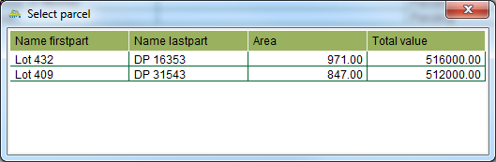

Figure 74 - Select Property

1. Update the property information as required and C:\Work\source\Help Images\icons\save.png Save your changes on the Property Details screen.
2. If Proof of Identity has been provided for the application, link the Proof of Identity document to the right(s) or restriction(s) created or modified. Make sure you C:\Work\source\Help Images\icons\save.png Save changes on the Property Details screen.
3. Once all changes are complete, close the Property Details screen and C:\Work\source\Help Images\icons\confirm.png Complete the service from the Services tab of Application Details. This will run the Registry business rules to validate the application data. If there is a critical failure, you must remedy the failure as it will not be possible to approve the application otherwise.

**Notes**

* If you complete a service then realize further changes are required, use the C:\Work\source\Help Images\icons\revert.png Revert tool. This will revert the service to a pending status and allow you to make further edits.

### Approve / Register the Application

Changes made to the property such as the addition or removal of rights remain pending until the application is approved. You can approve the application by completing all services on the application and approving the application using the C:\Work\source\Help Images\icons\approve.png Approve tool in the Application Details toolbar.

**Steps**

1. From the Dashboard, folder-open-document Open the land registration application to approve.
2. Use the C:\Work\source\Help Images\icons\validation.png Validate tool to check the status of the application data. If there are any rule failures, review the application data and correct the issues as appropriate before proceeding to approve the application.
3. Use the C:\Work\source\Help Images\icons\approve.png Approve action in the Application action dropdown to approve the application.
4. If the application is successfully approved, use the Property Search to open and print the Property Report for each property affected by the application.
5. Optionally stamp the printed report with the Registrar of Lands seal and send / deliver the certificates to the applicant. You can also record when the reports are sent by using the C:\Work\source\Help Images\icons\envelope.png Dispatch action of the Application action dropdown.
6. Use the C:\Work\source\Help Images\icons\archive.png Archive action to complete the Application.

### Also See

* Registry Concepts
  + Application Lifecycle
  + Services
  + Service Lifecycle
  + Rights Restrictions and Responsibilities
  + Documents
  + Business Rules
* Registry Desktop Screens
  + Application Details
  + Property Details
  + Simple RRR
  + Rightholder RRR
  + Ownership RRR
  + Lease RRR
  + Mortgage RRR
  + Document Details
  + Party Details
* General How To
  + Lodge a new Application
  + Edit an Application
  + Assign an Application
  + Un-assign and Application
  + Calculate Fees
  + Verify Property Details
  + Cancel, Withdraw or Lapse an Application
  + Add location for Application
* Documents How To
  + Add a Document to an Application
  + Attach a File to a New Document
  + Add or Update a File Attachment on an Existing Document
* Land Registration How To
  + Record and Change Ownership
  + Change the Type of Estate
  + Cancel Titles and Create New Titles
  + Register, Vary and Discharge Mortgage
  + Register, Vary and Terminate Lease
  + Register, Vary and Withdraw Caveat
  + Register, Vary and Cancel Easements
  + Register or Vary General Rights and Restrictions
  + Cancel a Right or Restriction
  + Convert a Paper Title
  + Use the Add Parent Property Wizard
* Appendix
  + Registry Business Rules

## Record and Change Ownership

Ownership details are linked to the primary right for the property and each property should only have one active primary right. The primary rights supported by SOLA are Apartment, Ownership, and State Ownership. These rights represent the estate type for the property.

### Record Ownership

To create a primary right and record ownership details on a new property you can use the New Freehold Title or Convert to Digital Title services.

There may also be situations where the property information migrated into SOLA does not include ownership details. In this case you can add ownership details to an existing property using the Registration on Title or New Apartment Title services.

**Steps**

1. C:\Work\source\Help Images\icons\start.png Start a service that supports creating a new primary right on the property. The Property Details screen will open.
2. On the Rights / Restrictions tab, the select the type of primary right to create (one of Freehold, Leasehold, Government or Customary) and click the C:\Work\source\Help Images\icons\create.png Create tool to create a pending primary right and open the Ownership screen.
3. Update the Notation text and add references to documents that confirm the ownership details.
4. Ownership rights consist of one or more shares which are expressed as fractions. The fractions from all current shares on the property must sum to 1. To enter a new share for the property, click C:\Work\source\Help Images\icons\add.png Add in the Shares section.
5. A share may be allocated to one or more parties. A party can be an individual or an entity. Shares that are allocated to more than one individual or more than one entity are considered undivided (a.k.a. joint tenants). This means Registry does not record the exact share for each party simply that multiple parties participate in the same share.
6. To add parties to the share, click C:\Work\source\Help Images\icons\add.png Add. This will open the Party Details screen allowing you to enter in details for an individual or an entity. Once the necessary party details have been entered, click C:\Work\source\Help Images\icons\save.png Save & Close.
7. Once all parties have been added to the share, click C:\Work\source\Help Images\icons\save.png Save & Close on the Share Details screen and once all shares have been added to the primary right, click C:\Work\source\Help Images\icons\save.pngSave and Close on the Ownership screen. The Property Details screen will then show a new pending Ownership right.

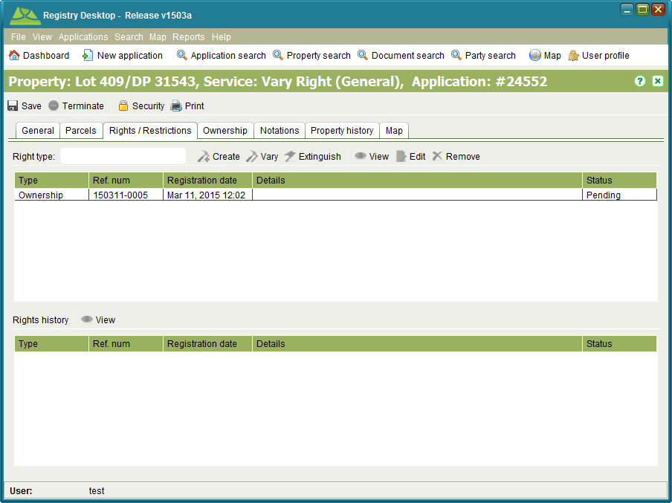

Figure 75 - Pending Ownership Right

1. If you need to make further changes to the ownership information, select the pending primary right in the Rights / Restrictions tab and click the C:\Work\source\Help Images\icons\document--pencil.png Edit tool.
2. If you need to remove the pending ownership details completely, use the C:\Work\source\Help Images\icons\remove.png Remove tool on the Rights / Restrictions tab.
3. C:\Work\source\Help Images\icons\save.png Save changes to Property Details and continue processing the service and application as required.

### Change Ownership (a.k.a. Transfer)

The Change of Ownership and Vary Right (General) services can be used to transfer a property to new owners.

The Change of Ownership and Vary Right (General) services do not allow you to create a primary right on the property. If the property being transferred does not have a primary right, you may need to use the Registration on Title or New Apartment Title services to create the primary right with the new ownership details.

**Steps**

1. start Start the Change of Ownership or Vary Right (General) service. The Property Details screen will open.
2. On the Rights / Restrictions tab, select the primary right. If the primary right is current, the C:\Work\source\Help Images\icons\vary.png Vary tool will enable. Click C:\Work\source\Help Images\icons\vary.png Vary to open the Ownership screen.
3. Update the ownership, share and party details as appropriate and set the Notation text.
4. Click C:\Work\source\Help Images\icons\save.png Create & Save and close the Ownership screen.
5. Varying a right creates a new pending version of that right. If you need to make further changes to the ownership information, select the pending primary right in the Rights / Restrictions tab and click the C:\Work\source\Help Images\icons\document--pencil.png Edit tool.
6. If you need to remove the pending ownership details completely, use the C:\Work\source\Help Images\icons\remove.png Remove tool on the Rights / Restrictions tab.
7. C:\Work\source\Help Images\icons\save.png Save changes to Property Details and C:\Work\source\Help Images\icons\confirm.pngComplete the service.

### Also See

* Registry Concepts
  + Rights Restrictions and Responsibilities
* Registry Desktop Screens
  + Application Details
  + Property Details
  + Ownership RRR
  + Document Details
  + Party Details

## Change the Type of Estate

The estate type for the property is determined by its primary right and can be Apartment, Ownership or State Ownership. The Registration on Title service can be used to change the primary right of a property. For example, changing the title from Ownership (Freehold) to State Ownership.

There may also be situations where the property information migrated into SOLA does not include ownership details. In this case you can add ownership details to an existing property using the Registration on Title service.

The Registration on Title service will not allow you to cancel the existing primary right on the property. If you must change the primary right for a property you will also need to use the Remove Right (General) service to cancel the existing primary right.

Note that changing the estate type of a property is only required when the property must maintain its existing title reference. Where new parcels have been created as a result of a survey or complied plan, then the existing property record should be cancelled (Cancel Title service) and new titles created (New Freehold Title service).

**Steps**

1. Check the property to determine if it has an existing primary right that must be cancelled. If so, ensure the Remove Right (General) service is added to the application.
2. start Start the Registration on Title service. The Property Details screen will open.
3. From the Right type dropdown, select the new primary right for the property and click the C:\Work\source\Help Images\icons\create.png Create tool to create a new pending primary right and open the Ownership screen.
4. Fill in the ownership, share and party details as appropriate and set the Notation text.
5. Click C:\Work\source\Help Images\icons\save.png Create & Save and close the Ownership screen.
6. If you need to make further changes to the ownership information, select the appropriate pending primary right in the Rights / Restrictions tab and click the C:\Work\source\Help Images\icons\document--pencil.png Edit tool.
7. If you need to remove the pending ownership details completely, use the C:\Work\source\Help Images\icons\remove.png Remove tool on the Rights / Restrictions tab.
8. C:\Work\source\Help Images\icons\save.png Save changes to Property Details and C:\Work\source\Help Images\icons\confirm.pngComplete the service.

### Also See

* Registry Concepts
  + Rights Restrictions and Responsibilities
* Registry Desktop Screens
  + Application Details
  + Property Details
  + Ownership RRR
  + Document Details
  + Party Details

## Cancel Titles and Create New Titles

The New Freehold Title service can be used to create new titles over new parcels created as a result of plan subdivision (e.g. Change to Cadastre) or similar actions. The Cancel Title service can be used to cancel a title by changing the status of a property to Historic. The Cancel Title and New Freehold Title services usually go together as it is often necessary to cancel a title so that one or more new titles can be created in its place. Note that the Cancel Title and New Freehold Title services can be used independently although Cancel Title should be used with caution if there is no new title to replace the one being cancelled.

The trigger for creating new titles will usually be the approval of an application with a Change to Cadastre service. As part of the plan approval, the Survey staff member will create a new application with a Cancel Title service and the appropriate number of New Freehold Title services (one for each new parcel that requires a title). Survey will also link the plan image to the new application so that Land Registration can determine the parcels to reference when creating the new titles.

### Verify Application

Before processing the application to create new titles, you should check that it contains the appropriate number of services by referring to the details of the plan.

**Steps**

1. Verify that the application has a Cadastral Survey document with the image of the approved plan associated to it.
2. Review the plan image and confirm that the application has a Cancel Title service if the plan extinguishes any parcels due to subdivision or amalgamation. Note that only one Cancel Title service is required even if there are multiple titles to cancel.
3. Check that all of the titles for the underlying parcels on the plan (i.e. the parcels being subdivided or amalgamated) have been added on the Property tab of the application. The Cancel Title service will only allow cancellation of those properties listed in the Property tab.
4. Check that the application has a New Freehold Title service for each new parcel that requires a title. For example, if there are 5 new parcels requiring titles, then ensure there are 5 New Freehold Title services on the application. A New Freehold Title service can only be used to create one title.
5. If there are any issues with the application, add or remove services as necessary and/or consult with the Survey staff member that created the application.

### Cancel Titles

Use the Cancel Title service to cancel the titles for the extinguished parcels. Note that if there are no titles to cancel, this step can be skipped.

**Steps**

1. C:\Work\source\Help Images\icons\start.png Start the Cancel Title service. If there is more than one property listed on the Property tab, you will be prompted to select one to cancel. Make your selection.
2. The Property Details screen will open. Click the C:\Work\source\Help Images\icons\stop.png Terminate tool to cancel the title and C:\Work\source\Help Images\icons\save.png Save changes. Note that the title is **not** cancelled immediately. It will remain live until the application is approved.
3. Close the Property Details screen and repeat steps 1 and 2 for all properties listed on the Application Details Property tab.
4. When all properties have been cancelled, C:\Work\source\Help Images\icons\confirm.png Complete the Cancel Title service.

**Notes**

* You can reverse the cancellation at any time prior to the approval of the application by starting the Cancel Title service and selecting a property you have previously cancelled. This will open the Property Details screen as before, except you will be presented with a C:\Work\source\Help Images\icons\undo.png Cancel termination tool instead of the C:\Work\source\Help Images\icons\stop.png Terminate tool. Click C:\Work\source\Help Images\icons\undo.png Cancel termination to reverse the cancellation.

### Create New Titles

1. Choose a parcel from the plan that you will create a new title for and take note of its appellation (i.e. first part and last part).
2. start Start the first New Freehold Title service. The Property Details screen will open and you will be prompted to bring forward any rights/restrictions. Click Yes to the prompt.
3. Use the Add Parent Property Wizard to add the appropriate prior title reference for your chosen lot. Bring forward any rights or restrictions from the prior title property relevant to the new property.
4. Set the area for the property to the area of your chosen parcel as noted on the plan.
5. On the Parcels tab, click C:\Work\source\Help Images\icons\add.png Add parcel to open the Add Parcel dialog.
6. Enter the appellation of your chosen parcel into the Search parcel text field. A parcel matching the parcel appellation should display in the result list. Select the parcel from the result list and click the Select button. If a parcel matching the appellation is not displayed, check that you correctly entered the appellation and/or check with Survey to confirm a parcel for the new parcel has been created.
7. save Save changes. This will create the new property record with a pending status and assign it a title reference.
8. On the Rights / Restrictions tab add all of the rights and restrictions required for the new property.
   1. Start by creating the primary right for the property (must be one of Apartment, Ownership or State Ownership). Select the appropriate primary right type from the Right type drop down and click C:\Work\source\Help Images\icons\create.png Create.
   2. Enter the details for the primary right (e.g. owner details and share information). Ensure the Is primary right checkbox is checked and enter an appropriate Registration date and Notation text. You will also need to C:\Work\source\Help Images\icons\add.png Add a document to the primary right. Use the Cadastral Survey document.
   3. Add any other rights or restrictions (i.e. mortgages, caveats, etc.) required for the new property by selecting the appropriate type of right/restriction in the Right type drop down and clicking C:\Work\source\Help Images\icons\create.png Create.
9. C:\Work\source\Help Images\icons\save.png Save changes to Property Details and C:\Work\source\Help Images\icons\confirm.pngComplete the New Freehold Title service.
10. Repeat steps 1-9 for each New Freehold Title service on the application using a different parcel from the plan for each service. Once all services are completed, continue processing of the application.

### Also See

* Registry Desktop Screens
  + Application Details
  + Property Details
  + Simple RRR
  + Rightholder RRR
  + Ownership RRR
  + Lease RRR
  + Mortgage RRR
  + Document Details
  + Party Details
* Land Registration How To
  + Lodge and Process a Land Registration Application
  + Record and Change Ownership
  + Change the Type of Estate
  + Use the Add Parent Property Wizard
* Survey How To
  + Record a Plan

## Register, Vary and Discharge Mortgage

### Register Mortgage

You can use the Register Mortgage service to register a new Mortgage right over a property.

**Steps**

1. C:\Work\source\Help Images\icons\start.png Start the Register Mortgage service. The Property Details screen will open
2. On the Rights / Restrictions tab, the Mortgage right will be selected as the default Right type. If not, select it from the dropdown list. Click the C:\Work\source\Help Images\icons\create.png Create tool to create a pending Mortgage right and open the Mortgage screen.
3. Fill in the mortgage details and update the Notation text
   1. All fields marked with a red asterisk are mandatory. You may need to estimate some values if the information you have does not contain the specific mortgage details.
   2. Click the ... button on the Lender field to search for the appropriate financial institution. Note that this search will only search parties that have been assigned the Bank role.
   3. The Ranking field indicates the priority of the mortgage.
   4. You must include a document reference with the mortgage details. This should be the scanned mortgage document.
   5. If you are prompted that the expiration date is before the registration date, enter the expiration date with a 4 digit year.
4. Click C:\Work\source\Help Images\icons\save.png Create & Save and close the Mortgage screen.
5. If you need to make further changes to the mortgage information, select the pending Mortgage in the Rights / Restrictions tab and click the C:\Work\source\Help Images\icons\document--pencil.png Edit tool.
6. If you need to remove the pending Mortgage details completely, use the C:\Work\source\Help Images\icons\remove.png Remove tool on the Rights / Restrictions tab.
7. C:\Work\source\Help Images\icons\save.png Save changes to Property Details and C:\Work\source\Help Images\icons\confirm.pngComplete the service.

### Vary Mortgage

You can use the Vary Mortgage service to vary the details of a mortgage including the priority of mortgage (Ranking).

**Steps**

1. start Start the Vary Mortgage service. The Property Details screen will open.
2. On the Rights / Restrictions tab, select the Mortgage right you intend to change. If the Mortgage right is current, the C:\Work\source\Help Images\icons\vary.png Vary tool will enable. Click C:\Work\source\Help Images\icons\vary.png Vary to open the Mortgage screen.
3. Update the mortgage details as appropriate and set the Notation text. If the mortgage was migrated from another system, you may need to populate some of the mortgage details before you can save your changes. Note that the Ranking field indicates the Priority of Mortgage.
4. Click C:\Work\source\Help Images\icons\save.png Create & Save and close the Mortgage screen.
5. Varying a right creates a new pending version of that right. If you need to make further changes to the mortgage information, select the pending Mortgage in the Rights / Restrictions tab and click the C:\Work\source\Help Images\icons\document--pencil.png Edit tool.
6. If you need to remove the pending Mortgage details completely, use the C:\Work\source\Help Images\icons\remove.png Remove tool on the Rights / Restrictions tab.
7. C:\Work\source\Help Images\icons\save.png Save changes to Property Details and C:\Work\source\Help Images\icons\confirm.pngComplete the service.

### Discharge Mortgage

To discharge the mortgage, see the Cancel a Right or Restriction section.

### Also See

* Registry Concepts
  + Services
  + Rights Restrictions and Responsibilities
* Registry Desktop Screens
  + Property Details
  + Mortgage RRR
* Land Registration How To
  + Lodge and Process a Land Registration Application

## Register, Vary and Terminate Lease

### Register Lease

The Register Lease service allows you to register new lease agreements over a property. You can record a Lease right over a property and identify the holder of the lease.

**Steps**

1. start Start the Register Lease service. The Property Details screen will open.
2. On the Rights / Restrictions tab, the Lease right will be selected as the default Right type. Click the C:\Work\source\Help Images\icons\create.png Create tool to create a pending Lease right and open the Lease screen.
3. In the Lease screen enter the right holder details for the lease. This is the party or parties that will hold the lease.
4. Fill in the Registration date and update the Notation text.
5. Click C:\Work\source\Help Images\icons\save.png Create & Save and close the Lease screen.
6. If you need to make further changes to the lease information, select the pending Lease in the Rights / Restrictions tab and click the C:\Work\source\Help Images\icons\document--pencil.png Edit tool.
7. If you need to remove the pending Lease details completely, use the C:\Work\source\Help Images\icons\remove.png Remove tool on the Rights / Restrictions tab.
8. C:\Work\source\Help Images\icons\save.png Save changes to Property Details and C:\Work\source\Help Images\icons\confirm.pngComplete the service.

### Vary Lease

To transfer, renew or update the details of a lease, use the Vary Lease service.

**Steps**

1. start Start the Vary Lease. The Property Details screen will open.
2. On the Rights / Restrictions tab, select the Lease right you intend to change. If the Lease right is current, the C:\Work\source\Help Images\icons\vary.png Vary tool will enable. Click C:\Work\source\Help Images\icons\vary.png Vary to open the Lease screen.
3. Update the lease details as appropriate and set the Notation text. If the lease was migrated from another system, you may need to populate some of the lease details before you can save your changes.
4. Click C:\Work\source\Help Images\icons\save.png Create & Save and close the Lease screen.
5. Varying a right creates a new pending version of that right. If you need to make further changes to the lease information, select the pending Lease in the Rights / Restrictions tab and click the C:\Work\source\Help Images\icons\document--pencil.png Edit tool.
6. If you need to remove the pending Lease details completely, use the C:\Work\source\Help Images\icons\remove.png Remove tool on the Rights / Restrictions tab.
7. C:\Work\source\Help Images\icons\save.png Save changes to Property Details and C:\Work\source\Help Images\icons\confirm.pngComplete the service.

### Terminate Lease

To surrender or terminate a registered lease, see the Cancel a Right or Restriction section.

### Also See

* Registry Concepts
  + Services
  + Rights Restrictions and Responsibilities
* Registry Desktop Screens
  + Property Details
  + Lease RRR
* Land Registration How To
  + Lodge and Process a Land Registration Application

## Register, Vary and Withdraw Caveat

Caveats are used to block any changes on the property until such time as the caveat is withdrawn. This means it is not possible to register, change or cancel any rights or restrictions on the property while the caveat is in force. Registry implements this restriction using business rules that prevent services other than Vary Caveat and Withdraw Caveat from being completed while a pending or current caveat is associated with the property.

### Register Caveat

The Register Caveat service allows you to register a caveat over a property.

**Steps**

1. start Start the Register Caveat service. The Property Details screen will open.
2. On the Rights / Restrictions tab, the Caveat right will be selected as the default Right type. Click the C:\Work\source\Help Images\icons\create.png Create tool to create a pending Caveat restriction and open the Caveat screen.
3. In the Caveat screen enter the right holder details for the caveat. This is the party or parties that will hold the caveat.
4. Fill in the Registration date and update the Notation text.
5. Click C:\Work\source\Help Images\icons\save.png Create & Save and close the Caveat screen.
6. If you need to make further changes to the caveat information, select the pending Caveat in the Rights / Restrictions tab and click the C:\Work\source\Help Images\icons\document--pencil.png Edit tool.
7. If you need to remove the pending Caveat details completely, use the C:\Work\source\Help Images\icons\remove.png Remove tool on the Rights / Restrictions tab.
8. C:\Work\source\Help Images\icons\save.png Save changes to Property Details and C:\Work\source\Help Images\icons\confirm.pngComplete the service.

### Vary Caveat

If you need to change the details of a registered caveat, use the Vary Caveat service. This service must be the only service on the application otherwise the Registry business rules will prevent successful completion of the service (i.e. step 7 will fail).

**Steps**

1. start Start the Vary Caveat service. The Property Details screen will open.
2. On the Rights / Restrictions tab, select the Caveat restriction you intend to change. If the Caveat restriction is current, the C:\Work\source\Help Images\icons\vary.png Vary tool will enable. Click C:\Work\source\Help Images\icons\vary.png Vary to open the Caveat screen.
3. Update the caveat details as appropriate and set the Notation text. If the caveat was migrated from another system, you may need to populate some of the caveat details before you can save your changes.
4. Click C:\Work\source\Help Images\icons\save.png Create & Save and close the Caveat screen.
5. Varying a restriction creates a new pending version of that restriction. If you need to make further changes to the caveat information, select the pending Caveat in the Rights / Restrictions tab and click the C:\Work\source\Help Images\icons\document--pencil.png Edit tool.
6. If you need to remove the pending Caveat details completely, use the C:\Work\source\Help Images\icons\remove.png Remove tool on the Rights / Restrictions tab.
7. C:\Work\source\Help Images\icons\save.png Save changes to Property Details and C:\Work\source\Help Images\icons\confirm.pngComplete the service.

### Withdraw Caveat

To remove a caveat from a property, use the Withdraw Caveat service. This service must be the only service on the application otherwise the Registry business rules will prevent successful completion of the service (i.e. step 7 will fail).

**Steps**

1. start Start the Withdraw Caveat service. The Property Details screen will open.
2. On the Rights / Restrictions tab, select the Caveat right you intend to cancel. If the Caveat right is current and there are no pending changes for the Caveat, the C:\Work\source\Help Images\icons\flag.png Extinguish tool will enable. Click C:\Work\source\Help Images\icons\flag.png Extinguish to open the Caveat screen.
3. Update the caveat details as appropriate and set the Notation text.
4. Click C:\Work\source\Help Images\icons\save.png Create & Save and close the Caveat screen.
5. Cancelling a restriction creates a new pending version of that restriction. If you need to make further changes to the caveat information, select the pending Caveat in the Rights / Restrictions tab and click the C:\Work\source\Help Images\icons\document--pencil.png Edit tool.
6. If you need to reverse the cancellation, use the C:\Work\source\Help Images\icons\remove.png Remove tool on the Rights / Restrictions tab or remove the pending restriction.
7. C:\Work\source\Help Images\icons\save.png Save changes to Property Details and C:\Work\source\Help Images\icons\confirm.pngComplete the service.

### Also See

* Registry Concepts
  + Services
  + Rights Restrictions and Responsibilities
* Registry Desktop Screens
  + Property Details
  + Rightholder RRR
* Land Registration How To
  + Lodge and Process a Land Registration Application

## Register, Vary and Cancel Easements

An easement is a right to use the property of another without possessing it. A good example is a right of way where access to a property may be granted across the property of another.

Easements over property can be in favor of one or more named right holders, but are more commonly in favor of another property (e.g. Right of Way). Registry provides the Servitude right to support the recording easements over the property subject to the easement.

### Register Easement

The Register Servitude service allows you to register an easement over a property (Servient Estate).

**Steps**

1. Before starting the service, verify the appropriate properties are recorded on the Property tab of the Application Details screen. All properties subject to the easement (i.e. Servient Estate) must be recorded.
2. start Start the Register Servitude service. Select a property from the Select Property dialog. The Property Details screen will open.
3. On the Rights / Restrictions tab, select the Servitude right and click the C:\Work\source\Help Images\icons\create.png Create tool to create a pending Servitude right and open the Servitude screen.
4. In the Servitude screen fill in the Registration date, add a document that describes the easement and update the Notation text to indicate what the easement is and the property, properties or right holder(s) it is in favour of.
5. Click C:\Work\source\Help Images\icons\save.png Create & Save and close the Servitude screen.
6. If you need to make further changes to the easement information, select the pending Servitude right in the Rights / Restrictions tab and click the C:\Work\source\Help Images\icons\document--pencil.png Edit tool.
7. If you need to remove the pending Servitude details completely, use the C:\Work\source\Help Images\icons\remove.png Remove tool on the Rights / Restrictions tab.
8. C:\Work\source\Help Images\icons\save.png Save changes to Property Details.
9. Repeat steps 2 to 8 for any other properties that are servient to the easement.
10. Once all properties affected by the easement have been updated, C:\Work\source\Help Images\icons\confirm.pngComplete the service.

### Vary Easement

If you need to change the details of a registered easement, use the Vary Right (General) service. This service allows you to change the details for any right or restriction.

**Steps**

1. Before starting the service, verify the appropriate properties are recorded on the Property tab of the Application Details screen. Depending on the change required, this could be all of properties associated with the easement or just some of them.
2. start Start the Vary Right (General) service. Select a property from the Select Property dialog if required. The Property Details screen will open.
3. On the Rights / Restrictions tab, select the Servitude right you intend to change. If the Servitude right is current, the C:\Work\source\Help Images\icons\vary.png Vary tool will enable. Click C:\Work\source\Help Images\icons\vary.png Vary to open the Servitude screen.
4. Update the servitude details as appropriate and set the Notation text. If the servitude was migrated from another system, you may need to populate some of the servitude details before you can save your changes.
5. Click C:\Work\source\Help Images\icons\save.png Create & Save and close the Servitude screen.
6. Varying a right creates a new pending version of that right. If you need to make further changes to the easement information, select the pending easement in the Rights / Restrictions tab and click the C:\Work\source\Help Images\icons\document--pencil.png Edit tool.
7. If you need to remove the pending easement details completely, use the C:\Work\source\Help Images\icons\remove.png Remove tool on the Rights / Restrictions tab.
8. C:\Work\source\Help Images\icons\save.png Save changes to Property Details and C:\Work\source\Help Images\icons\confirm.pngComplete the service.

### Cancel Easement

To cancel an easement, see the Cancel a Right or Restriction section.

### Also See

* Registry Concepts
  + Services
  + Rights Restrictions and Responsibilities
* Registry Desktop Screens
  + Property Details
  + Simple RRR
* Land Registration How To
  + Lodge and Process a Land Registration Application

## Register or Vary General Rights or Restrictions

### Register Right / Restriction

To register a general right or restriction (i.e. Building Restriction, Historic Preservation, Limited Access to Road, Occupation, Usufruct or Water Right) use the appropriate Register service or the Registration on Title service.

**Steps**

1. start Start the register service. The Property Details screen will open.
2. On the Rights / Restrictions tab, select the right to create in the Right type drop down. Click the C:\Work\source\Help Images\icons\create.png Create tool to create a pending right and open the screen to enter the right details.
3. In the screen enter the right holder details (if required). This is the party or parties that will hold the right.
4. Fill in the Registration date and update the Notation text.
5. Click C:\Work\source\Help Images\icons\save.png Create & Save and close the right screen.
6. If you need to make further changes to the right information, select the pending right in the Rights / Restrictions tab and click the C:\Work\source\Help Images\icons\document--pencil.png Edit tool.
7. If you need to remove the pending right details completely, use the C:\Work\source\Help Images\icons\remove.png Remove tool on the Rights / Restrictions tab.
8. C:\Work\source\Help Images\icons\save.png Save changes to Property Details and C:\Work\source\Help Images\icons\confirm.pngComplete the service.

### Vary Right / Restriction

If you need to change the details of a registered right, use the Vary Right (General) service. This service allows you to change the details for any right or restriction.

**Steps**

1. start Start the Vary Right (General) service. The Property Details screen will open.
2. On the Rights / Restrictions tab, select the right you intend to change. If the right is current, the C:\Work\source\Help Images\icons\vary.png Vary tool will enable. Click C:\Work\source\Help Images\icons\vary.png Vary to open the right screen.
3. Update the right details as appropriate and set the Notation text. If the right was migrated from another system, you may need to populate some of the right details before you can save your changes.
4. Click C:\Work\source\Help Images\icons\save.png Create & Save and close the right screen.
5. Varying a right creates a new pending version of that right. If you need to make further changes to the right information, select the pending right in the Rights / Restrictions tab and click the C:\Work\source\Help Images\icons\document--pencil.png Edit tool.
6. If you need to remove the pending right details completely, use the C:\Work\source\Help Images\icons\remove.png Remove tool on the Rights / Restrictions tab.
7. C:\Work\source\Help Images\icons\save.png Save changes to Property Details and C:\Work\source\Help Images\icons\confirm.pngComplete the service.

### Also See

* Registry Concepts
  + Services
  + Rights Restrictions and Responsibilities
* Registry Desktop Screens
  + Property Details
  + Simple RRR
  + Rightholder RRR
  + Ownership RRR
  + Lease RRR
  + Mortgage RRR
* Land Registration How To
  + Lodge and Process a Land Registration Application

## Cancel a Right or Restriction

The Remove Right (General) and Remove Restriction (General) services can be used to cancel, discharge or withdraw any right or restriction on a property with the exception of caveats. To cancel/withdraw a caveat, use the Withdraw Caveat service.

**Steps**

1. start Start the Remove Right (General) or Remove Restriction (General) service. The Property Details screen will open.
2. On the Rights / Restrictions tab, select the right you intend to cancel. If the right is current and there are no pending changes for the right, the C:\Work\source\Help Images\icons\flag.png Extinguish tool will enable. Click C:\Work\source\Help Images\icons\flag.png Extinguish to open the screen displaying the right details.
3. Update the details as appropriate and set the Notation text. If the right was migrated from another system, you may need to populate some of the details before you can save your changes.
4. Click C:\Work\source\Help Images\icons\save.png Create & Save and close the screen.
5. Cancelling a right creates a new pending version of that right. If you need to make further changes to the right information, select the pending right in the Rights / Restrictions tab and click the C:\Work\source\Help Images\icons\document--pencil.png Edit tool.
6. If you need to reverse the cancellation, use the C:\Work\source\Help Images\icons\remove.png Remove tool on the Rights / Restrictions tab or remove the pending right.
7. C:\Work\source\Help Images\icons\save.png Save changes to Property Details and C:\Work\source\Help Images\icons\confirm.pngComplete the service.

### Also See

* Registry Concepts
  + Services
  + Rights Restrictions and Responsibilities
* Registry Desktop Screens
  + Property Details
  + Simple RRR
  + Rightholder RRR
  + Ownership RRR
  + Lease RRR
  + Mortgage RRR
* Land Registration How To
  + Lodge and Process a Land Registration Application

## Convert a Paper Title

The Convert to Digital Title service can be used to convert a paper title into its digital equivalent in Registry. The need to use this service may be triggered by the lodgement of an instrument over a property that is not yet recorded in Registry.

**Steps**

1. Create a new application with the Convert to Digital Title service.
2. **Important:**  Note the title reference (i.e. First Part and Last Part) for the title to be converted on the Property tab of Application Details and click the Add property button. This will be used as the title reference for the new property record in Registry. If you omit a title reference here you will not be able to C:\Work\source\Help Images\icons\start.png Start the Convert to Digital Title service.
3. Add a Miscellaneous document to the application that describes why the title is being converted into Registry.
4. Scan the paper title and attach this to a Title document on the application
5. Lodge the new application. You do not need to print the lodgement notice.
6. Open the application and check the Fee paid flag on the Fees tab. If you do not have permission to check this flag, arrange for your team leader to check it on your behalf.
7. Assign the application with the Convert to Digital Title service to yourself.
8. Open the assigned application and start the Covert to Digital Title service.
9. Registry will open the Property Details screen with the title reference for the new property already set. Verify this matches the paper title. If the title reference is not correct, close the Property Details screen without saving and update the property details on the Property tab of the Application Details screen and try to C:\Work\source\Help Images\icons\start.png Start the service again.
10. On the General tab, click C:\Work\source\Help Images\icons\document-link.png Link paper title and link the Title document containing the scanned image of the paper title to the property.
11. Set the Area as noted on the paper title. If no area is recorded, leave the Area field blank.
12. On the Parcels tab, you can add a new parcel, select a parcel that is already associated to the application or search for an existing parcel.
    1. In most cases the parcel for the Property should already existing in Registry. Use C:\Work\SOLAHelp\images\icons\search.png Search locate the parcel using its appellation (i.e. Lot and Plan number). When you have found the appropriate parcel, Select it.
    2. If the parcel is already associated to the application, click C:\Work\source\Help Images\icons\add.png Add from Application and C:\Work\SOLAHelp\images\icons\confirm.png Select the appropriate parcel from the Parcels dialog.
    3. If the parcel is new, click C:\Work\SOLAHelp\images\icons\new.png New and enter the relevant details for the parcel into the Parcel form. C:\Work\SOLAHelp\images\icons\transaction-save.png Save the details to return to the Property Details screen.

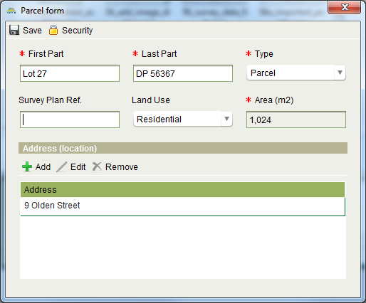

Figure 76 - Add Parcel dialog

1. On the Rights / Restrictions tab you must add all of the current rights and restrictions as noted on the paper title.
2. Start by creating the primary right for the property. Select the appropriate primary right type from the Right type drop down and click C:\Work\source\Help Images\icons\create.png Create.
3. Enter the details for the primary right (e.g. owner details and share information) and set the Registration date and Notation text. You will also need to C:\Work\source\Help Images\icons\add.png Add a document to the primary right. Use the Title document.
4. Add any other current rights or restrictions (i.e. mortgages, caveats, etc.) noted on the paper title to the property by selecting the appropriate type of right/restriction in the Right type drop down and clicking C:\Work\source\Help Images\icons\create.png Create.
5. Go to the Property history tab.
6. If the paper title indicates a Prior Title or Prior Folio then click the C:\Work\source\Help Images\icons\add.png Add tool in the Parent Properties section to launch the Add Parent Property Wizard. Use the search to locate the appropriate prior title and complete the wizard.
   1. Make sure the **Relationship Type** on the Select Rights and Parcels screen is set to **Prior Title**.
   2. If you cannot locate the prior title using the search, then cancel the wizard as Registry does not have a record of the prior title.
   3. Note that the prior title should have a status of Historic. If it is Current, then that indicates the prior title is live. You should investigate further to determine if the prior title should remain live or whether it must be cancelled as part of converting the paper title (using the Cancel Title service).
7. C:\Work\source\Help Images\icons\save.png Save changes to Property Details and C:\Work\source\Help Images\icons\confirm.pngComplete the Convert to Title service.
8. Continue processing the application and any other services as required.

### Also See

* Registry Concepts
  + Services
  + Rights Restrictions and Responsibilities
* Registry Desktop Screens
  + Application Details
  + Property Details
  + Simple RRR
  + Rightholder RRR
  + Ownership RRR
  + Lease RRR
  + Mortgage RRR
  + Document Details
  + Party Details
* Land Registration How To
  + Lodge and Process a Land Registration Application
  + Use the Add Parent Property Wizard

## Use the Add Parent Property Wizard

The Add Parent Property Wizard allows you to create a relationship between two properties. The main purpose of the wizard is to setup prior title references but it can also be used to create other relationships between properties. For example in SOLA Samoa, the wizard is used to setup prior title references as well as associate new property records with their village.

The wizard can be accessed when processing a Convert to Digital Title or New Freehold Title service by clicking the C:\Work\source\Help Images\icons\add.png Add tool on the Property history tab of the Property Details screen. In addition, when you C:\Work\source\Help Images\icons\start.png Start a New Freehold Title service, you will be prompted to bring forward current right/restrictions from the prior title property. If you choose Yes to that prompt, the Add Parent Property Wizard will be displayed automatically and will allow you to locate the prior title property and select rights and parcel information from that property to bring forward onto the new property record.

**Steps**

1. C:\Work\source\Help Images\icons\start.png Start a Convert to Digital Title or New Freehold Title service.
2. If prompted to bring forward current rights/restrictions, choose Yes. Note this prompt is only displayed for the New Freehold Title service. Otherwise go to the Property history tab and click the C:\Work\source\Help Images\icons\add.png Add tool.
3. Search for or select the appropriate parent property. Once selected, the Next button will become enabled allowing you to continue the wizard. Click Next.

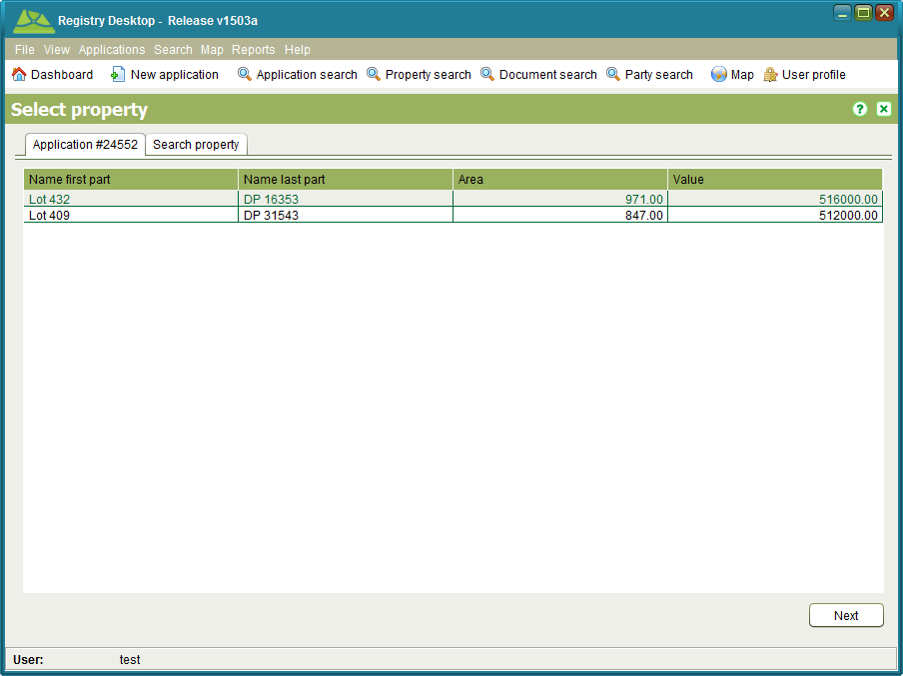

Figure 77 - Add Parent Property Wizard > Select property

1. You will be able to optionally select rights and parcels from the parent property to bring forward onto the new property. You should only bring through information relevant to the new property. For the other services, you will only be able to select the Relationship type.
2. Choose the appropriate Relationship type and click Next.

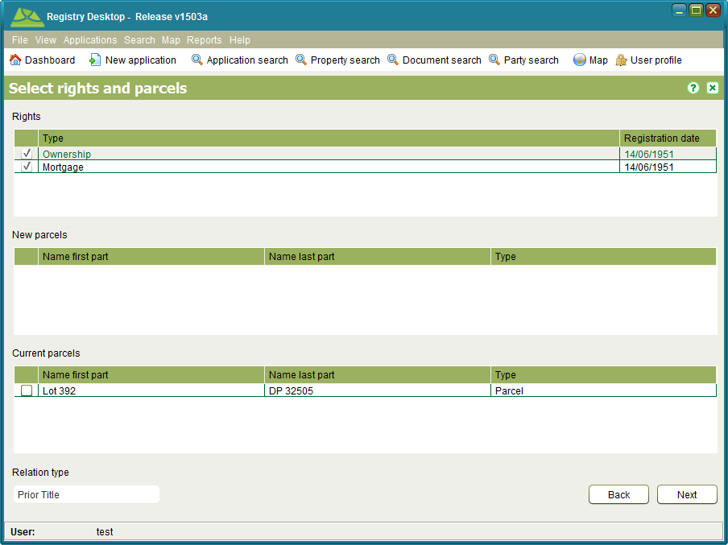

Figure 78 – Add Parent Property Wizard > Select rights and parcels

1. This will complete the wizard. Another prompt may display to confirm whether to bring forward the area of the parent property onto the new property. Respond to this prompt as appropriate.

### Also See

* Registry Desktop Screens
  + Property Details
* Land Registration How To
  + Lodge and Process a Land Registration Application
  + Convert a Paper Title

# Survey How To

## Record a Plan

When a new plan is submitted to the land administration agency for approval (i.e. Survey, Complied, Registry, etc.), the details from the plan must be recorded in Registry before the titles over any new parcels can be issued.

### Lodge an Application

The first step to record a new plan is to lodge a new application in Registry containing a Change to Cadastre service. This should be done while the surveyor (or their representative) is in attendance so that you can provide them with the lodgement notice detailing the fees to pay.

**Steps**

1. From the Dashboard select the C:\Work\source\Help Images\icons\new.png New application tool to open the Application Details screen.
2. On the General tab, select the surveyor as the Agent and/or set the appropriate contact details.
3. On the Services tab, add the Change to Cadastre service to the application.
4. On the Property tab, enter the title references for the underlying parcels of the plan (i.e. the parcels that will be extinguished by the plan) and add them to the application using the Add property button. You should verify each property using the C:\Work\SOLAHelp\images\icons\document-task.png Verify tool to confirm Registry contains the appropriate details to process the plan.
5. On the Documents tab, record each of the physical documents provided by the surveyor. At a minimum the Change to Cadastre services requires a Cadastral Survey document.
   1. Ensure you select the appropriate document type and record the document date (i.e. the date recorded on the face of the physical document) or today’ s date if the physical document is not dated.
   2. Enter a reference number for the document and a description. The reference number should be taken from the physical document. . If the physical document does not have any reference number, then enter the application number, period and document sequence number (e.g. 120001.03).
   3. The Source Agency is the name of the organization that created the physical document. E.g. For the plan, the name of the surveyors firm or the surveyors name can be entered here. This field is optional and can be left blank.
   4. If you have scanned the document, use the Attachment field to link in the scanned image. If you have not yet scanned the document, you will need to do this at a later stage and link it into the document using the Edit Document functionality available from Document Search.
6. On the Map points tab, navigate the map to the location of the plan and add one or more application points using the Add Application Point tool C:\Work\source\Help Images\icons\application-location-add.png.
7. Click the C:\Work\source\Help Images\icons\save.png Save button. This will lodge the application and produce the lodgement notice. Print the notice and give it to the surveyor (or their representative) as proof the application has been lodged. The lodgement notice will indicate the fee to pay for the application.

### Fee Payment

Once the lodgement notice is printed, the surveyor will need to take the notice to the cashier and arrange payment. When payment has been made, the cashier will C:\Work\source\Help Images\icons\folder-open-document.png Open the application from the Unassigned application list in the Registry Desktop and check the Fee Paid flag on the Fees tab to indicate the application can continue processing.

### Assign the Application

Before work can begin on recording the plan information in Registry, the application must first get assigned to a Survey staff member. Assignment of the application indicates that work on the plan is underway.

**Steps**

1. From the Registry Dashboard, check the Unassigned applications list to confirm the fee for the application has been paid. If the fee has not been paid it will not be possible to assign the application. In this situation contact the surveyor and/or cashier to confirm the payment status for the application.
2. If the application fee has been paid, select the application in the Unassigned applications list and click the C:\Work\source\Help Images\icons\assign.png Assign tool. This will open the Application Assignment screen.
3. Click the Assign button to assign the application. When the Assign action is complete, you will be returned to the Dashboard and the assigned application will appear in your Assigned applications list.

Typically users will only be able to assign applications to themselves (i.e. they will be able to pull work), however team leaders will be able to manage the workload of their teams and will be able to assign and reassign applications to other users. Note that the C:\Work\source\Help Images\icons\unassign.png Unassign and C:\Work\source\Help Images\icons\assign.png Assign tools can be used reassign the application to another user if necessary.

### Manual Assessment

The Survey staff member assigned to the application will perform the necessary manual checks to confirm the plan complies with the appropriate survey regulations. If the assessment of the plan is successful, the staff member can begin recording the details of the plan in SOLA using the Change to Cadastre service. If the assessment reveals issues with the plan that must be addressed by the surveyor, then the plan will need to be requisitioned.

### Requisitioning and Resubmitting the Plan

When the plan requires requisition it will be necessary to update the application in Registry to the Requisitioned status.

**Steps**

1. Confirm the plan requires requisition with the appropriate team leader.
2. Create the requisition notice describing the issues that need to be addressed by the surveyor.
3. Open the application from the Assigned applications list in the Dashboard. Go to the Documents tab and create a new Requisition Notice document with the requisition notice as the attachment. Attaching the requisition notice to the application will ensure the reasons for requisitioning the plan are recorded in Registry.
4. Using the Application action dropdown, select the C:\Work\source\Help Images\icons\requisition.png Requisition action. This will update the application status to Requisitioned and remove the application from your Assigned applications list. If the Requisition action is not enabled on the Application action dropdown, confirm the application is assigned to you and that you have the Requisition Application role by asking IT Services to check your Registry User setup.

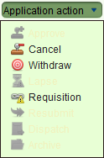

Figure 79 - Application Action Dropdown

1. Dispatch the requisition notice to the surveyor so that they are aware of the items that must be addressed. You can record that when the requisition notice is sent by using the C:\Work\source\Help Images\icons\envelope.png Dispatch action of the Application action dropdown.

Once the surveyor addresses the items listed in the requisition notice, they will resubmit the plan.

1. Use the C:\Work\source\Help Images\icons\search.png Application search to locate the plan and C:\Work\source\Help Images\icons\folder-open-document.png Open it.
2. Select the C:\Work\source\Help Images\icons\resubmit.png Resubmit action on the Application action dropdown. This will move the application back to the Assigned applications list ready for further processing.

It is possible the surveyor may choose to withdraw the survey following requisition. This can be achieved by using the C:\Work\source\Help Images\icons\withdraw.png Withdraw action on the Application action dropdown. Alternatively, if the plan remains on requisition for an extended period, and no further information is provided by the surveyor, the application can be lapsed using the C:\Work\source\Help Images\icons\lapse.png Lapse action. Be aware that once lapsed or withdrawn, the survey cannot be reinstated.

### Change to Cadastre Service

The Change to Cadastre service provides tools that allow you to modify the existing cadastral network. The following describes the basic process flow for capturing plan information. Variations to this basic flow are possible.

**Steps**

1. From the Dashboard, folder-open-document Open the application from your Assigned applications list.
2. On the Services tab, select the Change to Cadastre service and click the C:\Work\source\Help Images\icons\start.png Start tool. This will open the Change to Cadastre screen.
3. If the Map Viewer is not already zoomed to the location of the plan, use the map search or the map navigation tools to locate the area of the plan.
4. Use the Select Target Parcel tool C:\Work\source\Help Images\icons\select-parcel.png to select (or deselect) the underlying parcels. If you have an image of the survey plan, you can choose to add the plan image into the Map Viewer to assist with digitizing coordinates.
5. Capture the survey points for the plan. You can do this by using the Create / Link Survey Points tool C:\Work\source\Help Images\icons\node-linking.png to locate survey points directly on the Map Viewer using the mouse, load new coordinates from a survey data file or use the Survey Points screen to manually enter the new coordinate details.
6. Use the Create / Link Survey Points tool C:\Work\source\Help Images\icons\node-linking.png to link survey points that represent existing marks to the appropriate target parcel nodes. This step is important because it ties the new survey data to the underlying cadastral network. Once linked, a survey point will change from being a blue plus to a green plus.
7. Use the Survey Points screen to identify any traverse points from the plan by de-selecting/unchecking the Is boundary checkbox.
8. Create the new parcels from the plan using the Create New Parcel tool C:\Work\source\Help Images\icons\new-parcel.png. New parcels will automatically get assigned the plan number from the application. The lot number will also get automatically assigned, however this may need to be manually updated using the Parcel List screen.
9. Use the Parcel List tool C:\Work\source\Help Images\icons\eraser.png to open the Parcel List screen and enter the Official area for each parcel as noted on the Plan. The area should be entered in square meters only.
10. Once all of the relevant information from the plan has been captured into Registry, return to the Services tab of the Application Details screen, select the Change to Cadastre service and click the C:\Work\source\Help Images\icons\confirm.png Complete tool. This will run the Registry business rules to validate the application data. If there is a critical failure, you must remedy the failure as it will not be possible to approve the application otherwise.

**Notes**

* Use C:\Work\source\Help Images\icons\save.png Save on the Change to Cadastre screen regularly.
* The act of saving and/or completing the service will cause the Registry business rules to run validating the state of the data. If you receive rule failures, check Appendix 1 – Registry Busines Rules to determine how those failures can be remedied.
* Additional information on using the Change to Cadastre tools can be found in the Change to Cadastre section.

### Approving the Plan

The changes you make to the cadastral network while recording new plan information remain pending until the application is approved. Survey approval in Registry can be achieved using the C:\Work\source\Help Images\icons\approve.png Approve action in the Application action dropdown.

**Steps**

1. Open the application from your Assigned applications list and use the C:\Work\source\Help Images\icons\validation.png Validate tool to check the status of the application data. If there are any rule failures, review the application data and correct the issues as appropriate before proceeding to approve the application.
2. Use the C:\Work\source\Help Images\icons\approve.png Approve action in the Application action dropdown to approve the application. This will update the status of the application to Approved as well as update the cadastral network with the information captured from the plan.
3. Dispatch a notice and any other relevant information to the surveyor to notify them of the approval. You can record that when the notice is sent by using the C:\Work\source\Help Images\icons\envelope.png Dispatch action of the Application action dropdown.

### Lodge Application to Create New Titles

Once the notice of approval is sent to the surveyor, it is necessary to create a second application that will be used by Land Registration to create the titles for the new parcels created by the plan as well as cancel the titles that were superseded by the new parcels. If there are no new parcels created on the plan and no titles to cancel, you can simply C:\Work\source\Help Images\icons\archive.png Archive the application used to process the plan and skip the steps described below.

**Steps**

1. From the Dashboard select the C:\Work\source\Help Images\icons\new.png New application tool to open the Application Details screen.
2. On the General tab, enter the Agent and contact details as noted on the application used to process the plan.
3. On the Services tab add a Cancel Title service if there are properties that must be cancelled as a result of the new plan (i.e. properties to cancel for the parcels extinguished by the plan). Only one Cancel Title service is required regardless of the number of properties that are to be cancelled.
4. On the Services tab, add a New Freehold Title service for each new parcel on the plan that requires a title. E.g. if there are 5 parcels on the plan that require new titles, add 5 New Freehold Title services to the application.
5. On the Property tab, enter the title references for the underlying parcels of the plan and add them to the application using the Add property button.
6. **Important**: On the Documents tab, create a Cadastral Survey document and use the Document search to link to the plan image recorded on the application used to process the plan. The plan image will be used by Land Registration to determine the titles for the new parcels.
7. On the Map points tab, you can optionally navigate the map to the location of the plan and add one or more application points using the Add Application Point tool C:\Work\source\Help Images\icons\application-location-add.png.
8. On the fees tab, check the Fee Paid checkbox then click the C:\Work\source\Help Images\icons\save.png Save button. This will lodge the application and produce the lodgement notice. You can close the lodgement notice without printing it. If you do not have permission to check the Fee Paid checkbox, save the application and arrange for a person with the appropriate privilege to do this for you.
9. Once the Land Registration application has been lodged, open the application used to process the plan and archive it using the C:\Work\source\Help Images\icons\archive.png Archive action in the Application action dropdown.

### Also See

* Registry Concepts
  + Services
  + Documents
  + Business Rules
* Registry Desktop Screens
  + SOLA Map Viewer
  + Application Details
  + Change to Cadastre
* General How To
  + Lodge a new Application
  + Edit an Application
  + Assign an Application
  + Un-assign and Application
  + Calculate Fees
  + Cancel, Withdraw or Lapse an Application
  + Add location for Application
* Survey How To
  + Add a Plan Image for Digitizing
  + Import a Survey Data File
* Appendix
  + Registry Business Rules
  + Timble Pathfinder Software Configuration for SOLA Export CSV File

## Redefine the Cadastre

The Redefine Cadastre screen allows you to change the boundaries of an existing parcel both entirely and point by point (adding nodes and changing node coordinates) outside of the receipt of a survey plan. This may be required due to general maintenance of the cadastral network and/or correction of erroneous data.

### Lodge an Application

To redefine the cadastre, you must lodge a new application in Registry containing a Redefine Cadastre service. The only documentation required is a Cadastral Survey. This is not intended to be a survey plan, instead it will typically be a complied plan or a sketch that describes the changes required to the cadastre.

**Steps**

1. Discuss and confirm the changes required with your team leader.
2. From the Dashboard select the C:\Work\source\Help Images\icons\new.png New application tool to open the Application Details screen.
3. On the General tab, enter your details as the contact person.
4. On the Services tab, add the Redefine Cadastre service to the application.
5. You can optionally list the parcels affected by the application on the Property tab.
6. On the Documents tab, create a Cadastral Survey document and attach the documentation that describes the change and clarifies why the change is being made. Enter today’s date for the document. The other fields can remain blank.
7. On the Map points tab, navigate the map to the location of the change and add one or more application points using the Add Application Point tool C:\Work\source\Help Images\icons\application-location-add.png.
8. On the fees tab, check the Fee Paid checkbox then click the C:\Work\source\Help Images\icons\save.png Save button. This will lodge the application and produce the lodgement notice. You can close the lodgement notice without printing it. If you do not have permission to check the Fee Paid checkbox, save the application and arrange for a person with the appropriate privilege to do this for you.

### Assign the Application

Before work can begin on changing the map, the application must first get assigned to a Survey staff member. Assignment of the application indicates that work on the application is underway.

**Steps**

1. Assuming the Fee Paid checkbox is checked, select the application in the Unassigned applications list and click the C:\Work\source\Help Images\icons\assign.png Assign tool. This will open the Application Assignment screen.
2. Click the Assign button to assign the application. When the Assign action is complete, you will be returned to the Dashboard and the assigned application will appear in your Assigned applications list.

### Redefine Cadastre Service

The Redefine Cadastre service provides tools that allow you to modify the existing cadastral network. The following describes the basic process flow for changing the map. Variations to this basic flow are possible.

**Steps**

1. From the Dashboard, C:\Work\source\Help Images\icons\folder-open-document.png Open the application from your Assigned applications list.
2. On the Services tab, select the Redefine Cadastre service and click the C:\Work\source\Help Images\icons\start.png Start tool. This will open the Redefine Cadastre screen.
3. If the Map Viewer is not already zoomed to the location of the change, use the map search or the map navigation tools to locate the appropriate area.
4. Use Node tools and/or Boundary Change tools to update parcels as required.
5. Once all of the relevant information from the plan has been captured into Registry, return to the Services tab of the Application Details screen, select the Redefine Cadastre service and click the C:\Work\source\Help Images\icons\confirm.pngComplete tool. This will run the SOLA business rules to validate the application data. If there is a critical failure, you must remedy the failure as it will not be possible to approve the application otherwise.

**Notes**

* Use C:\Work\source\Help Images\icons\save.png Save on the Redefine Cadastre screen regularly.
* The act of saving and/or completing the service will cause the Registry business rules to run validating the state of the data. If you receive rule failures, check Appendix 1 – Registry Business Rules to determine how those failures can be remedied.
* Additional information on using the Redefine Cadastre tools can be found in the Redefine Cadastre section.

### Approval

The changes you make to the cadastral network while using the Redefine Cadastre tools remain pending until the application is approved. Survey approval in Registry can be achieved using the C:\Work\source\Help Images\icons\approve.png Approve action in the Application action dropdown.

**Steps**

1. Open the application from your Assigned applications list and use the C:\Work\source\Help Images\icons\validation.png Validate tool to check the status of the application data. If there are any rule failures, review the application data and correct the issues as appropriate before proceeding to approve the application.
2. Use the C:\Work\source\Help Images\icons\approve.png Approve action in the Application action dropdown to approve the application. This will update the status of the application to Approved as well as update the cadastral network with the recorded changes.
3. Following approval, you can complete the application immediately using the C:\Work\source\Help Images\icons\archive.pngArchive action in the Application action dropdown.

### Also See

* Registry Concepts
  + Services
  + Documents
  + Business Rules
* Registry Desktop Screens
  + SOLA Map Viewer
  + Application Details
  + Redefine Cadastre
* General How To
  + Lodge a new Application
  + Edit an Application
  + Assign an Application
  + Un-assign and Application
  + Cancel, Withdraw or Lapse an Application
  + Add location for Application
* Survey How To
  + Add a Plan Image for Digitizing
  + Import a Survey Data File
* Appendix
  + Registry Business Rules
  + Timble Pathfinder Software Configuration for SOLA Export CSV File

## Add a Plan Image for Digitizing

When performing a Change to Cadastre or Redefine Cadastre service, you can choose to add an image of the plan to the Map Viewer to assist with digitizing the survey point data directly from the plan.

To add a plan image to the map you must first have an image file available on your local hard drive. The file formats supported by the Map Viewer are TIFF, PNG and JPEG. Before adding the image, you should also select the target parcels as they may be difficult to select after the image is added.

The Add Image tool C:\Work\source\Help Images\icons\image-add.png works by matching two points you select on the map with two points you select from the image. Before adding the image, you should compare the plan to the Map Viewer and identify two candidate parcel nodes that exist on both the plan and the Map Viewer. For the best match accuracy, the first node you select should be at the bottom left of the plan image and the second point at the top right (or top left and bottom right). Note that the current Add image tool does not rotate the image. If the plan does not have the standard North orientation, then do not attempt to digitize from the plan as the result will be inaccurate.

Once you have the image file ready, identified the two matching points and selected your target parcels, click the Add image tool C:\Work\source\Help Images\icons\image-add.png. You will be prompted to select the first of two points on the Map Viewer. Zoom in if necessary to ensure your selection is accurate. You will then be prompted to select a second point. Again, zoom in if necessary to ensure your selection is accurate.

The Add Image tool will then prompt you to select your image file from your local hard drive. Upon making your selection, the image file will be displayed in the Add Image Preview dialog. You can enlarge this dialog as necessary to improve your selection accuracy. Click the image at the location matching the first point you selected from the map. A green cross will appear on the image. Click the image at the location matching the second point from the map and a second green cross will appear.

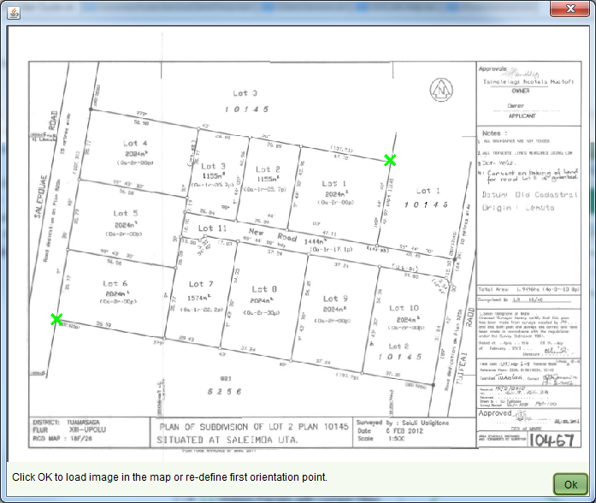

Figure 80 - Add Image Preview Dialog with 2 Selections

To proceed, click the OK button on the Add Image Preview dialog. The image will be scaled as required and displayed in the Map Viewer. The image will display on top of the standard Map Viewer navigation layers, but will appear below the editing layers added for Change to Cadastre and Redefine Cadastre.

If you make a mistake, you can remove the image from the Map Viewer using the Remove Image tool C:\Work\source\Help Images\icons\image-remove.png and re-add the image. You can also change your selections in the Add Image Preview dialog by re-selecting the location of the first point after you have added the second point. Be aware that re-selecting the first point will require you to re-select your second point as well.

### Also See

* Registry Desktop Screens
  + Change to Cadastre
  + Redefine Cadastre
* Survey How To
  + Record a Plan
  + Redefine a Cadastre

## Import a Survey Data File

When capturing survey plan data, you have the option of loading coordinate data directly from a Comma Separated Values (CSV) text file. The file must be a plain text file containing 3 columns of data. Those columns are:

1. Number for the point
2. X ordinate
3. Y ordinate

Other rules that apply to the Survey Data File include

* Each column value must be separated by a comma (,)
* If the first row of the file is a header row the default setting for the first line of ‘1’ can be retained and this first row will be ignored. If it is a Trimble GPS data file there is no header row and the setting for the first line (at the bottom of the dialog) should be set to ‘0’
* The file must have the .csv file extension (e.g. filename.csv)
* No transformation of the coordinates is performed during import. The coordinates must be in the same coordinate system as that used by the Map Viewer.

To import the CSV file, you must first attach the file as a document to the application using the Add Documents functionality available on the Documents tab of the Application Details screen. You should also select Survey Data File as the document type for the new document.

Once the CSV file has been attached to the application, Start the Change to Cadastre service and go to the Documents tab (displayed beside the Layers and Find tabs). Click the Add button to open the Select Document dialog and select the Survey Data File document from the application.

Next, select the Survey Data File document from the list of documents in the Documents tab. If the attached CSV file has a .csv file extension, then the Add points button will become enabled. Click the Add points button to add the coordinates from the file. The new survey points will be displayed on the map.

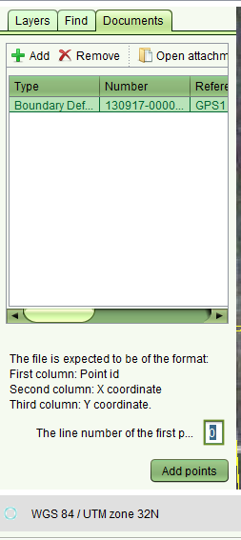

Figure 81 – Line Number Setting for Trimble GPS Data

If the Add Points button does not become enabled when you select the Survey Data File document, verify that the document has a file attachment and that file has a .csv extension.

### Also See

* Registry Desktop Screens
  + Change to Cadastre
  + Redefine Cadastre
* Documents How To
  + Add a Document to an Application
  + Attach a File to a New Document
* Survey How To
  + Record a Plan
  + Redefine a Cadastre
* Appendix
  + Timble Pathfinder Software Configuration for SOLA Export CSV File

# Troubleshooting Registry

## Logging

From time to time you may encounter unexpected issues while trying to run Registry. Usually the error message will recommend a course of action, but occasionally you may encounter a technical issue that requires further investigation by the IT Support Team or another Registry technical person. To assist that investigation you may be asked to provide a copy of the log files supporting Registry. The logs capture exception information and status messages that can help a technical person to determine the cause of a particular issue.

This section describes the two types of logs available with Registry; the Registry Application Logs and Java Runtime Environment (JRE) logging. It also describes how to access information from those logs.

### Registry Application Logs

Each Registry Web Start application (i.e. Registry Desktop and Registry Admin) creates an application log file on your local computer to capture exceptions and various status messages. You can find those log files at the following directory location **<User Home Directory>/sola/logs**.

The name of the log file will be DesktopApplication\_<date>.log (for Registry Desktop) or AdminApplication\_<date>.log (for Registry Admin). Simply open the appropriate log and copy the text from the log file into your email reply or issue ticket.

Note that your <User Home Directory> will depend on the operating system of your computer. For example, under Windows Vista and Windows 7 this will be C:\Users\<Your Windows User Name>.

### Java Runtime Environment (JRE) Logging

Registry is a Java application and the Java Runtime Environment (JRE) also provides a detailed logging capability. The advantage of using JRE Logging is that every exception and/or status message is reported whereas the Registry Application Logs only capture Registry specific exceptions and messages and may not necessarily capture the true cause of an issue.

JRE Logging is **not** turned on by default. You need to use the Java Control Panel to turn on the Java Console which can then be used to turn on JRE Logging as required. To turn on the Java Console and JRE Logging

1. From the Control Panel, choose the **Java** icon.
2. On the Java Control Panel, click the Advanced tab and expand the **Java console** node to select the **Show console** option.
3. Click the OK button to close the Java Control Panel and save changes.

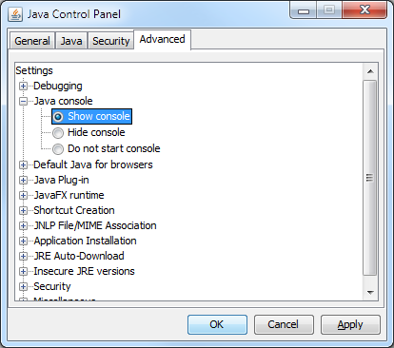

Figure 82 - Java Control Panel Advanced tab

1. Start the Registry Web Start application by double clicking the appropriate desktop shortcut. You will notice the Java Console display along with the Registry login page.
2. Click the Java Console so that it has focus and press **5**. The message **Trace level set to 5: all ...completed** should display in the console. Pressing 5 turns on logging to its maximum level.

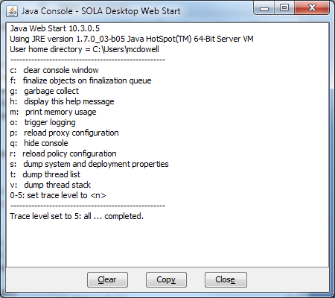

Figure 83 - Java Console with logging turned on

1. As you use the Registry application, messages will be output to the console. Repeat the actions that cause the issue to occur.
2. After successfully repeating the issue, click the **Copy** button on the Java Console and paste the contents of the JRE log into your email reply or issue ticket.

Be aware that JRE Logging will only be turned on for the duration of your current session. If you restart the Registry Web Start application, JRE Logging will be turned off until you set the logging level in the Java Console.

## Known Issues

This section lists some known issues and may help to resolve problems that you are encountering. Issues described here include

1. Unable to login
2. Registry Desktop shortcut does not appear
3. Lighthouse tickets

### Unable to login

While attempting to login to Registry you may get a message indicating your user name and password could not be verified. This message can be caused by a number of different reasons most of which will require IT Support to assist you.

|  |  |  |
| --- | --- | --- |
| **Cause** | **Description** | **Resolution** |
| Invalid user credentials |  | Enter valid user credentials. If you cannot remember your user credentials, contact IT Support to reset your password. |
| User account is disabled |  | Contact IT Support to verify if your account is enabled. |
| Application services are unavailable | The Registry Web Start applications use web services on the Registry Application Server to process information. If the web services are unavailable due to a problem with the network or the Registry Application Server, you will receive the user name and password could not be verified message. | Contact IT Support to restart the SOLA Application Server. |

### Registry Desktop shortcut does not appear

If you have installed Java 7 update 7 (build 1.7.0\_07) you may find that the Registry Desktop shortcut does not appear on your desktop. This is an issue with update 7. Upgrade to a later version of Java 7 or downgrade to an earlier version (e.g. Java 7 update 3).

### Lighthouse tickets

Lighthouse is the issue tracking system used by the SOLA Development Team to record and track issues with the software. You can view details of known issues and workarounds here <https://flossola.lighthouseapp.com/projects/89377-sola/overview>.

# Release Notes

This section summarises the changes made to Registry or it’s configuration as part of each new release. Further details for each change can be found in the [SOLA Lighthouse Project](https://flossola.lighthouseapp.com/projects/89377-sola/overview) using the Lighthouse ticket number as reference.

## Release 1503a

| **Ticket** | **Title** | **Change Summary** |
| --- | --- | --- |
| 218 | Service side caching of reference codes | New Cache EJB added to cache reference codes, settings and relatively static data values on the server. The cache is configured to refresh automatically once a day. |
| 399 | Create database backup scripts for Linux | Bash shell scripts added to the Registry database\_sola project to support regular automated backups of production Registry databases. |
| 402 | Implement Disaggregated Ownership Gender Report | Report added to show property ownership by gender. |
| 410 | Password encryption fails to correctly encrypt some words | Corrected minor issue password hash algorithm to ensure it matches the hash generated by Glassfish. |
| 418 | Email service introduced | Service to with capability of sending emails was added. |
| 420 | Update the Add Service dialog to use a TreeTable component | Add Service dialog modified to group and display services using a tree table control. |
| 421 | Improvements to FormatterFactory and Table Cell Renderers | FormatterFactory extended to provide formatting and editing for areas, currency and date fields. Table Cell Renderers updated to use FormatterFactory for consistent formatting of data. |
| 422 | Refactor method used to launch application services | Modified the service launch process so that it can be controlled through database configuration. |
| 423 | Applicant should be set as the owner of a property by default | When a new property is created the applicant is automatically set as the owner for the new property. The user can edit the ownership details if required. |
| 426 | Add Road Centreline and Locality into Waiheke dataset | Road centreline and street address data added to the demonstration test dataset. |
| 427 | Support retrieval of arrays from the database | Updated the Repository layer to support retrieval of arrays from the database. |
| 435 | Notification Service (incl. Gender Safeguards) | Added Record Person Relationship service and supporting forms |
| 448 | SOLA Desktop re-branding | Renamed SOLA Desktop to Registry Desktop. Updated colour scheme of Registry Desktop to reflect Voluntary Guideline colours. |
| 453 | Implement support for Security Classifications for Family Safeguard | Added ability to set security classifications for individual data records so that only authorized personnel can view sensitive records |
| 455 | Service to request the obscuration of party data | Added Privacy Request service |
| 456 | Disable Systematic Registration features in SOLA Registry | Disabled all Systematic Registration menus so these are no longer available from Registry. |
| 457 | Adjust system.language table to introduce text direction attribute | Added attribute to system.language table to indicate if the language is left to right or right to left. |
| 458 | Add Language Translations for Chinese, Spanish and Portuguese | Added language translations into Registry for Chinese, Spanish and Portuguese. |

# Appendix 1 – SOLA Business Rules

This appendix can be used to determine the remedial action that should be undertaken when a SOLA business rule fails.

| **Code** | **Message** | **Remedial Action** |
| --- | --- | --- |
| AP010 | An application including a new freehold service must also terminate the parent title(s) with a cancel title service. | Check that relationship to previous title has been defined in History Tab for the new title(s). |
| AP020 | All documents required for the services in this application are present. | In the Application Document Tab determine (in right hand column) the unchecked required document types and add these documents to the Application. |
| AP030 | All the titles identified for the application must be current. | Search titles and locate the current title reference for the property used in the application. |
| AP040 | An application must have at least one service. | Add a service to the Application. |
| AP050 | New Freehold title service must come before Cancel Title service in the application. | Order the services in the application so that the Cancel Title occurs last. |
| AP060 | When a new title is created there must be a cancel title service in the application for the parent title. | Create a service to cancel the titles to be superseded by the new titles. |
| AP070 | All services in the application must have the status 'cancelled' or 'completed'. | Check that all services have been completed (or cancelled). |
| AP080 | Changes on the system must have been made for all services in the application. | Check that all services have been completed (or cancelled). |
| AP090 | A primary right (such as ownership) must be identified for a request for a new title. | Check property form and ensure the primary right checkbox is checked for one right (usually ownership). |
| AP100 | All rights and restrictions from existing title(s) must be accounted for in the new titles created in this application. | Manually check that all current rights have been transferred to new titles or cancelled and add new services to cancel redundant rights (or restrictions). |
| AP110 | The identified property has a current or pending caveat registered on the title. The application must include a cancel or waiver/vary caveat service for registration to proceed. | Add another Remove Caveat or Vary Caveat service to the application. |
| AP120 | The scanned image of the title should be less than one week old. | Attach a more recent title image. |
| AP130 | Personal identification verification should be attached to the application. | Add scanned image of the applicant to a Proof of Identification document. |
| AP140 | The identified property is affected by another live application that includes a service to register a caveat. An application with a cancel or waiver/vary caveat service must be registered before this application can proceed. | Deal with caveat lodged on same property by a different application |
| AP150 | The applicants name should be the same as (one of) the current owner(s) | Check the applicant's name, whether they are appropriately verified (attach scanned images of personal id) and whether the application is authorised to initiate the services requested in the application |
| AP160 | Documents should have dates formalised by source agency that are not in the future. | Check the date of the document and amend where necessary |
| AP170 | There are services that should be dealt in the front office. These services are of type: serviceEnquiry, documentCopy, cadastrePrint, surveyPlanCopy, titleSearch. | Verify there is a good reason for these services to be provided as back office services |
| AP180 | An application can be associated with a property which should have a digital title record. | Add a Convert to Digital Title service to the application |
| AP190 | Documents lodged with an application should have a scanned image file (or other source file) attached | Add a scanned image (or other source file) to the document record |
| AP200 | Verify the identified primary right is permissible as a primary right | An allowable primary right (ownership, apartment, State ownership, lease) must be identified for a new title |
| AP210 | Verify the identifier for the title (Cof)) | Invalid identifier for title |
| AP220 | Verify if the period of public display is over | The publication period must be completed. |
| AP230 | Verify that all rights and restriction on the title to be cancelled have been transferred to new titles or these rights and restrictions are cancelled before this application proceeds | All rights and restrictions on the title to be cancelled must be transfered or cancelled in this application. |
| AP240 | Verify that the property area is the same as the sum of the associated parcel areas | Title has the same area as the combined area of its associated parcels |
| AP250 | Verify that property has a parcel(s) | Title must have Parcels |
| AP260 | Verify that all services are completed and included a transaction (for potential roll back of changes to core records) | Within an application, all services making changes to core records must be completed and have utilised an instance of transaction before application can be approved. |
| AP270 | Verify whether there is still a "live" objection | There must be no objection against the systematic registration |
| BA010 | Title must have a primary (ownership) right | Check property form and ensure the primary right checkbox is checked for one right (usually ownership) |
| BA020 | Pending registration actions (from other applications) affecting the title to be cancelled should be cancelled | Identify other application for same property and complete that application before proceeding with this application |
| BA030 | Title must have an associated parcel (or cadastre object) | Start service and in the Parcel Tab link existing parcel(s) or add new parcel records to title |
| BA040 | Title should have compatible parcel (or cadastre object) description (appellation) | Make sure cadastre object is compatible with title (usually a 'parcel') |
| BA050 | Title area should only differ from parcel area(s) by less than 1% | Review official area(s) of both the title and the corresponding parcel(s) and correct official area where appropriate |
| BA060 | Owners of new titles should be the same as owners of underlying titles | Check spelling of owner names and where new owners are to be recorded for new titles attached scanned documents to the ownership right collaborating the change in ownership |
| BA070 | Verify that a primary right has been specified | A title must have a valid primary right |
| BA080 | Verify that there is not a "live" caveat registered on the property | Caveat should not prevent registration proceeding |
| BA090 | Verify that mortgages on a property do not have the same ranking | The rank of a new mortgage must not be the same as an existing mortgage registered on the same title |
| BA100 | Verify the property area does not differ from the sum of the areas of the parcels associated with the property | Title area should only differ from parcel area(s) by less than 1% |
| CA060 | The union of the target parcels must be a polygon | Check that there are no additional, unexpected parcel records in Cadastre Change service form and that all parcels are properly formed polygons |
| CA080 | There should be no pending changes for any of target parcels | Identify other application dealing with target parcels and complete that application before proceeding with this application |
| CA100 | The parcel (cadastre object) should have a valid form of description (appellation) | Check parcel description/appellation is valid and amend where necessary |
| CA120 | The difference between the total of the new parcels official areas and the total of the old parcels official areas should not be greater than 0.1% | Check the official areas for both the new parcels and the official areas of the to be superseded parcels |
| CA140 | The difference between the new official parcel area and the new calculated area should be less than 1% | Check the official areas for the new parcels as they differ significantly from the system calculated areas |
| CA150 | New polygons do not overlap with each other. | Modify parcel redefinition changes as it appears the changes have caused overlaps |
| CA170 | The union of the new polygons must be the same as the union of the old polygons | Modify parcel redefinition changes as it appears the combined areas of the parcels affected has changed. |
| CA180 | The new parcel polygons must not overlap | Ensure all boundary nodes are included in polygons and that new boundary points coincident with existing boundary nodes have been linked |
| CA190 | New cadastral objects must be defined | Create new parcel polygons |
| CA200 | There are at least 3 survey points present | Add survey points through on screen digitising or the import of a CSV file of survey points |
| CA220 | The union of new parcel polygons is the same with the union of the target parcel polygons | Ensure all boundary nodes are included in polygons and that new boundary points coincident with existing boundary nodes have been linked |
| CA240 | Target parcel(s) must be selected | Identify the target parcel(s) |
| GE010 | Revise the spatial unit group identifier to ensure it is unique | Spatial unit groups must be unique. |
| RR010 | Caveat does not prevent registration proceeding. | Deal with requirements of caveat and then create new application with a Remove Caveat or Vary Caveat service and process. Once approve return to other applications that have been waiting for the caveat to be dealt with |
| RR020 | The rank of a new mortgage must not be the same as an existing mortgage registered on the same title | Review all mortgages on the title and revise rank of new mortgage accordingly |
| RR030 | There are no other pending actions on the rights and restrictions being changed or removed on this application | Review other applications for the same property and ensure their approval prior to auctioning the subsequent changes |
| RR040 | These rights (and restrictions) must have a recorded party (or parties) | Add rightholders names in the form defining the right |
| RR050 | The sum of the shares (in ownership rights) must total to 1 | Modify the shares so that they total to 1 |
| RR060 | Verify there are existing rights or restrictions to be modified | For cancellation or variation of rights (or restrictions), there must be existing rights or restriction (in addition to the primary (ownership) right) |
| RR070 | Verify rights or restrictions are not subject to other pending changes on other applications for the same property | There are no other pending actions on the rights and restrictions being changed or removed on this application |
| S0020 | Document (source file) must not have pending status | Revise attached source file to one that has current status |
| SO030 | Document to be registered must have an allowable current source type | Add only allowable file types |
| SV020 | Title must have Parcels | Start service and in the Parcel Tab link existing parcel(s) or add new parcel records to title |
| SV030 | Documents associated with a service must have a scanned image file (or other source file) attached | Add a scanned image (or other source file) to the document record |
| SV040 | Documents supporting rights (or restrictions) must have current status | Add or link a current document to the right (or restriction) that is being created, varied or cancelled |
| SV050 | Service 'req\_type' must have must have an associated Power of Attorney document | Add a scanned image of the Power of Attorney to the application |
| SV060 | Service 'req\_type' must have been started and some changes made in the system | Start service and complete all required data entry before attempting to complete service |
| SV070 | For cancellation or variation of rights (or restrictions), there must be existing rights or restriction (in addition to the primary (ownership) right) | Record the current right in the system through a separate service before actioning the service that varies or cancels the right |
| SV080 | Title has the same area as the combined area of its associated parcels | Check that the correct parcels have been identified for the parcel and that the total of the official parcel areas is within the specified limits with the given official total title area |
| SV090 | For the Register Mortgage service the identified title has no existing mortgages | Check that existing mortgage holders have agreed to new mortgage being registered |
| SV110 | For the Register Mortgage service, the new mortgage is for less than the reported value of property (at time application was received) | Verify the reported value of the property and the mortgage amount |
| SV120 | Name of person identified in Power of Attorney should match a (one of the) current owner(s) | Manually check that the owner name (recorded on the Power of Attorney) is the same as the recorded rightholder's name |
| SV130 | For the Convert Title service there must be no existing digital title record (including the recording of a primary (ownership) right) for the identified title | Confirm whether there is already a digital record of this title |
| SV140 | Add the required documents to this application | All documents required for the service 'req\_type' are present. |
| SV150 | Add a personal ID record image to this application | Within the application for the service a personal identification verification should be attached. |
| SV160 | Verify that all rights and restriction on the title to be cancelled have been transferred to new titles or these rights and restrictions are cancelled before this application proceeds | For the service 'req\_type' the title must be terminated (after all rights recorded on the title are transferred or cancelled). |

# Appendix 2 – Features of Registry

The Registry application supports the following feature list.

**Case Management**

1. Personal dashboard for each user showing all unassigned applications along with the applications currently assigned to them.
2. Users can assign themselves to applications (i.e. pull workflow)
3. Power users can manage the workload of other users by assigning and un-assigning applications
4. Applications can be re-assigned allowing different users to work on different parts of an application
5. Details that can be captured on the application include
   1. Agent and contact person information
   2. Services that indicate the type of changes the application will make to the land registry records
   3. Property records affected by the application
   4. The fee paid and receipt details
   5. Documentation supporting the application
   6. Approximate location of the application can be noted on the map
6. Lodgement checklist available so the user can ensure the necessary documentation is provided when the application is lodged
7. User can validate the property references provided with the application to confirm they are valid and recorded in Registry
8. Lodging an application assigns a unique number, calculates the fee and generates a lodgement notice
9. An application can have one or more services
10. The services supported by Registry can be configured to match those required by the land administration agency
11. The services users can work on can be controlled using security roles
12. Applications transition into different states as they are processed
13. Applications can be lodged, requisitioned, cancelled, withdrawn, lapsed, approved and completed
14. Changes to land registry records do not become live until an application is approved
15. Users can record when notifications are sent to the agent or contact
16. The history of changes to an application (who did what and when) can be viewed
17. The status of the application including the history log can be printed
18. An application statistics report is available that lists lodgements, requisitions and approvals over a given period

**Search**

1. Search applications by application number, date of lodgement, agent name, contact person name or document reference
2. Search properties (a.k.a. titles) by property reference or owner name
3. Search parties by name or party role
4. Search documents by document reference number, date submitted, document type, document source or description
5. Search spatial records using Map Find (supports zoom to and highlight of selected result)
6. The spatial searches supported by Registry can be configured to match those required by the land administration agency
7. Partial/wildcard matching is supported for text based search criteria

**Map Viewer**

1. Layer control to manage data displayed on the map
2. The layers supported by the Map Viewer can be configured to match those required by the land administration agency
3. Layer symbology defined using Style Layer Descriptor (SLD) OGC standard
4. Auto sizing scale bar displayed to help gauge distances on the map
5. Editable map scale to allow fast zooming of the map
6. Mouse enabled map navigation and map editing tools
7. Context sensitive map editing tools (depending on the service being worked on)
8. Map printing with page size and orientation selection
9. Information tool to summarize spatial object details
10. Supports orthophoto layers
11. Extract selected spatial objects to KML for display in other GIS tools (e.g. Google Earth)

**Document Management**

1. Attached scanned documents to an application from the local computer or a preconfigured network folder
2. Attach files up to 100Mb
3. Change or remove the attachment for an existing document
4. Cross link new documents with attachments previously loaded into SOLA
5. View a thumbnail preview of a document prior to attaching it (PDF and image formats only)
6. View attachments using the default application for that file type
7. Client side document cache that is auto sizing to prevent excessive disk usage
8. Register Power of Attorney and Standard Memorandum documents for reference by later applications

**Cadastral Editing**

1. Create new cadastral objects by subdividing and/or amalgamating existing cadastral objects
2. Capture survey points using the mouse, manually entering the survey coordinates or importing survey coordinate data from a CSV data file
3. Add nodes to existing cadastral objects
4. Modify the boundaries of existing cadastral objects
5. Capture irregular boundaries
6. Digitize survey information from an image of the plan
7. Link or snap survey points to existing cadastral object nodes
8. Calculate the variances between survey point coordinates and existing cadastral object nodes
9. Identify traverse points from the survey
10. Record the official area for new parcels
11. Validate spatial changes to avoid gaps and overlaps in the cadastral network

**Title Management**

1. Create new titles (a.k.a. properties) and record ownership, mortgage and other rights (and restrictions) on the title
2. The rights and restrictions supported by SOLA can be configured to match those required by the land administration agency
3. Convert existing paper titles into SOLA
4. Cancel titles
5. Memorials/notations are created on the title when a right or restriction is added, modified or removed
6. View the history of changes to a title
7. View the pending changes to a title
8. Link to the prior title when creating a new title or converting a title from paper
9. Property owners can be individuals or entities (a.k.a. parties) with each owner associated to a share
10. A share is expressed as a fraction and can be allocated to one or more parties
11. Print Title Certificate (a.k.a. Property Report)

**Gender Safeguards**

1. Individual parties can have their private information protected to prevent disclosure of their information to other parties
2. One party (the notifiable party) can register a relationship with another party (the target party) and obtain notification if there are changes to the target parties property rights or interests
3. Report illustrating property ownership by gender

**Business Rules**

1. Automated validation of application using configurable business rules
2. Rules executed just prior to changes in state of an application or service
3. Rules can also be manually executed using the Validate action
4. Rules to execute at a particular stage can be configured with the same rule executing at multiple stages
5. Severity rating for a rule can be configured based on the stage of execution
6. The failure of a critical rule aborts the current action
7. Rules are defined as SQL statements and can be versioned
8. New versions of rules can be uploaded into SOLA and configured to come into force at a future date without requiring redeployment of SOLA

**System Administration**

1. Add, edit and disable reference data values (e.g. service types, document types, RRR types, etc)
2. Version business rules and change business rule severity
3. Add, edit and disable user accounts
4. Configure security roles into groups and assign groups to users
5. User passwords expire at regular intervals determined by the system administrator.

**General**

1. Context sensitive online help
2. User profile to record user preferences and change password
3. All screen labels, messaging, database reference codes and online help documentation supports localization to different languages
4. General information enquiries can be logged and dealt with as applications
5. Secure individual data records so that only users with appropriate permissions can view those records
6. Email service to send email notifications

**Technical**

1. PostgreSQL database (supported versions v9+) with PostGIS spatial database extension (supports v1.5+ and v2+)
2. Database table structures based on the Land Administration Domain Model (LADM)
3. Web service architecture developed using Java Enterprise Edition (Java EE 6) and hosted in a JEE 6 compatible application server (Glassfish v4)
4. Uses the Metro Web Service stack compatible with .NET and Java web service technologies (WSIT compatible) and WS-Security
5. Java Web Start used for deployment
6. Java 7 JRE required on all client computers
7. Patches and enhancements to the SOLA Registry Desktop application are automatically downloaded by Java Web Start
8. Implements optimistic concurrency control to prevent loss of information due to concurrent data edits
9. The details for every exception that occurs on the server or the client are recorded in a log file to assist debugging and issue resolution.
10. The source code for SOLA is licensed under the Berkeley Software Distribution (BSD) 3-clause license
11. SOLA Registry can run on both Windows and Unix based operating systems
12. SOLA Registry does not require a geospatial data server, but it can integrate with any Web Map Service (WMS) capable server for display of orthophotos and other spatial data

# Appendix 3 – Trimble Pathfinder Software Configuration for SOLA Export CSV File

SOLA CSV Format definition:

First column: Is a unique identifier of the point within the file. It can start with 1 and incrementing by one.  
Second column: X coordinate.(Easting)  
Third column: Y coordinate. (Northing)  
The values are separated by commas

Example:

|  |  |  |
| --- | --- | --- |
| *Id,X,Y* |  |  |
| *1,570559.75,5931649.69* | | |

In this example the coordinate system will be UTM, Zone 31N and the datum is WGS84.

Setup:

1. Start Pathfinder Office and create/select a project.
2. Select **Utilities** > **Export** and **New**:

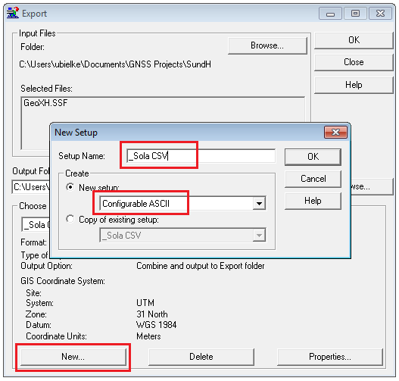

1. In the New Setup Window enter a Setup name (for example: \_Sola CSV ).

Note: The underscore will bring the Sola format to the top of the list later on.

1. Select **New Setup** and scroll for **Configurable ASCII** and tap **OK**

**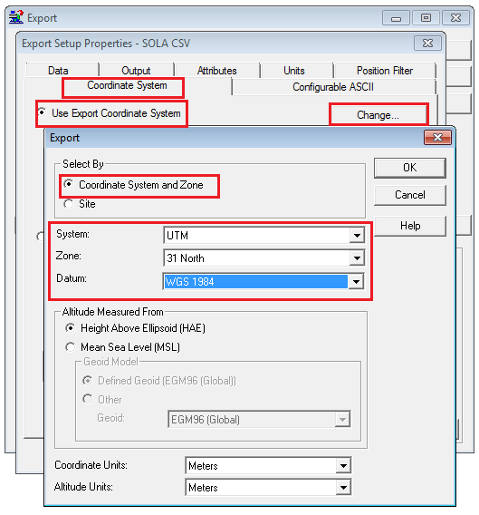**

The Export Setup Properties Window will open.

5. Select the **Coordinate System** Tap.

1. Select **Use Export Coordinate System** and tap **Change…**

The Export Window will open.

1. Select **System**: UTM

**Zone**: 31 North

**Datum**: WGS84

**OK**

The Export Setup Properties Window will open again.

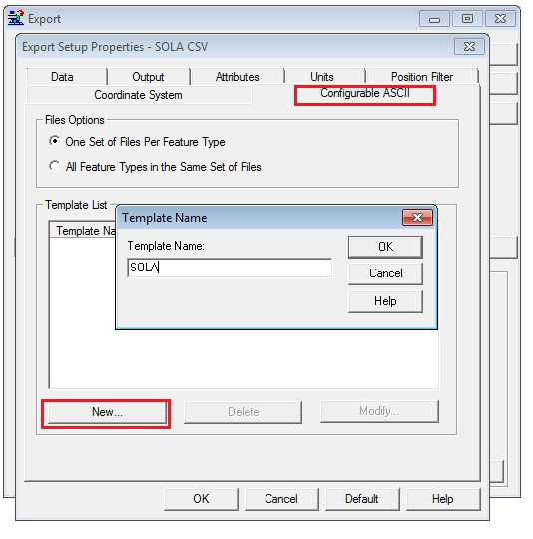

1. Select the **Configurable ASCII** Tab and **New**…
2. Enter a name for your new format (Example SOLA)

**OK**

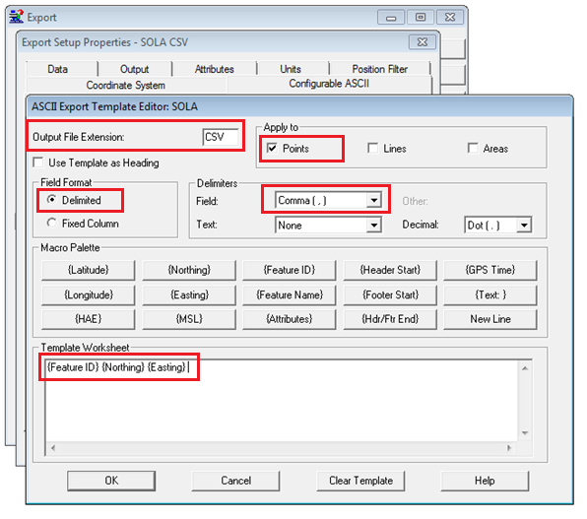The **ASCII Export Template Editor** page will open.

1. Enter the **Output File Extension** : CSV
2. **Apply to** : Points only
3. Select the **Field Format** : Delimited
4. Select the **Delimiters Field** : Comma (,)
5. Select the following output definitions from the Macro Palette with left mouse click:

{Feature ID}  
{Easting}

{Northing}  
**OK**

Note: Easting refers to the eastward-measured distance (or the x-coordinate) and Northing refers to the northward-measured distance (or the y-coordinate).

To use the define Export system select Select **Utilities** > **Export,** select your data file and **Choose an Export Setup:**

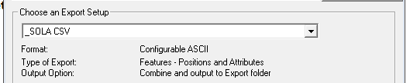

1. <http://www.linz.govt.nz/> [↑](#footnote-ref-1)
2. <http://bugs.sun.com/view_bug.do?bug_id=6780968> [↑](#footnote-ref-2)